Press release

Multifaceted shapes
In cooperation with Behnisch Architekten and ArtEngineering GmbH, Zumtobel created an extraordinary lighting solution for the new conference hall of the World Intellectual Property Organization (WIPO). Light-weighted, “cloud-like” appearing spherical luminaires facilitate pleasant illumination and simultaneously mask the halls technological components.
Dornbirn, April 2015 – In Geneva numerous international organisations are headquartered: the World Health Organization (WHO) and the United Nations Office as well as the World Intellectual Property Organization (WIPO), whose new conference hall has only recently been inaugurated in September 2014. Situated at the Place des Nations – between WIPO's main building and an administration building completed three years earlier, also designed by Behnisch Architekten – the new hall seats almost 900 delegates.
Due to its low thermal mass and favourable structural engineering properties, wood as a carbon-neutral building material has played a crucial role right from the start for the architects of Behnisch Architekten in the implementation of this exemplary sustainable project. Hence, they designed the conference hall as a pre-fabricated timber construction – clad in untreated larch wood shingles and supported by just a few pillars and walls – that seems to float elegantly above a foyer landscape. This impression of lightness is further increased by up to 35 m wide protrusions and extensive glazing, the purpose of which is both daylight provision and establishing a visual link between the building and its surroundings.
What was essential for the design of the conference hall was the architects' idea to create a clearly structured space that would surround the delegates with the pleasant warmth of wood and at the same time direct their full attention to the speaker's desk. In order to achieve the mean illuminance level of 500 lx required on all task areas, ceiling-mounted luminaires were not an option because they would have added unruly structures to the wooden ceiling and thus gravely disturbed the uniform room ambience.
With the aim of contrasting the relatively stern triangle geometry of the wooden ceiling with a “soft” counterpart, Behnisch Architekten in cooperation with Zumtobel and the Stuttgart-based engineers from ArtEngineering started to design a light-weight, spherical luminaire with a “cloud-like” appearance. This luminaire was on the one hand supposed to provide atmospherically diffuse lighting, and on the other hand to accommodate technical components such as for instance loudspeakers or cameras.
For the luminaires inside the engineers designed a supporting structure made of aluminium and shaped like an icosahedron with 20 triangles and a side length of approx. 1000 mm. The actual surface geometry was based on a geodesic dome. The triangular elements typical of such structures were combined in a total of 260 hexagons, with the icosahedron's 12 junctions resulting per definition in pentagons. The precise three-dimensional shape and the uniformly 14 mm wide joint spacings of the 272 aluminium sheet honeycombs with a depth of some 100 mm as well as an appropriate lattice-type substructure were defined using efficient 3D software.
The final design represents the aesthetically appealing ideal of an oversized pollen grain with funnel-shaped hexagonal honeycombs and LED lighting points, which uniformly illuminate all spaces. Per sphere at the intersections between the individual honeycombs are therefor 540 custom-made, dimmable Zumtobel LED lighting points with a diameter of only 67 mm installed – a solution that is expected to be extremely beneficial thanks to the expected LEDs' long service life and extended maintenance intervals. For maintenance work inside the spheres weighing at least 500 kg, suspended from the ceiling on three stainless steel cords, one of the lateral segments can be removed at any time.
Also the rest of the building features aesthetic and subtle lighting solutions. For instance, numerous LINARIA LED light lines installed along the ceiling peripheries enhance the building's structure – flush mounted into the individual elements of the wooden vane ceiling – while providing light in the foyer. For this purpose, Zumtobel developed, among other things, an opalised plexiglass enclosure ensuring that no individual LED lighting points are visible.
The wood, the inventive architecture and the carefully into the interior design integrated lighting solutions bestow the new conference hall of WIPO with a distinct appearance, which appears to be magical when entering, but in no way disturbs the delegates doing their work.

Building Owner: OMPI, Genf/CH
Architect: Behnisch Architekten, Stuttgart/D
Construction project luminaire: Art Engineering, Stuttgart/D
Lighting design: Lichtimpulse, Höchst/A
Electrical design: Amstein + Walthert, Genf/CH
Electrical engineering: Felix Badel SA, Genf/CH
Lighting solution: Projektleuchte Konferenzsaal, DIAMO, LINARIA

Captions:
(Photo Credits: Zumtobel)
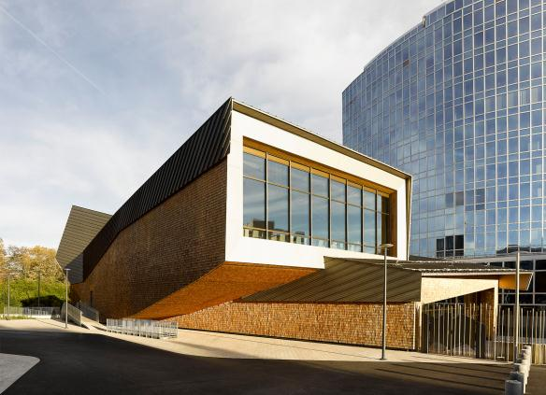
Fig. 1: The new conference hall of the World Intellectual Property Organization (WIPO).
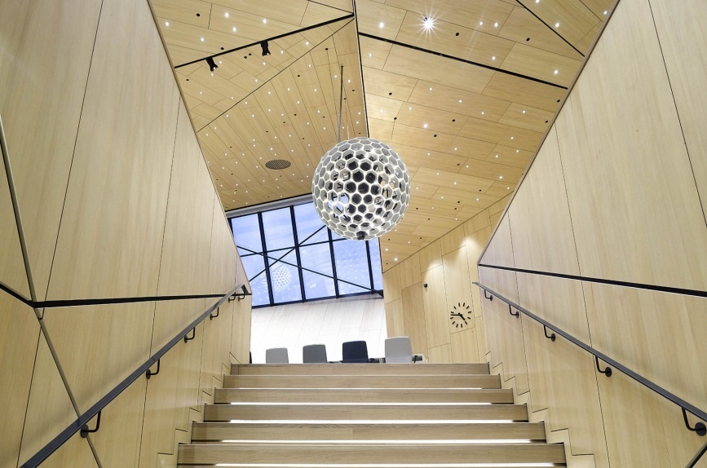
Fig. 2: Wood as a carbon-neutral building material has played a crucial role right from the start for the architects of Behnisch Architekten in the implementation of this exemplary sustainable project.
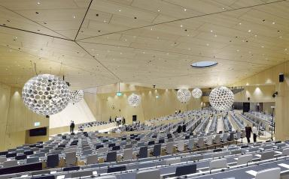
Fig. 3: The light-weight, “cloud-like” appearing spherical luminaire fractures the relatively stern triangle geometry of the wooden ceiling.
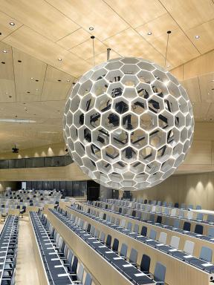
Fig 4: The diffuse lighting effect of the sphere is gained with the 540 Zumtobel LED lighting points each, which are positioned at the intersections between the individual honeycombs.
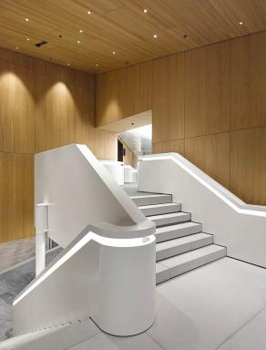
Fig 5: Further Zumtobel lighting solutions are carefully integrated into the interior design and bestow the building a distinct appearance.

Press contact:
Zumtobel Lighting GmbH
Sophie Moser
PR Manager
Schweizer Strasse 30
A-6850 Dornbirn

Tel +43-5572-390-26527
Mobil +43-664-80892-3074
E-Mail press@zumtobel.com
www.zumtobel.com

Sales contact:
Zumtobel Lighting Ltd.  Chiltern Park  Chiltern Hill, Chalfont St Peter  Buckinghamshire SL9 9FG  United Kingdom  Tel: +44 1753 482 650  Fax: +44 1753 480 350  uksales@zumtobel.com  www.zumtobel.co.uk | Zumtobel Lighting Inc.  3300 Route 9  Highland , NY 12528  United States  Tel: +1 845 691-6262  Fax: +1 845 691-6289  zli.us@zumtobelgroup.com  www.zumtobel.us

For further contact details in further sales regions please visit: http://www.zumtobel.com/com-en/contact.html

About Zumtobel
Zumtobel, a leading international supplier of integral lighting solutions, enables people to experience the interplay of light and architecture. As a leader in innovation, Zumtobel provides a comprehensive range of high-quality luminaires and lighting management systems for professional interior lighting in the areas of offices, education, presentation & retail, hotel & wellness, health, art & culture as well as industry. Zumtobel is a brand of Zumtobel AG with its head office in Dornbirn, Vorarlberg (Austria).
Zumtobel. The Light.

