Press release

Audi Hungaria's high-end factory illuminated by Zumtobel
Audi Hungaria's newly extended factory cannot fail to impress due to its huge size and extraordinary significance for the location. Since 2011, Zumtobel has been providing a vast number of technically and economically highly efficient luminaires as well as custom solutions for the Hungarian car factory the size of a small town.
Dornbirn, June 2015 – In the Hungarian town of Győr, AUDI HUNGARIA MOTOR Kft. develops and manufactures engines for AUDI AG and other companies of the Volkswagen Group. In 2013, the company officially inaugurated its new car factory encompassing the entire manufacturing process. In the same year, Audi Hungaria started serial production of the Audi A3 Sedan and the A3 Cabriolet. 2014 saw the beginning of serial production of the new Audi TT Coupé and the TT Roadster. By now, these models are completely manufactured at the Hungarian site.
Since its foundation in 1993, the company has evolved into one of the country's largest exporters and highest-grossing companies. The engine and car manufacturer is now one of the most important foreign investors in Hungary and one of the largest employers in the region: in August 2014, Audi Hungaria hired its 11,000th employee. As at 31 December 2014, the company had a staff of 11,274. In total, 1,973,734 engines and 135,232 cars were produced by Audi Hungaria last year. Thus, Audi Hungaria ensures employment of more than 25,000 people, including its service providers and suppliers.
In 2010, when the project planning for extending the premises around Plant 2 started, Zumtobel Budapest directly contacted the decision-makers of Audi Hungaria – who had already gained some experience in collaborating with Zumtobel when the staff lounges of Plant 1 were fitted with a new lighting system – and arranged for preliminary discussions to be held. The requirements specified for a lighting concept of this scope were very exacting: a basic prerequisite was the superior quality of the lighting solution, which was to be provided by a one-stop supplier to ensure that the project would be implemented as efficiently as possible. In particular, Audi demanded an extremely high level of service quality, which required the supplier of the lighting solution to provide support far beyond what is customary. Perfect solutions had to be found for all rooms, and ongoing adjustment of the lighting solution to continuously changing parameters had to be ensured during the entire planning stage. With a view to the vast expanse of the factory premises, maintenance efforts needed to be kept as low as possible. On account of its superior product quality and constructive collaboration in the past, Zumtobel Budapest was able to win over the decision-makers of Audi Hungaria and was awarded the contract for the large-scale project in Győr.
The order placed by Audi Hungaria involved a lighting solution for the entire new factory building complex that included quite varied areas such as the manufacturing hall, the logistics and short-term storage facilities, the body shop, the paint shop, the laboratory, the surface-monitoring section, the canteen with a restaurant and dining rooms, the staff lounges as well as the offices and administrative areas. The project, which started at the end of 2011, was implemented in close collaboration with the German design studios IBB Blomeier from Nuremberg, IB Kaulich & Hofmann from Lappersdorf and Ingenieurbüro Michael Huber from Bergen. Contrary to the clients' wish laid down in the tender documentation that only conventional light sources be used, Jean Mehrmann, Project Manager at Zumtobel Budapest, was able to demonstrate the huge savings potential that could be opened up by the use of LEDs. “We are very pleased that we were able to convince Audi Hungaria to use the LED versions of some of the luminaires. This allows us to cut the factory's energy costs by up to 50 percent. Considering the dimensions of the premises, this contributes considerably to increasing the factory's economic efficiency,” says Jean Mehrmann.
By far the largest share of the order volume is made up by the TECTON continuous-row lighting system, which is able to meet a huge variety of lighting requirements and adjust to the demands of specific visual tasks with more flexibility than any other system. For traditional models fitted with T16 fluorescent lamps as those installed at Audi Hungaria's Plant 2, the system provides a wide range of optics and reflectors as well as escape-sign and emergency luminaires. What all lighting modules have in common is outstanding thermal management and high light output ratios, which lay the foundation for an integral energy-efficient solution. In the assembly bays, approx. 140 kilometres of the TECTON continuous-row lighting system were installed. Ambient lighting in the factory hall is provided by Zumtobel's TECTON luminaires fitted with ST reflectors designed for rooms of up to 10 m in height. In order to ensure perfect illumination of the 18 m high short-term storage facility and the logistics section, TECTON SH reflectors boasting extremely narrow-beam light distribution are used. In highly sensitive rooms such as the laboratory, the TECTON IP50 luminaires installed comply with the prescribed clean-room requirements.
The LED emergency lighting system implemented by Zumtobel is a sophisticated custom solution that allows communication between the existing external emergency lighting system and Zumtobel's emergency luminaires. For this purpose, the ONLITE RESCLITE LED emergency luminaire was elaborately reprogrammed. It is the only emergency luminaire currently available on the market that is suitable for mounting heights between 2.2 m and 20 m, nevertheless requiring only a minimum of energy. In addition, ONLITE ECOSIGN escape-sign luminaires were installed at Audi Hungaria's Plant 2 as well. In total, the volume of emergency and escape-sign luminaires installed in this project marks the largest emergency lighting order in the history of Zumtobel: the number of luminaires installed corresponds to Zumtobel's entire annual production in 2011.
Other Zumtobel luminaires installed within Plant 2 include the 2 x 49 W TECTON laser cabin luminaires featuring IP 50 rating and a special reflector as well as the CLEAN clean-room luminaire for wind tunnel illumination. Both were implemented as custom solutions to meet the special requirements of the new factory building. In the canteen and the restaurant, CARDAN recessed LED luminaires in various colour temperatures were installed. Ambient lighting of the dining rooms is provided by Zumtobel's SCONFINE pendant LED luminaires. The canopies and splash-guard area are illuminated by SCUBA moisture-proof luminaires. LED downlights of the PANOS infinity and CREDOS ranges brighten up the factory's staff lounges. In the offices of Plant 2, LED luminaires of the LIGHT FIELDS range provide perfect task lighting at the workstations.
Since the beginning of the companies' collaboration in 2010, Audi Hungaria has confirmed the positive business relationship by constantly increasing its order volume, with more follow-up projects already in the pipeline. For instance, Audi Hungaria plans a step-by-step upgrade of the entire Plant 1 with LED products by Zumtobel. As a first step of this extensive conversion project, the changing rooms and lounges of Plant 1 are presently being fitted with LED downlights of the PANOS infinity range. Simultaneously, 40 TECTON LED continuous-row luminaires are currently being tested for a refurbishment of the lighting system installed at the engine manufacturing plant, which would cut energy consumption by half as compared to the conventional T16 continuous-row system.

Facts & figures on the Zumtobel products used
TECTON | Continuous-row system with trunking, integrating power supply, lighting control and connection to emergency lighting; various optics; perfect light control; optionally available with daylight-based control, presence detection or movement sensors; can easily be upgraded to LED technology
ONLITE RESCLITE LED | LED emergency luminaire for escape routes; only 5 W installed load; high protection rating: IP 65 or IP 40; optional central or battery-operated power supply
ONLITE ECOSIGN LED | LED escape-sign luminaire; only 7 W installed load; high protection rating of IP 65; recognition range of 32 m; designed by Matteo Thun

Captions:
(Photo credits: AUDI Hungaria, Kardán ulca 1, 9027 Győr)

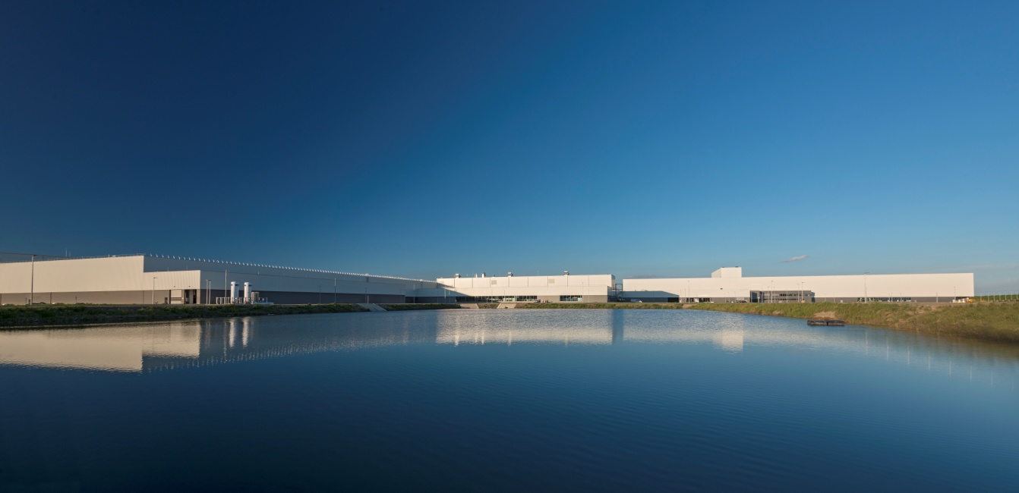
Fig. 1: At the world's largest engine and automobile factory of Audi Hungaria in Győr, Hungary, approx. 11,274 staff members are employed on a floor space of 5,167,366 square metres (as at 31 December 2014).
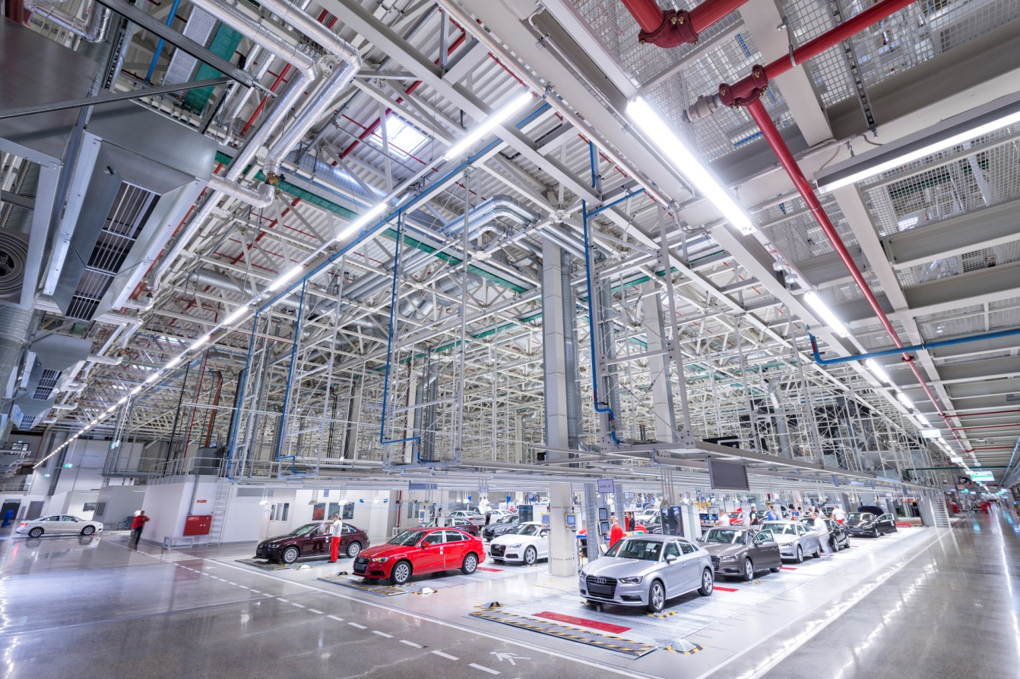
Fig. 2: In the assembly bays, more than 140 kilometres of the TECTON continuous-row lighting system were installed.
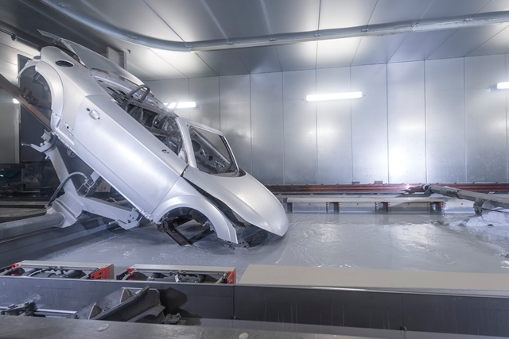
Fig. 3: In the splash-guard area, SCUBA moisture-proof luminaires were installed.
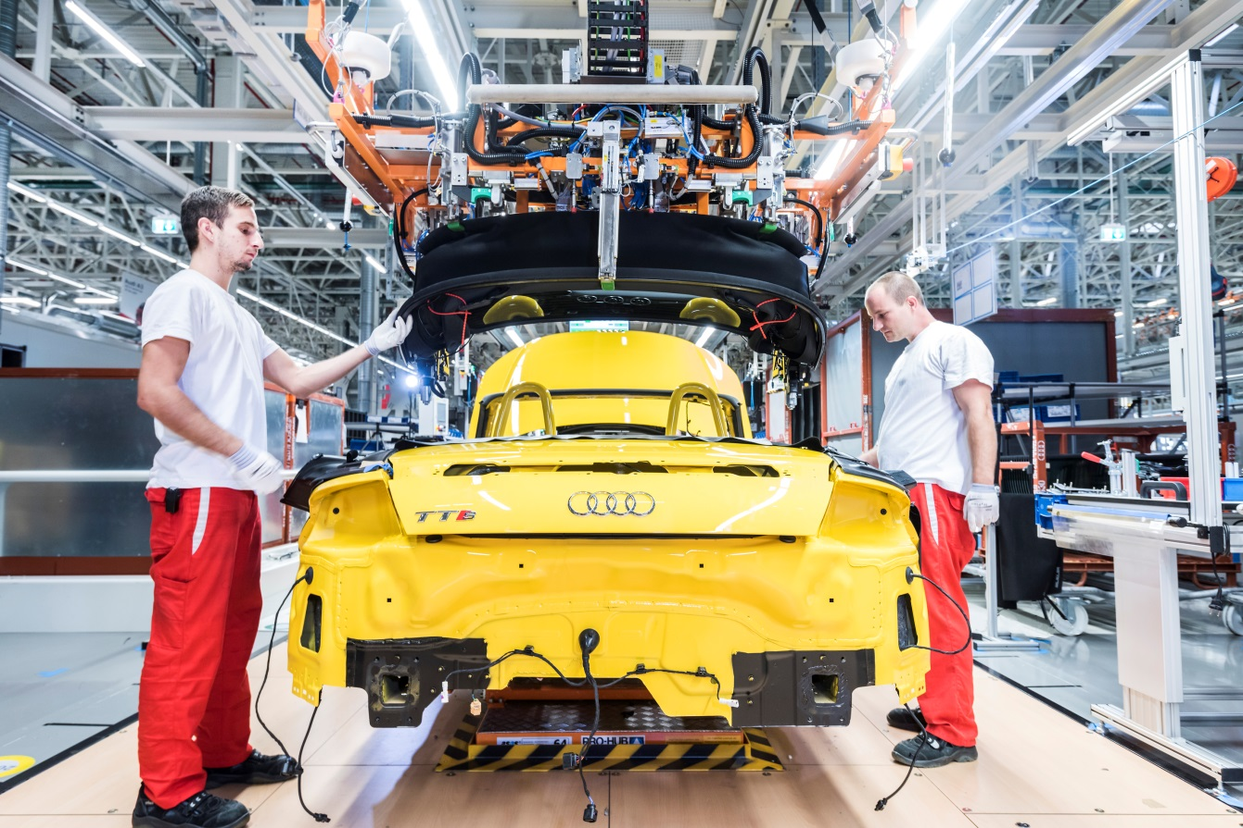
Fig. 4: In addition to TECTON, a special version of the ONLITE ECOSIGN escape-sign luminaire was also installed at Audi Hungaria's Plant 2.

Press contact:
Zumtobel Lighting GmbH
Sophie Moser
Head of Brand Communications
Schweizer Strasse 30
A-6850 Dornbirn

Tel +43-5572-390-26527
Mobil +43-664-80892-3074
E-Mail press@zumtobel.com
www.zumtobel.com

Sales contact:
Zumtobel Lighting Ltd.  Chiltern Park  Chiltern Hill, Chalfont St Peter  Buckinghamshire SL9 9FG  United Kingdom  Tel: +44 1753 482 650  Fax: +44 1753 480 350  uksales@zumtobel.com  www.zumtobel.co.uk | Zumtobel Lighting Inc.  3300 Route 9  Highland , NY 12528  United States  Tel: +1 845 691-6262  Fax: +1 845 691-6289  zli.us@zumtobelgroup.com  www.zumtobel.us

For further contact details in further sales regions please visit: http://www.zumtobel.com/com-en/contact.html

About Zumtobel
Zumtobel, a leading international supplier of integral lighting solutions, enables people to experience the interplay of light and architecture. As a leader in innovation, Zumtobel provides a comprehensive range of high-quality luminaires and lighting management systems for professional interior lighting in the areas of offices, education, presentation & retail, hotel & wellness, health, art & culture as well as industry. Zumtobel is a brand of Zumtobel Group AG with its head office in Dornbirn, Vorarlberg (Austria).
Zumtobel. The Light.

