Press release

Zumtobel brilliantly highlights premium car dealership in Valais
Garage Zénith has been standing for powerful dynamics and athletic elegance on four wheels for almost 30 years. Thanks to the conversion and extension of the car dealership for the premium brands Ferrari, Maserati and other select sports car manufacturers, Garage Zénith is now setting a shining example in Sion (Switzerland). In close collaboration with the architects and the electrical design engineer, a sophisticated lighting concept was created by the Austrian luminaire manufacturer Zumtobel.
Dornbirn, June 2015 – In 2011, Michel Zuchuat, founder and director of Garage Zénith SA, commissioned the Rome-based architects' studio Fortebis Group to draw up a design for the conversion and extension of the exclusive car dealership. The existing building was to be refurbished and the adjacent new building was to be extended. The Italian group of architects, which has already implemented a great number of Ferrari and Maserati car dealerships all over the world, has developed a simple, functional and unobtrusive architectural design that sets the exciting sports cars centre stage. In this context, it was important to stage a new showroom in the existing ground-level building which does not only shine the best possible light on the cars on display, but also turns the handover of new cars into a unique experience. Apart from the showroom, several sales offices as well as a lounge for customers of the exclusive car dealership were built in this construction phase. During implementation, strict specifications regarding the corporate design of both brands had to be taken into account. High-quality new and used cars of other premium sports car manufacturers were meant to be displayed on the ground floor of the new three-storey building equipped with a car lift. The storage depot for materials such as tyres, rims and other technical accessories was planned to be located in the basement, another storage facility – expandable at a later date – was to be set up on the second floor.
For the different conditions in the two units, Zumtobel has developed an individual lighting concept in collaboration with electrical consultants Bäbler & Pirker from Geneva, that helps to showcase the perfectly modelled sports cars for customers and potential buyers in a sculptural, unadulterated way thanks to an interplay of diffuse and directional light. Ten luminous ceilings with a size of 5 x 2 m, installed above the high-end sports cars on display in the entrance area of the Ferrari and Maserati showrooms, constitute a special feature. The stretch ceilings, each backlit by 44 TECTON Tetris continuous-row luminaires and framed by six swivelling CARDAN 1000 spotlights, were custom-built to meet the requirements of Garage Zénith. The diffuse light of the luminous ceilings ensures a clear profile of the cars' reflective bodies, whereas targeted spots produce a brilliant light, making details visible and emphasising the dynamic contours of the vehicles. The lighting of the Ferrari and Maserati display recesses, all of which were meant to be lit from below or backlit, had to comply with strict specifications. In this case, Zumtobel chose a tailor-made solution with continuous-row luminaires of the TECTON Tetris and LINARIA ranges. The continuous-row lighting systems showcase their impressive luminous power also in the conference and presentation rooms. In the sales offices, Zumtobel has installed SLOTLIGHT II recessed luminaires that ensure pleasantly uniform light distribution thanks to their homogeneously lit lines, making the car purchase an exclusive experience in a personal environment. Downlights of the MICROS range provide atmospheric accent lighting in the lounge of the refurbished original building. To illuminate the high-end new and used cars in the new building, Zumtobel chose continuous-row systems of the TECTON range featuring wide-angle reflectors.
All luminaires can be addressed individually thanks to a KMX/DALI system, and can be dimmed individually to create targeted accent lighting, among other things. Various lighting scenes are already predefined and can be modified as required. For Garage Zénith this results in enormous potential energy savings: using the control system and due to the luminaires being dimmable, the car dealership benefits from a reduction of energy consumption by some 30 per cent. A positive result that also appeals to owner Michel Zuchuat in the long run: “Even after two years, we are still absolutely convinced of the lighting concept that Zumtobel has developed for us. In this context, we not only value the highly superior lighting quality, but also the lower energy costs. In addition, we did not have to replace a single luminaire in two years. An ideal solution and an investment that absolutely pays for itself.”
Facts & figures of the Zumtobel products used
TECTON Tetris | Continuous-row luminaire made of roll-formed sheet steel; 1- or 2-lamp version; halogen-free wiring; pre-fitted transparent lampholder shells; dimmable; electronic ballast featuring DALI control
SLOTLIGHT II | Individual luminaire with extruded aluminium section; PMMA diffuser made of opal acrylic glass to ensure uniform light distribution; halogen-free wiring; dimmable; electronic ballast featuring DALI control
CARDAN 1000 | Recessed ceiling luminaire; lighting head pivots on gimbals through ± 30°; faceted reflector made of aluminium; luminaire housing made of sheet steel
MICROS | Functional downlight range; housing made of die-cast aluminium; optionally available with swivelling gear tray; Ø 79 mm
LINARIA | Batten luminaire with open light distribution made of aluminium; halogen-free wiring; dimmable; electronic ballast featuring DALI control

Captions:
(Photo credits: Zumtobel)

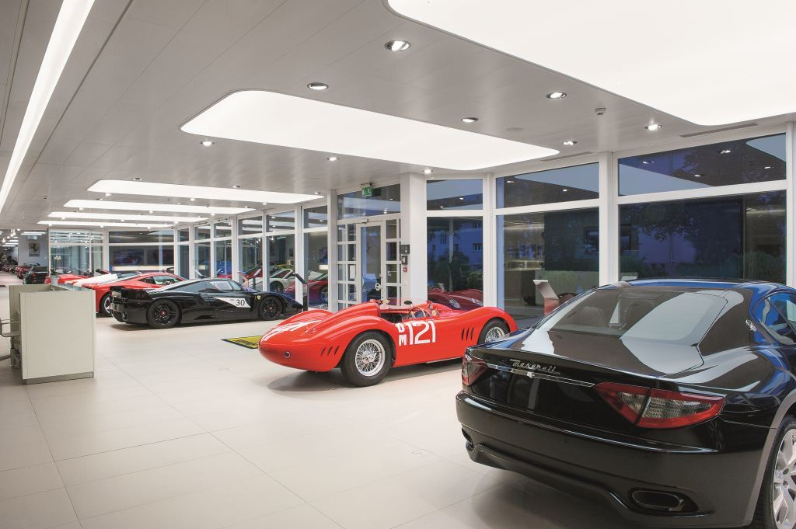
Fig. 1: Custom-built luminous ceilings ensure brilliant staging of the high-end sports cars.

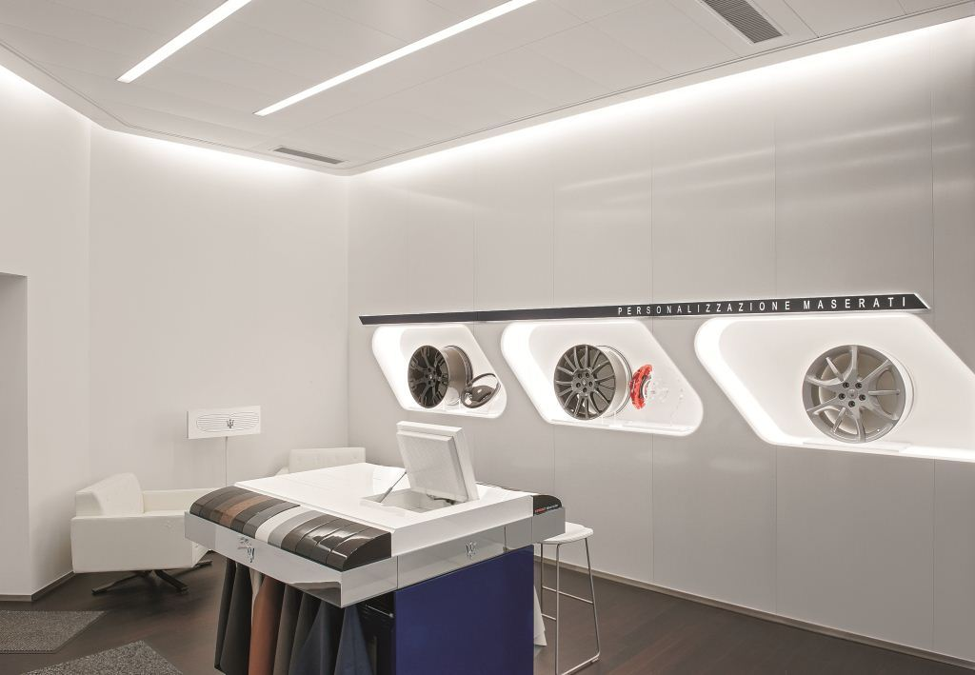
Fig. 2: The lighting of the display recesses had to comply with strict specifications.

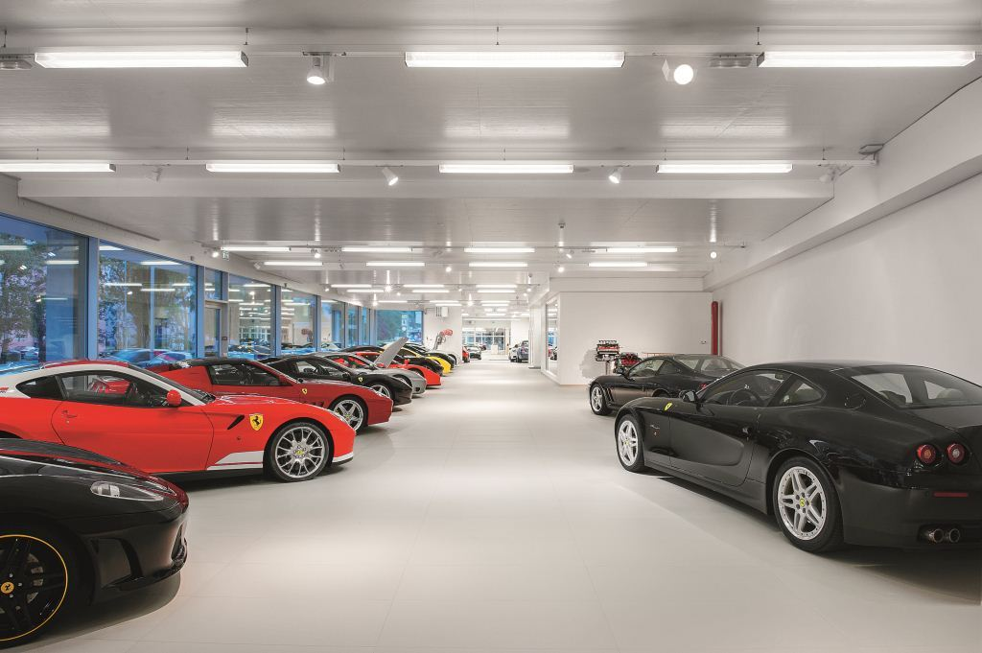
Fig. 3: A tailor-made solution with continuous-row luminaires of the TECTON Tetris and LINARIA ranges illuminates the exhibition space.

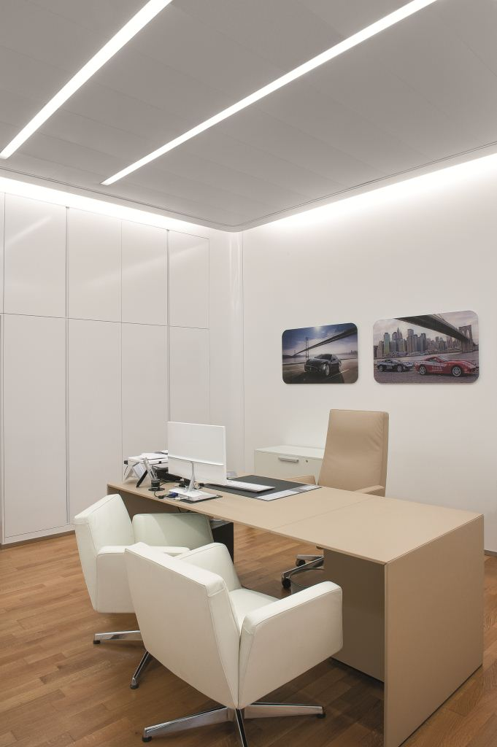

Fig. 4: In the sales offices, Zumtobel has created a bright and pleasant lighting ambience.

Press contact:
Zumtobel Lighting GmbH
Sophie Moser
Head of Brand Communications
Schweizer Strasse 30
A-6850 Dornbirn

Tel +43-5572-390-26527
Mobil +43-664-80892-3074
E-Mail press@zumtobel.com
www.zumtobel.com

Responsible sales office:
Zumtobel Licht AG
Lichtzentrum
Thurgauerstrasse 39
8050 Zurich
Switzerland

Tel: +41 44 305 35 35
Fax: +41 44 305 35 36
info@zumtobel.ch
www.zumtobel.ch

Sales contact:
Zumtobel Lighting Ltd.  Chiltern Park  Chiltern Hill, Chalfont St Peter  Buckinghamshire SL9 9FG  United Kingdom  Tel: +44 1753 482 650  Fax: +44 1753 480 350  uksales@zumtobel.com  www.zumtobel.co.uk | Zumtobel Lighting Inc.  3300 Route 9  Highland , NY 12528  United States  Tel: +1 845 691-6262  Fax: +1 845 691-6289  zli.us@zumtobelgroup.com  www.zumtobel.us

For further contact details in further sales regions please visit: http://www.zumtobel.com/com-en/contact.html

About Zumtobel
Zumtobel, a leading international supplier of integral lighting solutions, enables people to experience the interplay of light and architecture. As a leader in innovation, Zumtobel provides a comprehensive range of high-quality luminaires and lighting management systems for professional interior lighting in the areas of offices, education, presentation & retail, hotel & wellness, health, art & culture as well as industry. Zumtobel is a brand of Zumtobel Group AG with its head office in Dornbirn, Vorarlberg (Austria).
Zumtobel. The Light.

