Press information

Light as a design element - Porsche Showroom Abu Dhabi

The Porsche brand was first introduced to the city of Abu Dhabi in 1987 when the Ali & Sons Group was entrusted with the exclusive dealership rights. Today the latest Porsche range is showcased in a state-of-the-art showroom facility. The centre reflects both the unique Porsche philosophy and the customer-focused approach of the Ali & Sons Group. In close collaboration with Ali & Sons and Porsche CI, a sophisticated lighting concept was created by the Austrian luminaire manufacturer Zumtobel.
Dubai, September 2015 – Light is naturally an important design element in the showrooms, particularly when it comes to supporting presentation concepts and accurately displaying colours and materials. The lighting solution provided by Zumtobel fulfils all of these functions and simultaneously meets the corporate identity guidelines stipulated by Porsche. VIVO spotlights provide brilliant pinpoint light that picks out the fine details of the cars. The excellent colour rendering of the VIVO range helps enhance the natural appearance of the different surfaces and materials. The silver finish of the iF award-winning luminaire merges perfectly with the ceiling of the showroom and in no way distracts from the interior architecture or the luxurious cars.
A pleasantly illuminated lounge or waiting area fosters positive feelings and can make waiting times feel shorter. The excellent lighting quality of PANOS infinity enables reading and creates a congenial atmosphere for open communication. These factors generate a positive feeling and can help sales discussions get off to a good start. The reception area often shapes the first impressions of a company. This is where potential customers are first welcomed to the showroom, so appropriate lighting can clearly play a vital role. In addition, service personnel require functional task lighting to work efficiently and effectively. PANOS infinity meets all of these requirements with the highest lighting quality delivered by the latest LED technology. The downlight also creates a special effect in the ceiling, as the discrete mounting of the light source in no way detracts from the visual impact of the light itself.
In the course of day-to-day work in office applications, it is quite normal to encounter a huge variety of different visual stimuli. This means that achieving the right lighting concept is crucial. Light affects almost all vital processes in the human body and also has an impact on our performance, health, safety and sense of wellbeing. The office study conducted by Zumtobel with Frauenhofer IAO found that people clearly prefer different light levels and colour temperatures. The research also demonstrated that direct/indirect lighting and individual controls are important for many office users. The Porsche offices located within the showroom area take all of these factors into account with one single luminaire. The OPURA freestanding luminaire ensures uniform illumination of the task areas whilst also giving employees the option to easily adjust the light levels. The asymmetric indirect light distribution provides optimum visual conditions by directing light onto the working plane and delivering uniform illumination of the ceiling.
Facts & figures on the Zumtobel products used
PANOS infinity/evolution LED | LED downlight range; dimmable; colour temperature: 3000 K or 4000 K; high colour rendering index of Ra > 90; luminaire efficiency of > 100 lm/W; symmetrical beam pattern
VIVO LED | LED spotlight for accent lighting; swivelling spotlight; excellent colour rendering, choice of perfect light colour and glare control; luminous flux: up to 4210 lm; colour temperature: 3000 K or 4200 K; IR- and UV-free light
OPURA | Freestanding LED luminaire with seamless low-profile aluminium luminaire head with absolutely no joins; Asymmetric head attachment at 90° angle to base for optimum positioning over desk; high luminaire efficiency of 89 lm/W, 4000 K colour temperature, colour rendering index CRI Ra > 80,  Ultra-uniform illumination of entire surface of direct-light optic  Direct light employs MPO + micro-pyramidal system with multilayer technology, specially designed to cut out glare from tilted / horizontal monitors

High resolution images: http://we.tl/rUXB8EU6Z1

Photo captions:
(Photo credits: Robert James Bova)
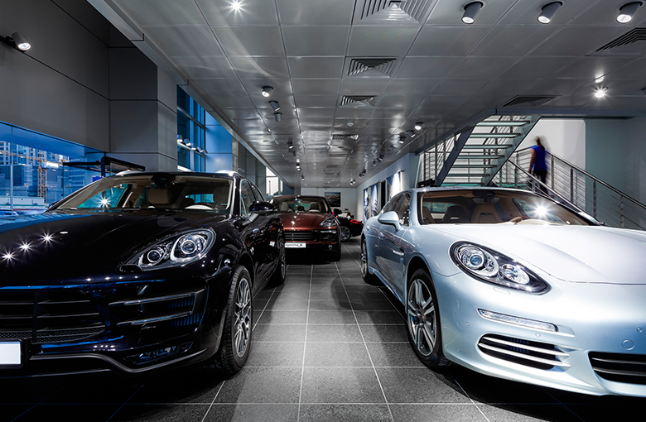
Photo 1: VIVO spotlights provide brilliant pinpoint light that picks out the fine details of the cars.
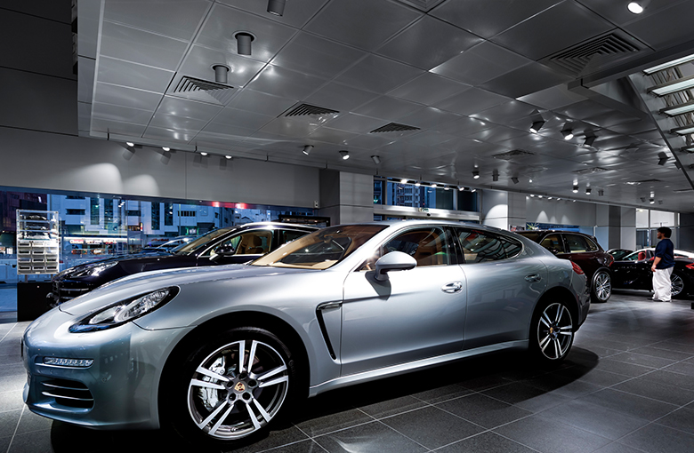
Photo 2: The excellent colour rendering of the VIVO range helps enhance the natural appearance of the different surfaces and materials.
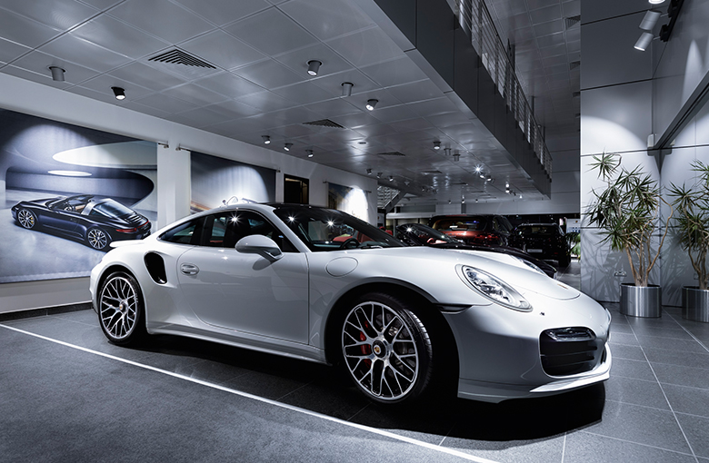
Photo 3: The silver finish of the iF award-winning luminaire merges perfectly with the ceiling of the showroom and in no way distracts from the interior architecture or the luxurious cars.
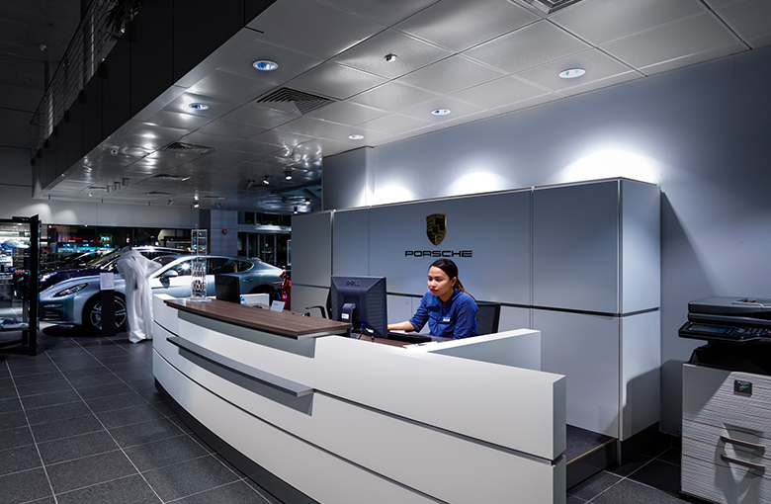
Photo 4: PANOS infinity offers the highest lighting quality delivered by the latest LED technology.
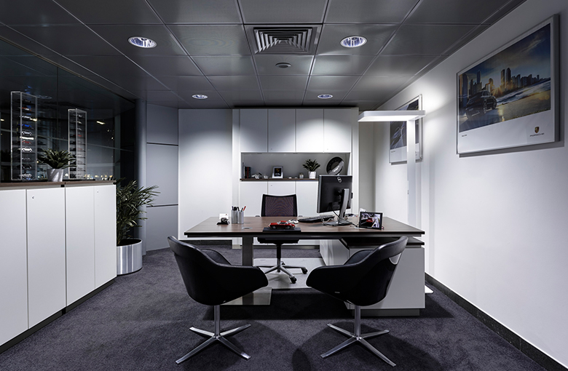
Photo 5: The OPURA freestanding luminaire ensures uniform illumination of the task areas whilst also giving employees the option to easily adjust the light levels.

Press contact:
Zumtobel Lighting GmbH
Donna Dederding
Marketing Manager
Middle East, India, Africa

Zumtobel Lighting GmbH
4B Street, Al Quoz Industrial Area 1
Dubai, United Arab Emirates

T +971 4 3404646 Ext.: 107
M +971 50 554 6959

donna.dederding@zumtobelgroup.com
www.zumtobel.ae

Headquarters:
Zumtobel Lighting GmbH
Schweizer Strasse 30
6850 Dornbirn
Austria

Tel: +43 5572 390 26527
Mobil: +43 664 80892 3074
press@zumtobel.com

www.zumtobel.com

For further contact details in further sales regions please visit: http://www.zumtobel.com/com-en/contact.html

About Zumtobel
Zumtobel, a leading international supplier of integral lighting solutions, enables people to experience the interplay of light and architecture. As a leader in innovation, Zumtobel provides a comprehensive range of high-quality luminaires and lighting management systems for professional interior lighting in the areas of offices, education, presentation & retail, hotel & wellness, health, art & culture as well as industry. Zumtobel is a brand of Zumtobel Group AG with its head office in Dornbirn, Vorarlberg (Austria).
Zumtobel. The Light.

