Press information

TIGNUM: Purist elegance for ergonomic working light
TIGNUM from Zumtobel does more than simply capture the design spirit of the modern age – the stylish table lamp also harks back to an original concept involving the separation of general and workplace illumination. This approach delivers key benefits in terms of energy efficiency and activity-specific lighting for key visual tasks.
Dornbirn, December 2015 – The TIGNUM table lamp represents an elegant addition to any office environment. The appearance of the product is dominated by the clean, straight lines of a housing that seems to float centrally over a desk that is carefully illuminated with efficient and glare-free neutral white LED light. The sketches of Graz-based designers Benjamin und Markus Pernthaler were immediately characterised by rigid lines and an extremely flat design, thanks in no small part to the inclusion of an external mains adapter. The blend of purist design and powder-coated aluminium profile conveys a clear feeling of quality. Both the luminous efficiency of 85 lm/W and the superior functionality of TIGNUM push the established boundaries, whilst the sleek haptic rotary control adds intuitive handling and the option of stepless dimming. The adjustable lighting element, measuring 107 centimetres in length, can also be slid horizontally to achieve the optimum positioning for every workplace.
The homogeneous dissolution of the individual LED points with a colour temperature of 4000 K and a colour rendering index of Ra > 80, the innovative lens optics to direct the light and the specially coated reflectors all combine to ensure ergonomic working light of the very highest quality. The reduced luminance also makes the lamp ideal for use with screens and tablets.
(R)evolution of an established concept
The TIGNUM table lamp revisits the concept of deliberately separating the ergonomic workplace illumination from the ambient lighting. This method is now very much in line with modern thinking and guarantees a two-fold benefit - standards-compliant levels of illuminance that are delivered precisely and directly onto the visual task area. This also means that considerably less energy is required than for a room-based solution with uniform levels of brightness. As initial calculations have shown, energy efficiency can be improved by around 30 percent with the help of the direct element for workplace lighting.
In addition, the defined distribution of direct light on the working plane creates a pleasant atmosphere, which gently relaxes the strict uniformity of modern open-plan offices with a series of light zones. Employees can also alter the lighting to reflect their individual requirements, helping to meet the varied demands of modern office life, where computers, tablets, paperwork, meetings and presentations all feature on a daily basis. Adjusting the lighting leads to an improved feeling of wellbeing and even greater energy efficiency, as TIGNUM is only used as and when required.
In this way, the TIGNUM table lamp embodies a future-oriented approach in much the same way as the Science Tower in the Austrian city of Graz. Set to open in the middle of 2016, the Science Tower will be the first operational building in the "Smart City Graz" complex, where the inspiring effect of TIGNUM will be on show. Yet with puristic elegance and advanced functionality, this lamp already has all the makings of a true classic. The project luminaire TIGNUM is currently available exclusively in Germany, Austria and Switzerland.

Captions:
(Photo Credits: Zumtobel)
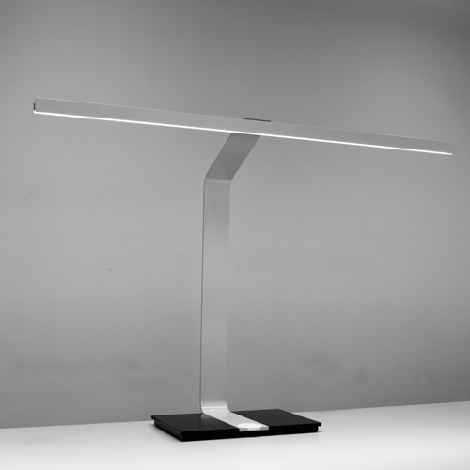
Fig. 1: The TIGNUM table lamp, whose slender housing floats centrally over the desk, is about more than just puristic design - LED light ensures targeted, efficient and glare-free illumination of the working plane.

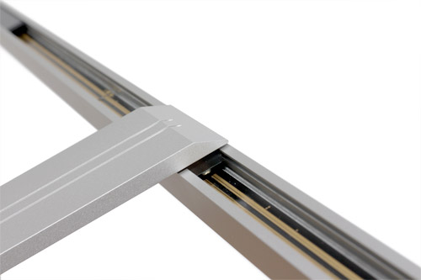
Fig. 2: The lighting element can be slid horizontally to achieve the optimum positioning for every workplace.

Press contact:
Zumtobel Lighting GmbH
Sophie Moser
Head of Brand Communications
Schweizer Strasse 30
6850 Dornbirn
Austria

Tel: +43 5572 390 26527
Mobil: +43 664 80892 3074
press@zumtobel.com

www.zumtobel.com

Sales contact:
Zumtobel Lighting Ltd.  Chiltern Park  Chiltern Hill, Chalfont St Peter  Buckinghamshire SL9 9FG  United Kingdom  Tel: +44 1753 482 650  Fax: +44 1753 480 350  uksales@zumtobel.com  www.zumtobel.co.uk | Zumtobel Lighting Inc.  3300 Route 9  Highland , NY 12528  United States  Tel: +1 845 691 6262  Fax: +1 845 691 6289  zli.us@zumtobelgroup.com  www.zumtobel.us

For further contact details in further sales regions please visit: http://www.zumtobel.com/com-en/contact.html

About Zumtobel
Zumtobel, a leading international supplier of integral lighting solutions, enables people to experience the interplay of light and architecture. As a leader in innovation, Zumtobel provides a comprehensive range of high-quality luminaires and lighting management systems for professional interior lighting in the areas of offices, education, presentation & retail, hotel & wellness, health, art & culture as well as industry. Zumtobel is a brand of Zumtobel Group AG with its head office in Dornbirn, Vorarlberg (Austria).
Zumtobel. The Light.

