Press release

SCONFINE Sfera LED delivers unique lighting effects in public and private spaces
Light defines the emotional impact of a room. That is exactly why so many public places such as hotel lobbies and restaurants and even residential living spaces combine functional lighting with a clear element of decorative light. The new generation of the spherical SCONFINE Sfera LED pendant luminaire from Zumtobel is like a shining jewel, floating in the space. With brilliant lighting quality and a range of colour temperatures, SCONFINE Sfera LED can provide unique lighting effects and create expressive lighting accents.
Dornbirn, March 2016 – The new LED generation of the SCONFINE Sfera decorative pendant luminaire from Zumtobel combines unique and timeless design with the very latest LED technology and lighting efficiency. This expressive luminaire is very much at home in both residential living spaces as well as key applications such as Presentation and Retail or Hotel and Wellness. Designer Matteo Thun used the spherical shape to create a clearly defined geometric form that blends undisputed charm with flexible installation. The partially transparent and mirrored luminaire unit in chrome or bronze only partially encases the inner opal glass sphere, further strengthening the impression of plasticity and room depth. "Lighting effects can dissolve spatial boundaries and create completely new spatial effects" - this idea was central to the work of designer Matteo Thun. The result is a product series that has echoes of levity and minimalism, shaping lighting scenes that underline the architecture of a space and help convey real emotion.

The pendant luminaire is available with a diameter of 170mm, 250mm and 500mm and is truly a sight to behold as a single unit or when mounted as part of a constellation. The high-quality materials create reflections in the luminaire unit as well as direct light, helping to give the impression that SCONFINE is floating. The utilisation of the latest LED technology ensures precise light distribution and increased system efficiency. SCONFINE with a colour temperature of 3000 K is ideal for use in offices, reception areas and hotel lobbies. The version with 2700 K is a genuine decorative lighting solution that complements residential living spaces or restaurants - locations where warm white light generates a pleasant, cosy atmosphere. The excellent lighting quality is demonstrated by the high colour rendering index of Ra >90.SCONFINE Sfera LED has many talents, playing with light and shadow to craft striking effects in prestigious public areas whilst simultaneously creating a stunning spectacle in private residential spaces.

Facts and figures - SCONFINE Sfera LED

- Decorative pendant lamp with spherical luminaire unit
- Diameter: 170mm, 250mm or 500mm
- Colours: Chrome and bronze
- Luminous efficiency: Up to 70 lm/W
- Colour temperature: 2700 K and 3000 K
- Colour rendering: Ra> 90
- Lifetime: 50,000 hours

Photo captions:

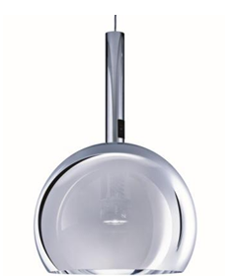
(Photo credits: Zumtobel)

Photo 1: Designer Matteo Thun created a clearly defined geometric form with SCONFINE Sfera LED, blending undisputed charm with flexible installation.

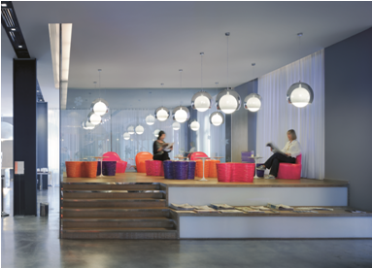

Photo 2: With brilliant lighting quality and a range of colour temperatures, SCONFINE Sfera LED can provide unique lighting effects and create expressive lighting accents.

Press contact:
Zumtobel Lighting GmbH  Andreas Reimann  Brand PR Manager  Schweizer Strasse 30  6850 Dornbirn  Austria  Phone: +43 5572 390 26522  press@zumtobel.com  www.zumtobel.com | Zumtobel Group  Jennifer Sewell  Marketing Communications Manager  Chiltern Park, Chiltern Hill  Chalfont St Peter, Buckinghamshire SL9 9FG  United Kingdom  Phone: +44 0 7785 232 294  jennifer.sewell@zumtobelgroup.com  www.zumtobel.com
Zumtobel Lighting Inc.
Donna Fischer
Marketing Manager Americas
Zumtobel Lighting US
3300 Route 9W
Highland, NY 12528
Phone: +1 845-691-6262 - 7611
donna.fischer@zumtobelgroup.com
www.zumtobel.us

About Zumtobel
As a leader in innovation, Zumtobel develops sustainable lighting solutions tailored to the needs of people in their respective applications. With a comprehensive portfolio of high-quality luminaires and intelligent lighting management systems, the Austrian company provides optimum indoor and exterior products for working and living spaces - the right light for every activity at any time of day. The applications office, education, presentation and retail, hotel and wellness, health, art and culture and industry are now perfectly complemented with portfolios for living and outdoor areas. Zumtobel is a brand of Zumtobel Group AG with its head office in Dornbirn, Vorarlberg (Austria).
Zumtobel. The Light.

