Press Release

Zumtobel extends outdoor illumination portfolio
Zumtobel lighting solutions for task-specific illumination of outdoor areas
Dornbirn, February 2016 – At the Light + Building trade fair that will be held from 13 to 18 March 2016, Zumtobel will demonstrate the versatility of light in outdoor applications. The focus will be on people's individual requirements in urban spaces. With its new application, Zumtobel provides architects and lighting designers with new opportunities for task-specific illumination of paths, squares, roads and façades. For the development of the lighting concept, Zumtobel is collaborating with the UNStudio design team.

When it is dark, urban spaces place a variety of requirements on lighting: light is used to present façades as visual points of attraction, to uniformly illuminate roads and paths so as to increase the feeling of security, and to upgrade squares in meeting places – all the while saving resources and avoiding light pollution. At night, security and orientation are especially important to people in urban spaces. With SUPERSYSTEM outdoor, Zumtobel introduced its first lighting solution for outdoor areas in the International Year of Light. SUPERSYSTEM outdoor allows targeted illumination and presentation of outdoor spaces. Now, Zumtobel extends its outdoor illumination portfolio, thus offering a way to handle various lighting tasks and meet human needs.

To develop the modular NIGHTSIGHT LED outdoor lighting system, Zumtobel has collaborated closely with Ben van Berkel's UNStudio experts and designers. The NIGHTSIGHT product range covers all lighting tools that are needed to illuminate both vertical and horizontal areas uniformly and create selective accents. Excellent glare control and prevention of spill light are ensured by high-precision light control. Luminaire versions with a colour temperature of 3000 K and 4000 K are ideal for presenting both a city's historic centre and a modern skyline in the right light. In addition, the consistent design language ensures that NIGHTSIGHT is perceived as an enrichment to the townscape by day as well.

In combination with lighting tools for architectural lighting of indoor areas, Zumtobel thus provides a unique portfolio to create an attractive townscape. Streets and squares, as well as public buildings such as museums, present themselves in a uniform design language and with a distinctive identity. This slightly different approach and NIGHTSIGHT enhance the appeal of urban spaces. The portfolio allows lighting designers and architects to develop a consistent lighting solution. NIGHTSIGHT will be introduced at Light + Building 2016.

Zumtobel at Light + Building
Light + Building, the world's leading trade fair for lighting and building technology, will be held in Frankfurt am Main from 13 to 18 March. At Zumtobel's trade fair stand (hall 2.0, stand B30/31), visitors can experience on some 340 square metres the entire range of intelligent lighting solutions. Following the natural course of daylight, the Living, Office, Industry, Shop & Retail, Art & Culture and Outdoor application areas are arranged clockwise.
This year, Zumtobel will share a fair trade stand with its sister brands Thorn, Tridonic and acdc for the first time. All these brands are part of the international Zumtobel Group, and will be present in hall 2.0, at stand B30/31.
For further information on Zumtobel and Light + Building 2016, or to register for a guided tour of our stand, please go to http://www.zumtobel.com/lightbuilding2016

light+building, 13 to 18 March 2016 in Frankfurt am Main
Zumtobel Group trade fair stand: hall 2.0, stand B30/31

Captions:

(Photo credits: Zumtobel)
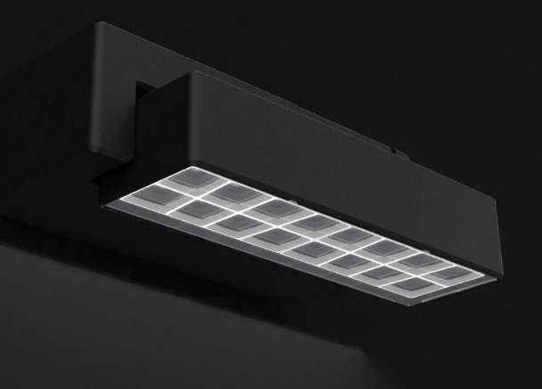
Fig. 1: The NIGHTSIGHT product range covers all lighting tools that are needed to illuminate both vertical and horizontal areas uniformly and create selective accents.

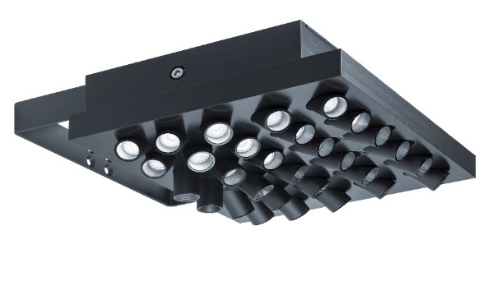
Fig. 2: With SUPERSYSTEM outdoor, Zumtobel introduced its first lighting solution for outdoor areas in the International Year of Light.
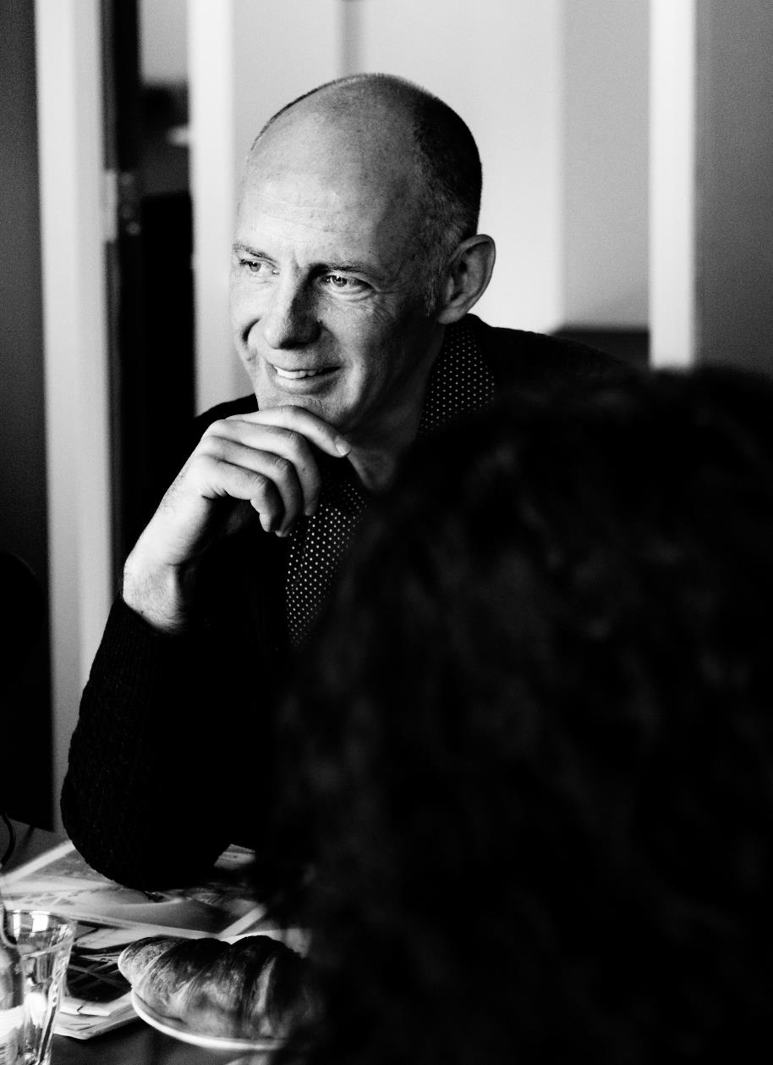

Fig. 3: Ben van Berkel, UNStudio

Press contact:
Zumtobel Lighting GmbH  Sophie Moser  Head of Brand Communications  Schweizer Strasse 30  6850 Dornbirn  Austria  Phone: +43 5572 390 26527  Mobile: +43 664 80892 3074  press@zumtobel.com  www.zumtobel.com | Zumtobel Group  Jennifer Sewell  Marketing Communications Manager  Chiltern Park, Chiltern Hill  Chalfont St Peter, Buckinghamshire SL9 9FG  United Kingdom  Phone: +44 0 7785 232 294  jennifer.sewell@zumtobelgroup.com  www.zumtobel.com
Zumtobel Lighting Inc.
Donna Fischer
Marketing Manager Americas
Zumtobel Lighting US
3300 Route 9W
Highland, NY 12528
Phone: 845-691-6262 x 7611
donna.fischer@zumtobelgroup.com

About Zumtobel
Zumtobel, a leading international supplier of integral lighting solutions, enables people to experience the interplay of light and architecture. As a leader in innovation, Zumtobel provides a comprehensive range of high-quality luminaires and lighting management systems for professional interior lighting in the areas of offices, education, presentation & retail, hotel & wellness, health, art & culture as well as industry. Zumtobel is a brand of Zumtobel Group AG with its head office in Dornbirn, Vorarlberg (Austria).
Zumtobel. The Light.

