Press Release

ATIVO – Multisensor for detecting light and motion
The ATIVO from Zumtobel is an intelligent multisensor for detecting light and motion. When in use, the sensor recognises when a room is in use and adapts the lighting accordingly. ATIVO thus resolves the conflict between illuminance and energy consumption. After installation, configuration and zoning are easily carried out via an intuitive software interface.
Dornbirn, March 2016 – Although rapid technological advances are now allowing highly automated installation processes, the demand for high quality manual work is not decreasing. As a result, industrial workstations at which complex installation tasks are carried out require a high illuminance of up to 700 lx. However, improving the quality of light can often result in higher energy consumption, thus higher costs. In fact, however, this high illuminance is only needed at individual workstations; traffic routes or storage areas often only need 200 lx. The solution to this problem has been developed by Zumtobel with its ATIVO multisensor. The principle is incredibly simple: A task-based, flexibly adaptable zone control system ensures that the light is reduced according to time and activity in places where it isn't required. At workstations that demand a high level of concentration to ensure good productivity, the lighting level is increased. For added safety, the lighting level in general areas and corridors is also increased. The motion sensor recognises when people or vehicles are in the corridors and dims up automatically. The ATIVO DALI IP64 Kit that is already available is specially designed for detecting light and motion in even high-ceiling rooms. The contrast sensor system with its intelligent object detection is, unlike normal PIR and radar sensors, not only much more accurate, but also quicker – and therefore less prone to error. The ATIVO Sensor DALI Kit can be used in a wide variety of situations, including sports and multi-function events halls, industrial, production and assembly facilites, even in high-bay warehouses and logistics centres. In these situations, the sensor can precisely detect motion in rooms with ceilings between 6m and 20m.
ATIVO can be used as a DALI master system to autonomously actuate the luminaires. Integrated into LITECOM, it supports tried-and-tested lighting management functions, such as daylight control, and is an important pillar in activity based lighting. With this function, LITECOM can automatically select the right lighting scene to suit the room's use. It differentiates between people or vehicles, such as fork lift trucks, or adapting the lighting level due to the intensity of room use. The ATIVO multisensor is designed for application-specific solutions that place great value on high energy efficiency: To do this, users can define five areas for detecting motion and program five brightness values so that each room can be zoned specific to each activity. Plug&Play technology on the ATIVO multisensor means it is simple to assemble and install, with any further configuration being carried out via the software. ATIVO for industry comes with a rugged housing that meets protection class IP64. For use in offices, a recessed ceiling version is set to follow in 2016. The multisensor is then specially optimised for the sensing range of typical ceiling heights, and gives office workers the right light for every situation.

Image captions:
(Photo Credits: Zumtobel)
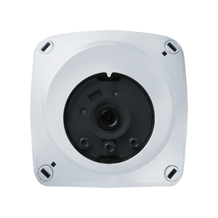
Image 1: ATIVO (here the ATIVO Dali IP64 Kit) is an intelligent multisensor for detecting in rooms with high ceilings.

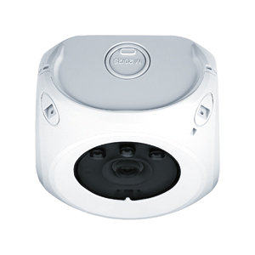

Image 2: Plug&Play technology on the ATIVO multisensor means it is simple to assemble and install, with any further configuration being carried out via the software.

Media contact:
Zumtobel Lighting GmbH  Sophie Moser  Head of Brand Communications  Schweizer Strasse 30  A-6850 Dornbirn  Tel: +43 5572 390 26527  Mobile: +43 664 80892 3074  press@zumtobel.com  www.zumtobel.com | Zumtobel Lighting GmbH  Andreas Reimann  Brand PR Manager  Schweizer Strasse 30  A-6850 Dornbirn  Tel: +43 5572 390 26522  Mobile: +43 664 80892 3334  press@zumtobel.com  www.zumtobel.com
Marketing for Germany, Austria, Switzerland:
ZG Licht Süd GmbH
Beratungszentrum Frankfurt
Carl-Benz-Straße 21
60386 Frankfurt / Mannheim
Tel: +49 69 26 48 89 0
Fax: +49 69 69 26 48 89 80
info@zumtobel.de
www.zumtobel.de

ZG Lighting Austria GmbH  Beratungszentrum Wien, Niederösterreich, Burgenland  Wagramer Straße 19  A-1220 Vienna  Tel: +43 1 258 2601 0  Fax: +43 1 258 2601 82845  welcome@zumtobel.at  www.zumtobel.at | Zumtobel Licht AG  Thurgauerstrasse 39  CH-8050 Zurich  Tel: +41 44 305 35 35  Fax: +41 44 305 35 36  info@zumtobel.ch  www.zumtobel.ch
About Zumtobel
As an innovation leader, Zumtobel develops sustainable lighting solutions tailor-made to meet the needs of people for various application areas. With an exentsive range of premium luminaires and intelligent lighting control systems, the Austrian lighting provider offers the right light for any activity and any time or day, for workspaces and private spaces, inside and outside. The areas of Office, Education, Presentation and Retail, Hotel and Wellness, Health and Care, Art and Culture, and Industry are perfectly complemented with a portfolio for the Living and Outdoor areas. Zumtobel is a brand of the Zumtobel Group AG with headquarters in Dornbirn, Vorarlberg (Austria).
Zumtobel. The Light.

