Press release

Light as the core element of a major museographic project
The LUXMATE LITENET lighting management system combines with IYON Tunable White spotlights to perfectly present the works of Rodin in the heart of the renovated Hotel Biron in Paris.
Paris, May 2016 – After a complete restoration project lasting three years, the magnificent Hotel Biron, which has housed the Rodin Museum in Paris since 1919, reopened on 12th November 2015 - the 175th anniversary of the birth of the renowned French sculptor. The renovation of the building started in 2012 and involved the complete renewal of the museographic course with the careful design and integration of a continuous flowing circuit. Accessibility has been significantly improved and issues such as the protection of both the artworks and the building, as well as the preservation of the architectural heritage, were also addressed. Richard Duplat, Chief Architect of Historic Monuments, led the historic renovation of the building, whilst revisions to the museography and the upgrading of standards throughout the museum were planned and implemented by the architect Dominique Brard of l’Atelier de l’Île.
The new Rodin Museum now presents the work of the sculptor in a more comprehensive manner, helping a wide audience gain a better understanding of the history, work and techniques of Auguste Rodin. “Find the peculiarity of bright, warm and moving environments and promote personal confrontation of the visitor with the object - these were my priorities,” explained Catherine Chevillot, Rodin Museum Director. The lighting concept imagined by Stéphanie Daniel is very much focused on the effective highlighting of the sculptures. At the beginning of the project, the lighting designer planned to expose the artificial light to natural light, but several obstacles hindered the process. Budgets were restricted, LED performance did not yet meet the requirements stipulated by the lighting designer and no lighting management system was able to vary the intensity and colour temperature of each unit according to the daylight. Indeed, the first tests showed that it was necessary to programme each luminaire individually to specifically highlight bronze and plaster sculptures in the same room.
Once the IYON LED spotlight was chosen, thanks to its high CRI rating of 90 and compact form, Stéphanie Daniel worked together with engineers from Zumtobel to adapt the design of the product by replacing the glass diffuser and white louvres with a honeycomb material. The patented reflector-lens system enables a precise photometric distribution. In addition, the Tridonic TALEXXengine SLE PREMIUM, and the blend of red and white LEDs offer an exceptionally high-quality spectral distribution. Based on the PI-LED technology, the Tunable White technology makes it possible to vary the colour temperature between 2600 K and 5300 K. Finally, the lighting management programme was configured to include different scenarios specific to each spotlight, depending on the particular work of art, the season (summer or winter) and the time of day (afternoon or evening).
The spotlights all differ in intensity and around half of them vary in terms of colour temperature. In this way, variations of natural light can be taken into account whilst still very much respecting the contrasts on the works. A photometric curve has been extrapolated for each luminaire and reflected in the LITENET lighting management system that operates the entire installation. Thanks to this combination of considered planning and innovative technology, it has been possible to exquisitely preserve the subtle connection between daylight and artificial light throughout the course of the day and the different seasons. “This kind of lighting design has been realised in a museum for one of the first times. The treatment of light has occupied a prominent place in the planning for the new Rodin Museum. It has been a founding value of the museographic project and essential in order to display the sculptures properly and to play with the volumes,” commented architect Dominique Brard from Atelier de l’Île.

Photo captions:
(Photo credits: Zumtobel)
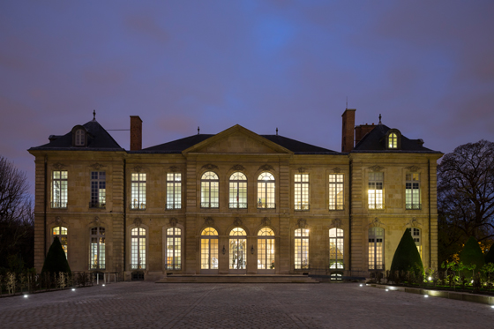
Photo. 1: After a complete restoration over the past three years, the Rodin Museum in Paris reopened its doors to the public on 12th November 2015 - the 175th anniversary of the birth of the famous French sculptor.
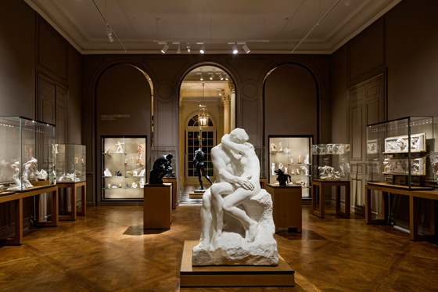
Photo 2: The perception of the work changes radically, depending on the colour temperature that is used.
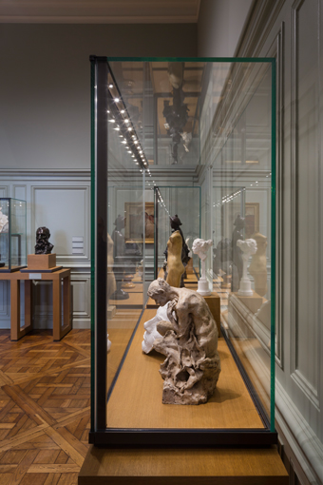
Photo 3: All the showcases in the museum are equipped with LED MICROTOOLS modules that can be tilted (flood beam, 4000 K). The lighting intensity can vary from 1% to 35% depending on the daylight situation.
Press contact:
Zumtobel Lighting GmbH  Andreas Reimann  Brand PR Manager  Schweizer Strasse 30  A-6850 Dornbirn  Tél: +43 5572 390 26522  Mobil: +43 664 80892 3334  press.zumtobel@zumtobelgroup.com  www.zumtobel.com | ZG Lighting France  Jean-Charles Lozat  Chargé de Communication  156 Boulevard Haussmann  F-75379 Paris Cedex 08  Tél: +33 1 49 53 62 52  Mobil: +33 6 64 70 22 31  jean-charles.lozat@zumtobelgroup.com  www.zumtobel.fr

About Zumtobel
As a leader in innovation, Zumtobel develops sustainable lighting solutions tailored to the needs of people in their respective applications. With a comprehensive portfolio of high-quality luminaires and intelligent lighting management systems, the Austrian company provides optimum indoor and exterior products for working and living spaces - the right light for every activity at any time of day. The applications office, education, presentation and retail, hotel and wellness, health, art and culture and industry are now perfectly complemented with portfolios for living and outdoor areas. Zumtobel is a brand of Zumtobel Group AG with its head office in Dornbirn, Vorarlberg (Austria).
Zumtobel. The Light.

