Press release

Brilliant colours for a natural art experience
Zumtobel LED lighting solution for the new “Museum Ton Schulten”

On 25 April 2013, the Ton Schulten Museum was opened in Ootmarsum. The Dutch artist is known for his expressive pictures painted in bold colours, the brilliance and vitality of which are enhanced to optimum effect by the right light. Due to its excellent colour rendering properties, the artist opted for an LED lighting solution by Zumtobel, which also minimises potential damage and lowers energy consumption by 50 percent.

Ootmarsum, July 2013 – The newly opened “Museum Ton Schulten” in Ootmarsum is far more than an artistic biography of Ton Schulten, one of the most successful and renowned contemporary Dutch painters. In several rooms, he not only displays his own oeuvre, but also selected works of art by a number of international artists. He placed particular emphasis on an authentic, yet gentle lighting concept. In Zumtobel he found a partner who was able to perfectly implement his demands in terms of colour rendering quality, flexibility and conservational requirements.

Excellent colour rendering
Most of Ton Schulten's paintings show landscapes where nature shines in all her colourful splendour. Visitors are supposed to get the impression of standing right in the middle of such a landscape, experiencing it in natural sunlight. Against this background, the lighting solution faces particular challenges, for while bold blue or green shades are presented to optimum effect in cool white light, warm white is ideal for red and yellow. Hence, colour rendering and colour brilliance were very important aspects in Ton Schulten's decision for the right lighting solution. “I am highly satisfied with the result, because the paintings are presented in a very natural light so that they can unfold their full effect,” says a pleased Ton Schulten.
The solution was provided by a customised version of the Arcos LED spotlight system boasting a colour rendering index of up to Ra > 95 at 2700 K. In order to set the perfect lighting stage for presenting the artworks, a total of 230 spotlights were installed on Supersystem tracks. The dimming level can be adjusted directly on the spotlight, which allows individual adjustment to any exhibit. In addition, a variety of beam angles and an oval outline lens ensure sufficient flexibility to solve the most diverse lighting tasks.

Gentle and efficient illumination
However, the LED lighting solution was able to outcompete conventional halogen lighting not only due to excellent colour rendering, but also thanks to its compliance with conservational requirements. “As the new generation of LED luminaires emits significantly less heat towards the precious exhibits and the light they generate is nearly completely free from IR and UV radiation, we can ensure gentle illumination for sensitive objects as well,” says Barry Harmes from Zumtobel who was involved in the project from the beginning.
This was further corroborated by a study conducted by Zumtobel in collaboration with the Lighting Engineering Department of Darmstadt University of Technology. As part of this study, the quality of various light sources was tested on a real object of art, Picasso's “Harlequin” drawing, using predefined evaluation parameters. Basically, potential damage caused by the LED spotlight is significantly lower at comparable colour temperatures. At the same time, energy efficiency is increased by the LED spotlight, as the input of electrical energy is around 50 percent less than with a halogen spotlight. An additional benefit is the LED's long service life, combined with reduced maintenance effort.

Zumtobel Research
Measurement of lighting of Pablo Picasso‘s
“Harlekin” (1916) at the Lindau Town Museum http://www.zumtobel.com/tunablewhite/downloads/Studie_picasso_EN.pdf

Lighting solution | ARCOS LED spotlight (custom solution)  Ra > 95 at 2700 K  www.zumtobel.com/arcos
Client | Museum Ton Schulten, www.tonschulten.nl
Architect | Architectenbureau Ronald de Baas / LeferinkArchitecten BNA
Lighting design | MeutznerLicht Design
Electrical design / installation | LammerinkInstallatiegroep

Captions:

(Photo Credits: Grobet Toon)

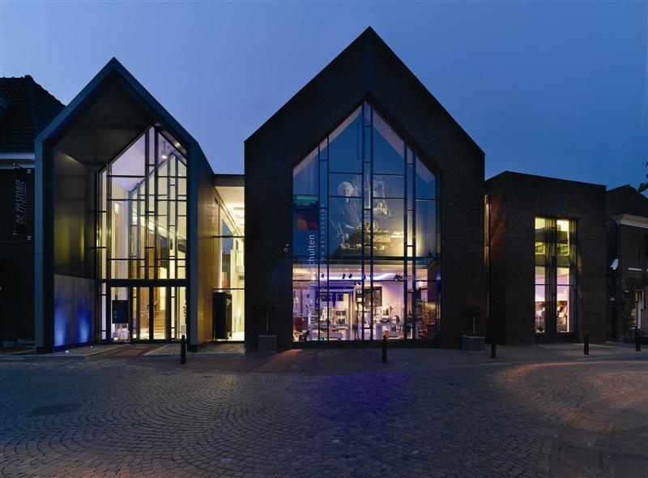

Picture 1: Due to its excellent colour rendering properties, the artist opted for an LED lighting solution by Zumtobel.

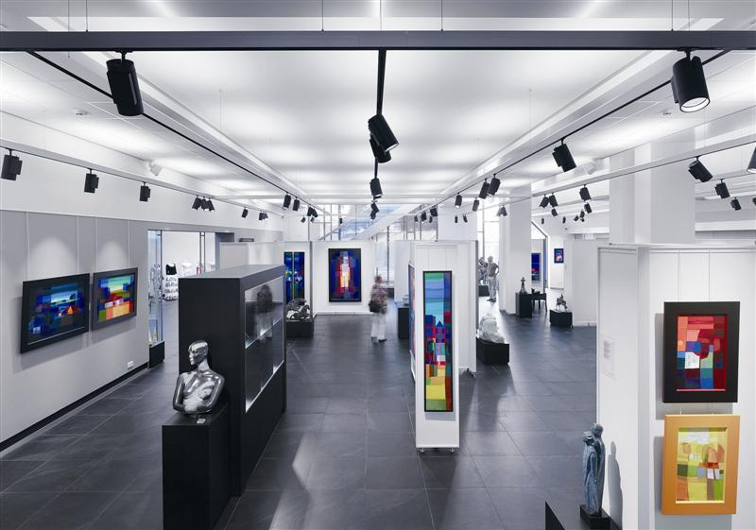

Picture 2: In order to set the perfect lighting stage for presenting the artworks, a total of 230 spotlights were installed on Supersystem tracks.

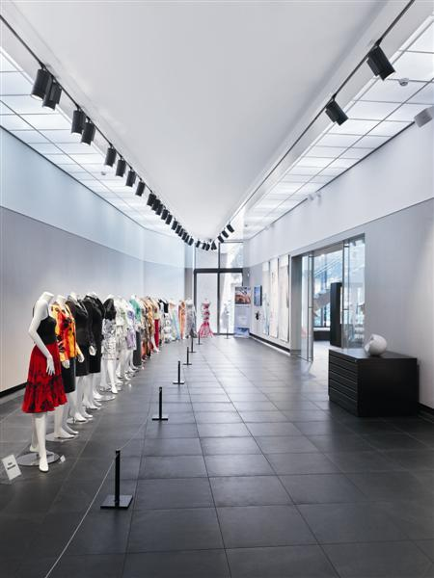

Picture 3: The LED lighting solution was able to outcompete conventional halogen lighting due to excellent colour rendering and its compliance with conservational requirements.

For more information, please contact:
Zumtobel Lighting GmbH  NikolausJohannson  Head of Brand Communication  Schweizer Strasse 30  A-6851 Dornbirn  Tel +43-5572-390-26427  Mobil +43-664-80892-3202  E-Mail nikolaus.johannson@zumtobel.com  www.zumtobel.com | Zumtobel Lighting GmbH  Sophie Moser  PR Manager  Schweizer Strasse 30  A-6850 Dornbirn  Tel +43-5572-390-26527  Mobil +43-664-80892-3074  E-Mail sophie.moser@zumtobel.com  www.zumtobel.com

About Zumtobel
Zumtobel is a leading international supplier of integral lighting solutions that enable people to experience the interplay of light and architecture. As a leader in innovation, the luminaire manufacturer provides a comprehensive range of high-quality luminaires and lighting management systems for the most varied application areas of professional interior lighting – including offices and educational facilities, presentation and retail, hotels and wellness, health and care, art and culture as well as industry and engineering. Zumtobel is a brand of Zumtobel AG with its head office in Dornbirn, Vorarlberg (Austria).

Zumtobel. The Light.

