Press release

Bringing a glint to eyes in the new Borussia Dortmund (BVB) Fan World
Borussia Dortmund is banking on an innovative LED lighting solution by Zumtobel

Borussia Dortmund's recently opened "BVB Fan World" is a paean of love to this German football brand and a unique voyage of discovery for the supporters of this traditional club. Zumtobel has implemented an efficient LED lighting concept for the building; it provides a perfect setting for the black-and-yellow themed Fan World and creates an attractive feel-good ambience for visitors that will make the hearts of football fans leap for joy.

Dornbirn, August 2014 – The new "BVB Fan World" of traditional football club Borussia Dortmund is the latest highlight in the Signal Iduna Park: visitors can find out everything they need to know about the history of the club, buy tickets and merchandise or relive BVB's most thrilling, exciting football moments in this two-storey building, which covers a floor area of more than 2,000 m². An important aspect in the Fan World's design was to find a perfect lighting system for the various areas of the building that could also be adjusted flexibly and quickly. To fulfil these requirements, Zumtobel developed a tailor-made lighting concept for the building, which combines efficient lighting with great lighting quality and ideal colour rendering, in close cooperation with its partners a·g Licht and DULA Ladenbau Dortmund. A pleasant, authentic lighting situation makes it possible to experience the BVB brand and identify emotionally with it, and also creates an attractive feel-good atmosphere that invites visitors to linger. Merchandise in the sales area is showcased by accent lighting to ensure products are presented in an appealing manner and make it easy for shoppers to find their way around.

Zumtobel uses track-mounted swivelling black VIVO LED spotlights to provide ambient lighting throughout the entire Fan World. A special design of this luminaire with a colour temperature of 3500 K shows off the club's black and yellow colours to great effect. VIVO LED features a high colour rendering index of Ra 90, which enables strong visual contrasts. VIVO LED is also used in the multifunctional presentation area in the lobby on the ground floor.
To ensure perfect presentation of items of merchandise, miniaturised DIAMO LED and MICROS LED downlights are installed in the shelves in the BVB Fan Shop. These efficient recessed luminaires ensure precise light distribution without any scattering losses as well as excellent glare control. High-performance LED modules that offer excellent lighting quality and maximum brilliance provide powerful accent lighting for merchandise. In the POS and information area, PANOS infinity downlights provide diffuse lighting. These high-efficiently downlights are perfectly dimmable and boast a high colour rendering index of Ra > 90 and a symmetrical beam pattern.

The "Podium of the Greats", which features statues of players in the current team, is the main attraction on the ground floor. A dimmable luminous ceiling measuring 4.5 x 2.1 m above the players is a special design with a colour temperature of 3500 K which sets the exhibits centre stage perfectly. The "Yellow Wall", which represents the South stands of Signal Iduna Park on a photo wall that extends over both storeys, is an impressive eye-catching feature on the way up to the upper floor. This is the emotional highlight of the BVB Fan World, for this is where 25,000 excited fans stand in their black and yellow strip and follow every home match. This is where the heart of Borussia Dortmund beats. Zumtobel uses ARCOS Xpert spotlights to make sure that the photo wall is staged to perfection. Pinpoint light distribution and a specially developed conical dual reflector allow particularly precise lighting. The 365° swivelling spotlights can also be positioned extremely flexibly and show the stands realistically thanks to excellent colour rendering.

Zumtobel also installed a decorative highlight in the lounge on the upper floor: spherical SCONFINE SFERA pendant luminaires provide pleasant ambient lighting thanks to their chrome-plated luminaire unit. As well as direct light, the semi-transparent chrome-plated luminaires also create reflections in the luminaire unit, which lend the luminaire its seemingly weightless character.

Zumtobel Group and Borussia Dortmund – real partners
The Zumtobel Group is a partner of Borussia Dortmund. The partnership is shaped by the Group’s two lighting brands, Thorn and Zumtobel. With its strategic multi-brand approach, the Group covers the full range of professional lighting solutions, making it a strong and versatile partner for Borussia Dortmund. The partnership includes the implementation of various lighting projects for the football club, as well as sales supporting measures for the target groups of both brands.

Facts & figures on the Zumtobel products used
VIVO | LED spotlight for accent lighting; swivelling spotlight; excellent colour rendering, choice of perfect light colour and glare control; luminous flux: up to 4210 lm; colour temperature: 3000 K or 4200 K; IR- and UV-free light
DIAMO | Minimalist LED downlight; available as wallwasher or 3-phase spotlight; colour temperature: 2700, 3000 and 4000 K; colour rendering index: Ra 80 or 90; dimmable
MICROS | Functional LED downlights; service life: 50,000 hours at 70% luminous flux; colour temperature: 3000 or 4000 K; colour rendering index: Ra 80; luminaire efficiency > 45 lm/W
PANOS infinity | LED downlight range; dimmable; colour temperature: 3000 or 4000 K; high colour rendering index of Ra > 90; luminaire efficiency of > 100 lm/W; symmetrical beam pattern
ARCOS Xpert | LED spotlight for accent lighting for delicate exhibits; UVA- and IR-free light; innovative thermal conditions with COOL TOUCH function; compact shape and minimalist design; spotlight rotates through 365° and pivots through 90°; Ø 100 mm; colour temperature 3000 or 4000 K
SCONFINE SFERA | Spherical pendant luminaire with LED light source, polycarbonate sphere chrome-plated for semi-transparent, reflective finish; colour temperature: 2700 K; colour rendering index: Ra 80; heat sink for optimum heat dissipation; installed load: approx. 9.5 W

Captions
(Photo Credits: Zumtobel)
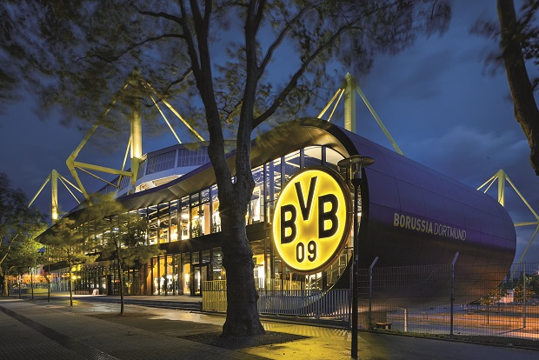
Caption 1: The lighting concept of "BVB Fan World" in the Signal Iduna Park was developed by Zumtobel.
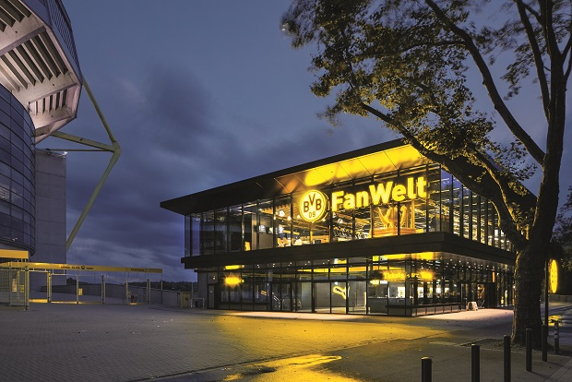
Caption 2: An important aspect in the Fan World's design was to find a perfect lighting system for the various areas of the building that could also be adjusted flexibly and quickly.

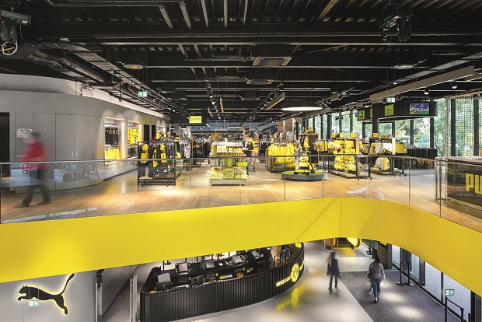
Caption 3: Zumtobel uses track-mounted swivelling black VIVO LED spotlights to provide ambient lighting throughout the entire Fan World.

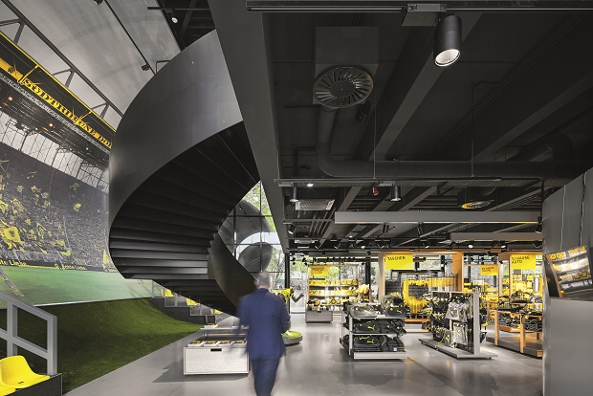
Caption 4: Zumtobel uses ARCOS Xpert spotlights to make sure that the photo wall is staged to perfection.
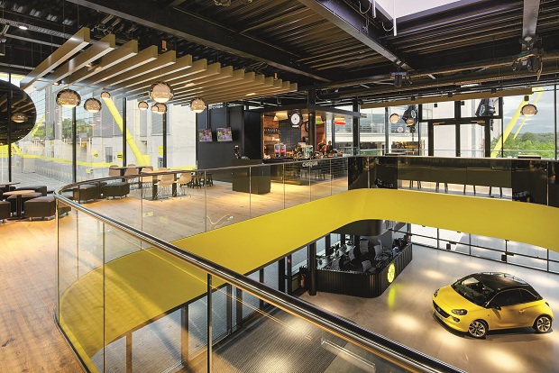

Caption 5: The spherical SCONFINE SFERA pendant luminaires provide pleasant ambient lighting thanks to their chrome-plated luminaire unit.
Press contact:
Zumtobel Lighting GmbH
Sophie Moser
PR Manager
Schweizer Strasse 30
A-6851 Dornbirn

Tel.: +43-5572-390-26527
Mobile: +43-664-80892-3074
E-mail: sophie.moser@zumtobel.com

www.zumtobel.com

About Zumtobel
Zumtobel, a leading international supplier of integral lighting solutions, enables people to experience the interplay of light and architecture. As a leader in innovation, Zumtobel provides a comprehensive range of high-quality luminaires and lighting management systems for professional interior lighting in the areas of offices, education, presentation & retail, hotel & wellness, health, art & culture as well as industry. Zumtobel is a brand of Zumtobel AG with its head office in Dornbirn, Vorarlberg (Austria).
Zumtobel. The Light.

