Press release

Dynamic media façade for Casino Bregenz

Zumtobel lighting solution illuminates redesigned Casino Bregenz façade

A new architectural highlight adds fresh impetus and appeal to the setting of Bregenz's cultural mile. In 2014, Casino Bregenz was transformed and expanded in two construction phases: an extension was added to the terrace facing towards the Festival House, and the outer façade was given a complete facelift. In order to present the attractive location of Casinos Austria AG in Bregenz to optimum effect also at night, and to create the right backdrop for a highly atmospheric evening at the casino, the clients opted for a dynamic media façade. Zumtobel's CAPIX evolution LED media façade luminaire was able to meet the high requirements.

Dornbirn, 19 September 2014 – It is a truly Hollywood-style setting, and not just since the shooting of the James Bond movie “Quantum of Solace”. Situated in the immediate vicinity of the lake, Casino Bregenz opens up above the stairs to the summer terrace facing the Festival Square in the heart of Bregenz. Guests and passers-by are fascinated by the redesigned façade, which surrounds both the existing glazed front and the annex with metal sheeting.
From inside, guests enjoy an unhampered view of the lake, while the attention of passers-by is drawn towards the flowing, slightly irregularly arranged metal elements. When night falls, the façade is transformed into a shining interplay of colours, thanks to the CAPIX evolution LED media façade luminaire. As the individual CAPIX elements are linked by only one data line and one supply line, the 6500 single CAPIX pixels cling to the curved façade of the extended casino like a second skin. In total, the casino was fitted with 1140 meters of CAPIX. Since each CAPIX pixel incorporates three RGB LEDs, the lighting effect produced by CAPIX evolution is bright and brilliant even when viewed from long distances. In addition to generating colours and other effects, the control system of CAPIX evolution also allows running a sequence of moving pictures.
If required, the sequence of façade illumination can also be changed on short notice. At the same time, the new LED façade lighting also complies with the strict requirements regarding nature and bird protection applicable in Bregenz and features excellent energy efficiency. Within the scope of refurbishment, the interior was redesigned and extended as well, so that now the lounge is illuminated by brilliantly sparkling DIAMO LED downlights that create a stylish ambience.

Together with the Festival House and the Floating Stage, the redesigned Casino Bregenz now forms a harmonious overall ensemble. The façade blends perfectly into the scenery and adds additional splendour to the cultural mile that has developed over the past years, ranging from the KUB Kunsthaus to the Landestheater and vorarlberg museum through to the Festival Square. For Casinos Austria, the media façade opens up new ways of presentation. Thus, not only guests but also passers-by can experience Casino Bregenz as an exciting work of lighting art at night.

Captions:

(Photo Credits: Marcel A. Mayer)

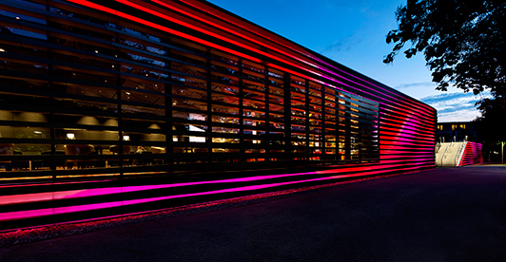
Image 1: In two construction phases, the Casino Bregenz was extended and the outer façade was given a complete facelift

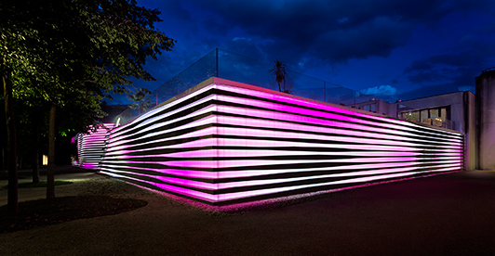

Image 2: When night falls, the façade is transformed into a shining interplay of colours, thanks to the CAPIX evolution LED media façade luminaire.

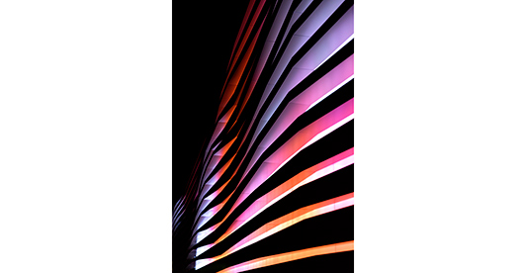

Image 3: 6500 single CAPIX pixels cling to the curved façade of the extended casino like a second skin.

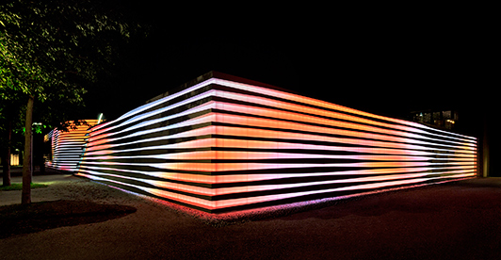

Image 4: If required, the sequence of façade illumination can also be changed on short notice.

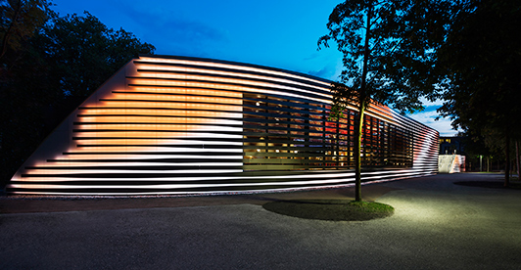

Image 5: The control system of CAPIX evolution also allows running a sequence of moving pictures.

Press contact:
Zumtobel Lighting GmbH
Sophie Moser
PR Manager
Schweizer Strasse 30
A-6851 Dornbirn

Tel.: +43-5572-390-26527
Mobile: +43-664-80892-3074
E-mail sophie.moser@zumtobelgroup.com

www.zumtobel.com

Sales Germany, Austria, Switzerland:
Zumtobel Licht GmbH  Grevenmarschstr. 74-78  32657 Lemgo  Germany  Tel.: +49-5261-212-7445  Fax: +49-5261-212-817445  E-mail: info@zumtobel.de  www.zumtobel.de | ZG Lighting Austria GmbH  Donau-City-Strasse 1  1220 Vienna  Austria  Tel.: +43-1-258-2601-0  Fax: +43-1-258-2601-82845  E-mail: welcome@zumtobel.at  www.zumtobel.at
Zumtobel Licht AG
Thurgauerstrasse 39
8050 Zurich
Switzerland
Tel.: +41-44-30535-35
Fax: +41 44 305 35 36
e-mail: info@zumtobel.ch
www.zumtobel.ch

About Zumtobel
Zumtobel, a leading international supplier of integral lighting solutions, enables people to experience the interplay of light and architecture. As a leader in innovation, Zumtobel provides a comprehensive range of high-quality luminaires and lighting management systems for professional interior lighting in the areas of offices, education, presentation & retail, hotel & wellness, health, art & culture as well as industry. Zumtobel is a brand of Zumtobel AG with its head office in Dornbirn, Vorarlberg (Austria).
Zumtobel. The Light.

