Press release

MIREL evolution: a leap into the future of louvre luminaires
Fitted with a lens optic and opal cover, MIREL evolution is the perfect tool for refurbishing projects in office environments.
Dornbirn, October 2014 – With MIREL evolution, Zumtobel is steering louvre luminaires towards modern times. By giving the luminaire a distinct appearance, Zumtobel has mastered the challenge of integrating energy-efficient LED technology into a tried-and-tested stylistic idiom: the lenses and the light source of MIREL evolution are visible to the user and are thus becoming a key design feature of the otherwise minimalist luminaire. Thanks to the particular shape of the lens, a directional beam pattern and a brilliant appearance are achieved without any annoying glare. Light distribution is effected via the lenses at a rate of 95 per cent; only 5 per cent of the luminous flux are reflected by the “louvre”. This results in more precise direction of light and higher luminous efficiency, which is also indicated by a luminaire efficiency factor of 112 lm/W. The luminaire's luminous flux levels and module sizes, however, have not changed as compared to the classic recessed luminaire. Conventional luminaires can be replaced on a one-to-one basis, which is a convincing argument in favour of using MIREL evolution in refurbishment projects.
The stylistic idiom of MIREL evolution featuring an opal optic has been reduced even further, so that the luminaire now appears as a flat, level luminous panel. For the version fitted with an opal cover, a 3Dprotect® reflector is used, which not only ensures perfect direction of light but also protects the sensitive LED modules during installation. Due to the interplay of innovative LED technology and direction of light in MIREL evolution fitted with an opal cover, a luminaire efficiency factor of up to 123 lm/W is possible.

With its clear, unobtrusive and universally applicable design, the luminaire developed by STUDIO AMBROZUS is able to exploit its full potential in terms of lighting quality and energy efficiency. With a colour rendering index of Ra > 80, the louvre luminaire is particularly suitable for the various visual tasks to be performed in offices. MIREL evolution is available as a recessed, lay-in and surface-mounted luminaire in a square or linear version.

Facts & figures
MIREL evolution  Lens optic | Recessed, surface-mounted or lay-in LED luminaire, linear or square version  Colour temperature: 4000 K and 3000 K  Colour rendering: Ra >80  Luminaire efficiency: up to 112 lm/W
MIREL evolution  Opal optic | Ceiling-recessed LED luminaire featuring an opal optic  Linear luminaire or square version  Colour temperature: 4000 K and 3000 K  Colour rendering: Ra >80  Luminaire efficiency: up to 123 lm/W

Captions:
(Photo credits: Zumtobel)
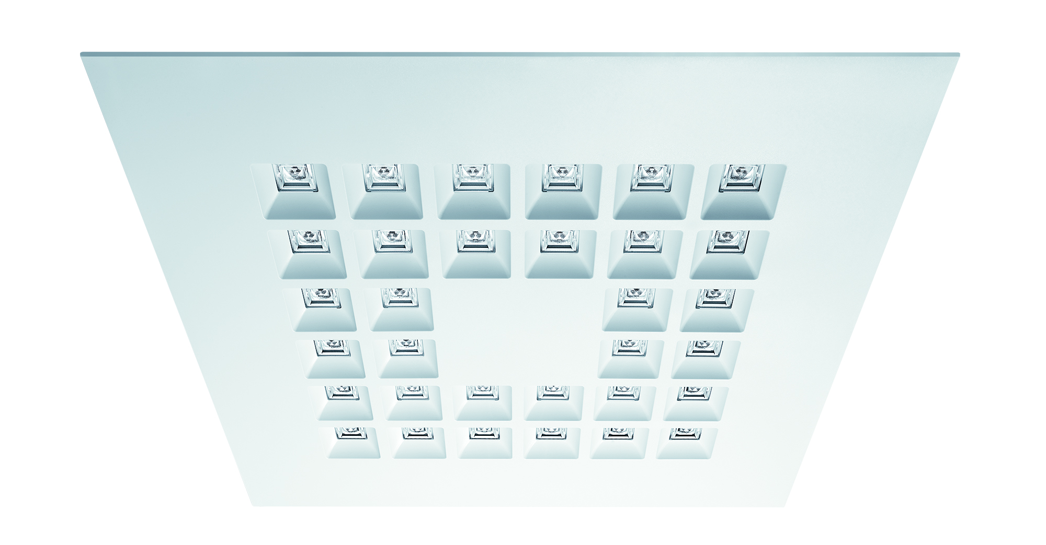
Fig. 1: Zumtobel has mastered the challenge of developing the louvre luminaire further by giving it a distinct appearance; square version of the MIREL evolution louvre luminaire.

Press contact:
Zumtobel Lighting GmbH
Sophie Moser
PR Manager
Schweizer Strasse 30
A-6851 Dornbirn

Tel +43-5572-390-26527
Mobile +43-664-80892-3074
E-mail press@zumtobel.com

www.zumtobel.com

Sales UK and USA:
Zumtobel Lighting Ltd.  Chiltern Park  Chiltern Hill, Chalfont St Peter  Buckinghamshire SL9 9FG  United Kingdom  Tel: +44 1753 482 650  Fax: +44 1753 480 350  uksales@zumtobel.com  www.zumtobel.co.uk | Zumtobel Lighting Inc.  3300 Route 9  Highland , NY 12528  United States  Tel: +1 845 691-6262  Fax: +1 845 691-6289  zli.us@zumtobelgroup.com  www.zumtobel.us

For further contact details in further sales regions please visit: http://www.zumtobel.com/com-en/contact.html

About Zumtobel
Zumtobel, a leading international supplier of integral lighting solutions, enables people to experience the interplay of light and architecture. As a leader in innovation, Zumtobel provides a comprehensive range of high-quality luminaires and lighting management systems for professional interior lighting in the areas of offices, education, presentation & retail, hotel & wellness, health, art & culture as well as industry. Zumtobel is a brand of Zumtobel AG with its head office in Dornbirn, Vorarlberg (Austria).
Zumtobel. The Light.

