Press information

Light through the ages
The multifunctional SUPERSYSTEM forms a unifying light element in the successful renovation of the listed arcades at the LWL Museum in the city of Muenster, Germany.
Dornbirn, 10. December 2014 – Eleven years in the planning, five years in the making – a combination of brand new construction and renovation of the existing building dating from 1908 has transformed the LWL Museum of Art and Culture in Muenster into one of the biggest art museums in Germany. In many ways, the architecture can be seen to reflect the 1,000 years of art on display. Old and new are merged into a single architectural unit to showcase works from the Middle Ages to modern times, ensuring a unique visitor experience. "Art needs daylight," explains Museum Director Hermann Arnhold. This principle applies not only to the new construction, but also to the historic parts of the building, where a spacious atrium is surrounded on two levels by an arcade. It was therefore necessary to design a new lighting solution for these officially protected arcades as part of the refurbishment.
Looking at how the arcades are currently used helped identify the key requirements. Flexibility and adaptability are extremely important factors for both temporary exhibitions and the correct presentation of a wide range of sculptures and objects. The integration of the lighting solution into the existing structures also played a major role, with visual disturbance caused by additional elements to be kept to an absolute minimum in the historical rooms. In addition, as the architecture offers visitors fine views across the central courtyard, it was necessary to find a suitable holistic lighting solution for both levels of the arcade.
After several test installations and close cooperation with the local listed buildings authority, lighting designer Licht Kunst Licht AG from Bonn opted for SUPERSYSTEM from Zumtobel. Given the combination of minimalist form, versatility and excellent lighting quality for sensitive artworks, this understated lighting system offered the perfect solution. When suspended centrally in line with the top of the columns, SUPERSYSTEM is the unifying light element that runs through the historic arcades.
SUPERSYSTEM performs several functions. It provides uniform indirect illumination of the vaulted areas for diffuse general lighting, carefully avoiding the transverse arches and only highlighting the vaults. In addition, fixed LED mini-spots enable direct lighting when required. The beam angle can be adapted for specific exhibitions by changing the lenses in the adjustable SUPERSYSTEM heads. Thanks to the flexibility of the light system, spotlights used elsewhere in the museum can also be mounted on the track to accentuate particular exhibits. The DALI lighting controls system works in combination with a portable control panel, making it easy for staff to independently regulate the direct and indirect lighting and individually adjust every group of LED mini-spots.

Photo captions:
(Photo credits: Marcus Ebener)
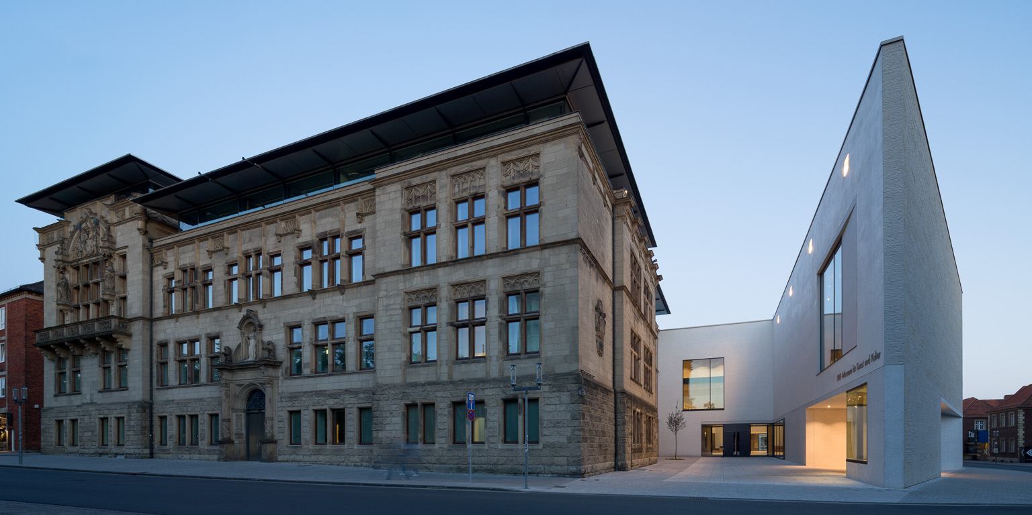
Image 1: Brand new construction and renovation of the existing building dating from 1908 have transformed the LWL Museum for Art and Culture in Muenster into one of the biggest art museums in Germany.
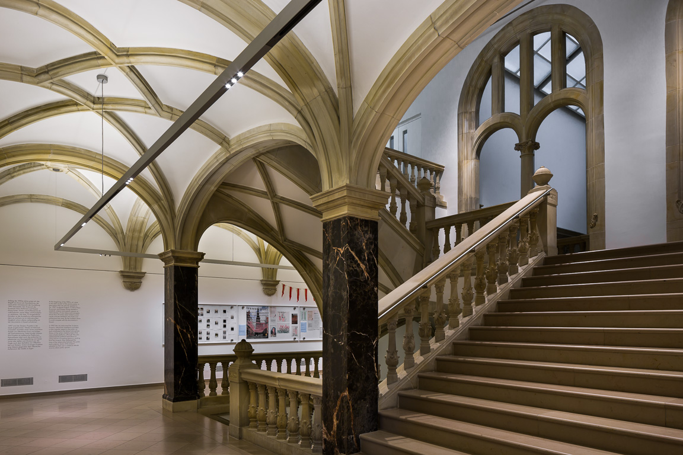
Image 2: A new lighting solution has been designed for the officially protected arcades as part of the refurbishment of the LWL Museum.
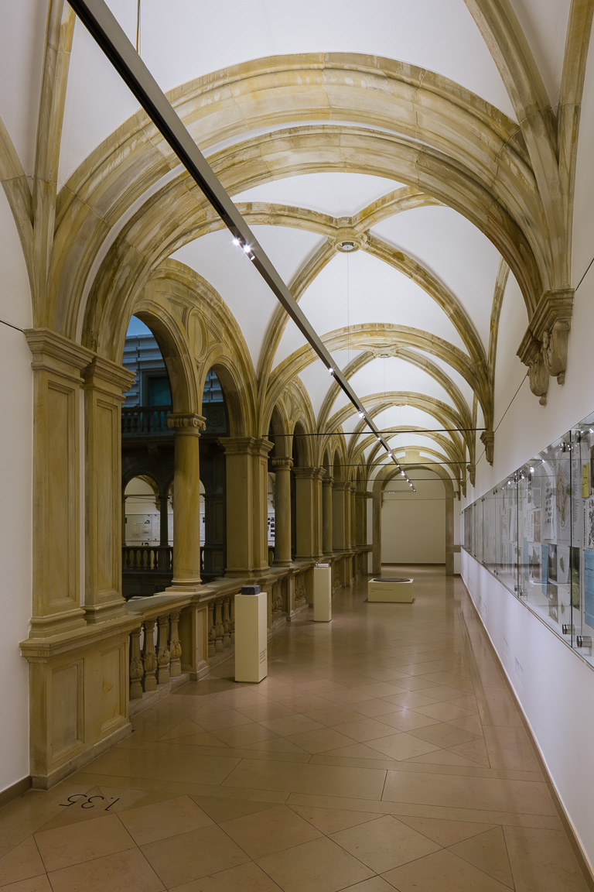
Image 3: Flexibility and adaptability are extremely important factors for both temporary exhibitions and the correct presentation of a wide range of sculptures and objects.

Press contacts:
Zumtobel Lighting GmbH  Sophie Moser  PR Manager  Schweizer Straße 30  A-6850 Dornbirn  Tel +43-5572-390-26527  Mobil +43-664-80892-3074  E-Mail press@zumtobel.com  www.zumtobel.com | ZG Licht Süd GmbH  Jennifer Achilles  Junior Field Marketing Manager  Solmsstraße 83  D-60486 Frankfurt  T +49 (0) 5261-212-7490  M +49 (0) 170-3385168  E-Mail: jennifer.achilles@zumtobelgroup.com  www.zumtobel.de

Sales contact UK, USA:
Zumtobel Lighting Ltd.  Chiltern Park  Chiltern Hill, Chalfont St Peter  Buckinghamshire SL9 9FG  United Kingdom  Tel: +44 1753 482 650  Fax: +44 1753 480 350  uksales@zumtobel.com  www.zumtobel.co.uk | Zumtobel Lighting Inc.  3300 Route 9  Highland , NY 12528  United States  Tel: +1 845 691-6262  Fax: +1 845 691-6289  zli.us@zumtobelgroup.com  www.zumtobel.us

For further contact details in further sales regions please visit: http://www.zumtobel.com/com-en/contact.html

About Zumtobel
Zumtobel, a leading international supplier of integral lighting solutions, enables people to experience the interplay of light and architecture. As a leader in innovation, Zumtobel provides a comprehensive range of high-quality luminaires and lighting management systems for professional interior lighting in the areas of offices, education, presentation & retail, hotel & wellness, health, art & culture as well as industry. Zumtobel is a brand of Zumtobel AG with its head office in Dornbirn, Vorarlberg (Austria).
Zumtobel. The Light.

