Press release

TECTON LED: form, functions and flexibility at its finest
Zumtobel's versatile TECTON continuous-row LED lighting system meets a variety of lighting requirements and is flexible like no other system. This spring, Zumtobel is adding a number of new products to the highly functional continuous-row lighting system. The new generation features improved energy efficiency combined with a pared-down stylistic idiom.
Dornbirn, May 2015 – The existing TECTON continuous-row LED lighting system by Zumtobel, the Austrian luminaire manufacturer, is part of a product range providing intelligent solutions to any lighting task. Since its introduction, more than 12 million metres of the TECTON continuous-row lighting system have been sold, which makes this system one of the most successful products manufactured by Zumtobel. TECTON is the world's first continuous-row lighting system to have an 11-pole current conducting section built into the trunking. All functions such as power supply, lighting control and connection to the emergency lighting system are integrated into this multi-functional trunking unit. The luminaires can be positioned flexibly, and the system can be adjusted to structural changes at any time. Only the various lighting modules, light sources or optics are replaced or added, if required. Moreover, TECTON cannot fail to impress on account of its easy installation: the batten luminaire can be installed by one single person, for example. Thanks to its high quality and slim design, TECTON LED is able to combine batten luminaires, other luminaires and reflectors in visual and functional harmony. Compact yet versatile, the linear luminaire radiates utter calmness. The continuous-row system does not have any butt joints and provides a consistent appearance without visible interruptions, even when different beam patterns are placed next to each other.
The new generation of the continuous-row LED lighting system boasts improved energy efficiency and a significantly pared-down stylistic idiom. On-going development of LED technology has resulted in miniaturised design as well as an increased luminaire efficiency factor of up to 148 lm/W. Moreover, the newly developed split-lens technology allows efficient direction of light with high precision. Based on a point light source, the split lens uniformly directs the light along both sides, which reduces glare (UGR < 19) and results in targeted direction of light. As this prevents reflections on screens, TECTON can for instance also be used above cash desks in supermarkets. Thanks to reduced energy consumption, the costs are reduced even further. Furthermore, the existing versions have been converted to metric measurements and are now available in lengths of 1 m and 1.5 m; another batten luminaire of 2 m length has been added as well. This considerably facilitates designing a lighting solution using TECTON.
The new generation of TECTON LED is available in various colour temperatures of 3000 K, 4000 K and 6500 K at a colour rendering of Ra > 80. Thanks to an IP rating of 50, the LED module and optic are protected against soiling. Thus, the new TECTON continuous-row LED lighting system is suitable for use in industrial and logistics applications as well as in supermarkets.

TECTON facts & figures
- Continuous-row LED lighting system with trunking integrating power supply, lighting control and connection to emergency lighting
- Various optics
- Installation: pendant, surface-mounted and recessed
- Direction of light in a targeted and efficient manner thanks to split-lens technology
- Three batten luminaire sizes: 1, 1.5 and 2 m long, 600 mm wide and 85 mm high
- Optionally available with daylight-based control, presence detection or movement sensors
- Luminaire efficiency: up to 148 lm/W
- Colour temperatures: 3000 K, 4000 K or 6500 K
- Excellent colour rendering of Ra > 80
- LED and optics in IP 50
- Service life: 50000 hours

Captions:
(Photo credits: Zumtobel)
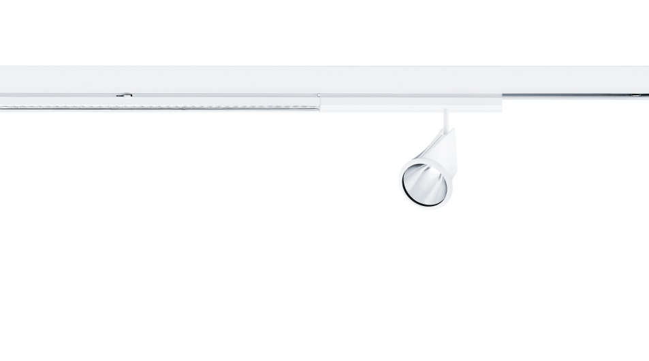
Fig. 1: The new generation of the continuous-row LED lighting system boasts improved energy efficiency and a significantly pared-down stylistic idiom.
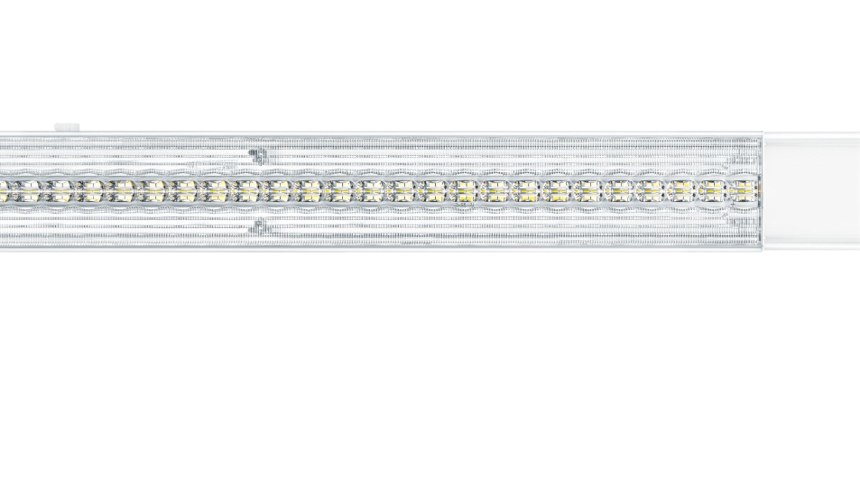
Fig. 2: On-going development of LED technology has resulted in miniaturised design as well as an increased luminaire efficiency factor of up to 148 lm/W.

Press contact:
Zumtobel Lighting GmbH
Sophie Moser
PR Manager
Schweizer Strasse 30
A-6850 Dornbirn

Tel +43-5572-390-26527
Mobil +43-664-80892-3074
E-Mail press@zumtobel.com
www.zumtobel.com

Sales contact:
Zumtobel Lighting Ltd.  Chiltern Park  Chiltern Hill, Chalfont St Peter  Buckinghamshire SL9 9FG  United Kingdom  Tel: +44 1753 482 650  Fax: +44 1753 480 350  uksales@zumtobel.com  www.zumtobel.co.uk | Zumtobel Lighting Inc.  3300 Route 9  Highland , NY 12528  United States  Tel: +1 845 691-6262  Fax: +1 845 691-6289  zli.us@zumtobelgroup.com  www.zumtobel.us

For further contact details in further sales regions please visit: http://www.zumtobel.com/com-en/contact.html

About Zumtobel
Zumtobel, a leading international supplier of integral lighting solutions, enables people to experience the interplay of light and architecture. As a leader in innovation, Zumtobel provides a comprehensive range of high-quality luminaires and lighting management systems for professional interior lighting in the areas of offices, education, presentation & retail, hotel & wellness, health, art & culture as well as industry. Zumtobel is a brand of Zumtobel Group AG with its head office in Dornbirn, Vorarlberg (Austria).
Zumtobel. The Light.

