Project information

A special addition to the product portfolio
High above the rooftops of Frankfurt shines the bold and purist architecture of the office and conference floor of DVB Bank, awash with high-quality details from a holistic design dominated by glass and a careful blend of white and grey tones. Entrusted with the demanding task of restoring the 40th floor of City-Haus, Frankfurt architects Theiss have created an environment for meetings and conferences that sets a new benchmark for modern working applications. The unusual axis dimensions and reduced installation depth placed special requirements on various features of the project, including a pioneering customised lighting solution that has now been integrated into the standard MIREL evolution product family.
Dornbirn, April 2016 – Located in the West End district of the German financial capital, the 142-metre-high City-Haus designed by architects Johannes Krahn and Richard Heil was one of the first Frankfurt skyscrapers to be built with a column-free facade structure. DZ Bank has owned this 1970s building on the Platz der Republik for more than 40 years, during which time the high-rise office block has gone through a number of renovation phases. After the illumination of the facade in 2006, it was then the turn of the interior to be gradually updated. The finishing touches to the striking contemporary design concept of the office and conference floor of DVB Bank were added at the end of 2014.
The contract for the ambitious planning assignment was awarded to the Frankfurt-based architects Theiss Planungsgesellschaft mbH, who have earned a burgeoning reputation in recent years in the field of urban planning, construction and interior design– both in the region and beyond. Architect and proprietor Alexander Theiss is a firm advocate of holistic concepts with high flexibility and sustainable design, in which light plays a significant role - core principles that are very much in evidence in the renovated office and conference floor.
The specific focus on building technology and light proved to be an important factor. The lighting solution had to integrate seamlessly with the high-quality design of the conference rooms, offices and a coffee bar, providing an open and welcoming visual appearance. The special axis dimensions of just 1.43 metres and the reduced installation depth offered very precise challenges. The creative idea for ​​the lighting design concept, which also had to comply with the building regulations, could not be realised using a standard solution. As a result, the project team from Zumtobel worked closely with the architects Theiss Planungsgesellschaft to swiftly develop a special luminaire based on the recessed version of MIREL evolution. The combination of low mounting height, excellent system efficiency and high lighting quality immediately convinced both the architect and the end users. The LED technology of MIREL evolution met the energy efficiency requirements, whilst simultaneously offering the optimum conditions for the future-oriented office and conference room architecture.
The glass facade fulfils an important double function, providing fantastic views far beyond the city limits of Frankfurt and allowing plenty of daylight to enter the building. The fusion of white and grey tones with a range of high-quality materials creates a pleasant atmosphere in the conference and meeting rooms. The design language of MIREL evolution and the neutral white light colour further enhance the purist design of this area. Precisely arranged in groups and integrated seamlessly into the office architecture, the luminaire defines the spaces, provides orientation and simultaneously delivers task-specific lighting for deskwork, meetings, presentations and lectures.
Individual LED modules make it possible to create a series of different-sized products using this modified MIREL evolution form. The modular design of the luminaire guarantees flexibility for a variety of functions. In this way, both the elegant lines of this project-specific solution and the new office architecture embody the design philosophy of the architects Theiss Planungsgesellschaft, whilst also meeting the exacting requirements of DVB Bank.
Inspired by the versatility of the customised MIREL product, architects Theiss Planungsgesellschaft and Zumtobel then set about devising a downlight that could be integrated in plasterboard and sheet-steel ceilings. This product palette is complemented by a compact surface-mounted luminaire, ideal for renovation projects where ceiling height constraints prohibit the installation of a false ceiling. With superior design and excellent functionality, this luminaire range lends itself to specification in a wide range of different applications. This project-specific lighting solution shows what can be achieved with a flexible approach and close collaboration. These three exciting new additions mean that the MIREL evolution product portfolio now encompasses yet more pioneering lighting solutions with consistent design language and clearly differentiated functionality.

Key partners
Builder:
DVB Bank
Architect:
Architekten Theiss Planungsgesellschaft mbh
Electrical planning:
Arnold & Hensel Partnerschaft Elektroingenieure
Electrician:
EAB Elektroanlagenbau GmbH Rhein/Main

Photo captions:
(Photo Credits: Jean-Luc Valentin)
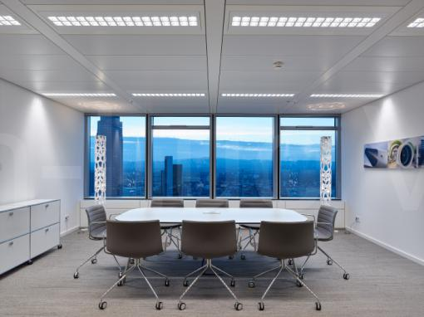
Photo 1: The design language of MIREL evolution and the neutral white light colour enhance the purist interior design of the conference floor of DVB Bank.
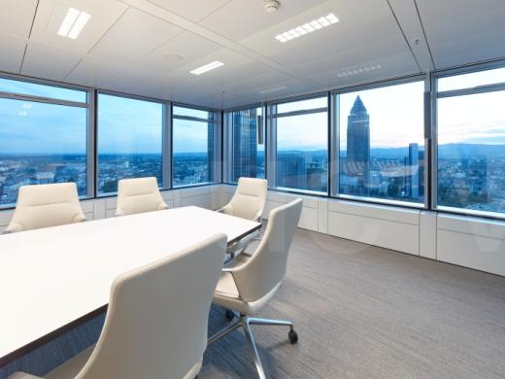
Photo 2: The glass facade fulfils an important double function, providing fantastic views far beyond the city limits of Frankfurt and allowing plenty of daylight to enter the building.
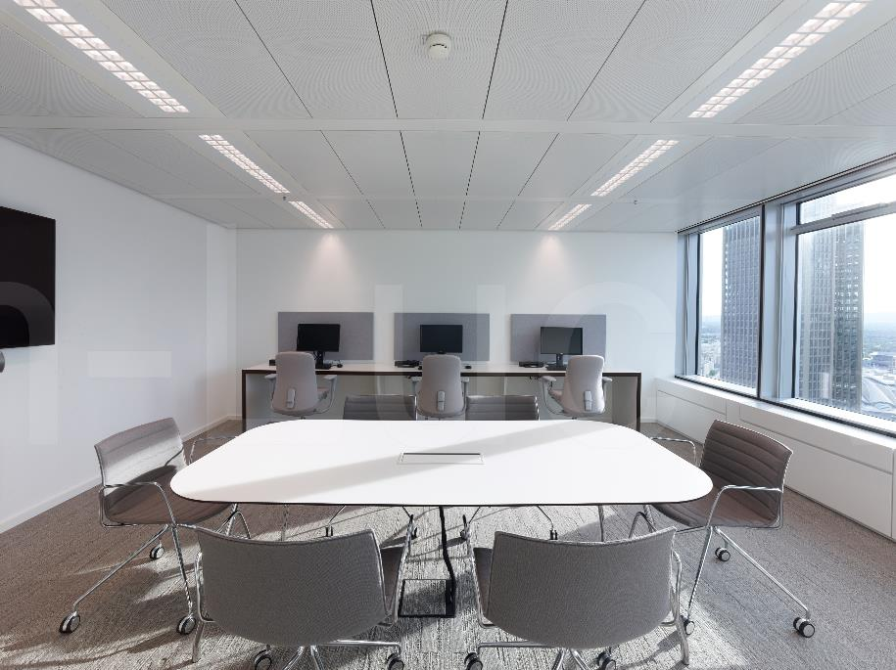
Photo 3: The lighting solution integrates seamlessly with the high-quality design of the conference level and creates an open and welcoming visual appearance.
Press contact:
Zumtobel Lighting GmbH  Andreas Reimann  Brand PR Manager  Schweizer Strasse 30  6850 Dornbirn  Austria  Phone: +43 5572 390 26522  press@zumtobel.com  www.zumtobel.com | Zumtobel Group  Jennifer Sewell  Marketing Communications Manager  Chiltern Park, Chiltern Hill  Chalfont St Peter, Buckinghamshire SL9 9FG  United Kingdom  Phone: +44 0 7785 232 294  jennifer.sewell@zumtobelgroup.com  www.zumtobel.com
Zumtobel Lighting Inc.
Donna Fischer
Marketing Manager Americas
Zumtobel Lighting US
3300 Route 9W
Highland, NY 12528
Phone: +1 845-691-6262 - 7611
donna.fischer@zumtobelgroup.com
www.zumtobel.us

About Zumtobel
As a leader in innovation, Zumtobel develops sustainable lighting solutions tailored to the needs of people in their respective applications. With a comprehensive portfolio of high-quality luminaires and intelligent lighting management systems, the Austrian company provides optimum indoor and exterior products for working and living spaces - the right light for every activity at any time of day. The applications office, education, presentation and retail, hotel and wellness, health, art and culture and industry are now perfectly complemented with portfolios for living and outdoor areas. Zumtobel is a brand of Zumtobel Group AG with its head office in Dornbirn, Vorarlberg (Austria).
Zumtobel. The Light.

