Press release
Dornbirn, November 2011

CV Daniel Libeskind
Architect. Designer. Mentor.
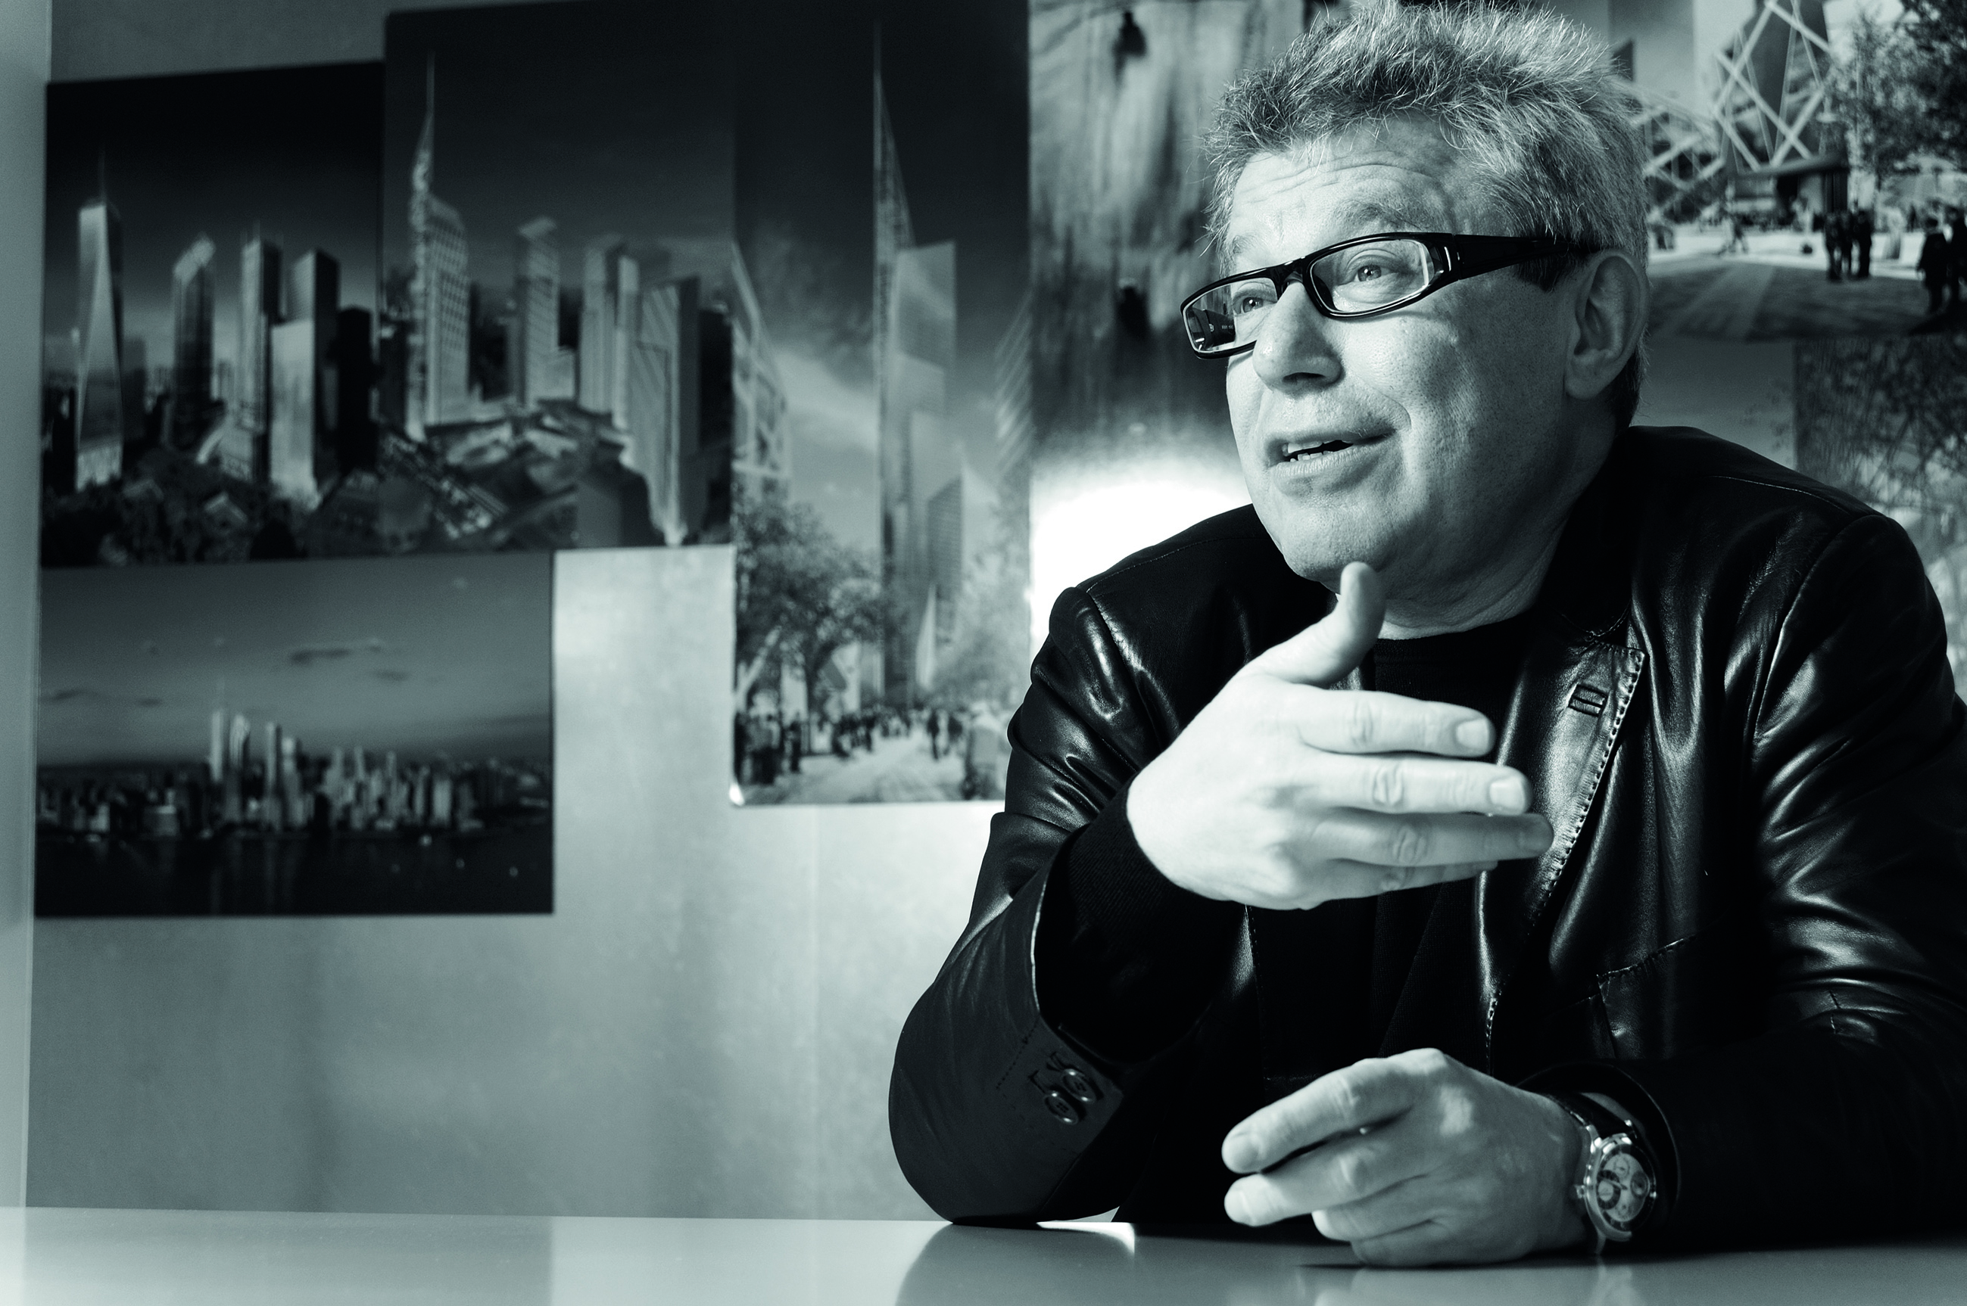
Life and work
Daniel Libeskind, B.Arch. M.A. BDA AIA, is an international architect and designer. Born in post-war Poland, Daniel Libeskind immigrated to America with his family becoming an American citizen in 1964. A virtuoso musician at a young age, he gave up music to study architecture. Mr. Libeskind went on to receive a degree in Architecture from the Cooper Union for the Advancement of Science and Art in New York City and a postgraduate degree in the History and Theory of Architecture from the School of Comparative Studies at Essex University in England. Libeskind established his architectural studio in Berlin, Germany in 1989 after winning the competition to build the Jewish Museum in Berlin. In February 2003, Studio Daniel Libeskind moved its headquarters from Berlin to New York City when Daniel Libeskind was selected as the master planner for the World Trade Center redevelopment.

Daniel Libeskind’s practice is involved in designing and realizing a diverse array of urban, cultural and commercial projects internationally. The Studio has a completed buildings that range from museums and concert halls to convention centers, university buildings, hotels, shopping centers and residential towers. In addition to the New York headquarters, Studio Libeskind has European partner offices based in Zürich, Switzerland and Milan, Italy.

Daniel Libeskind’s commitment to expanding the scope of architecture reflects his profound interest and involvement in philosophy, art, literature and music. Fundamental to Libeskind’s philosophy is the notion that building are crafted with the perceptible human energy, and that they address the greater cultural context in which they are built. Daniel teaches and lectures at universities across the world. He resides in New York City with his wife and business partner, Nina Libeskind.
Completed projects
Since establishing his practice in Berlin in 1989, Mr. Libeskind has designed major cultural, commercial and residential projects around the world. These include the master plan for the World Trade Center and the Jewish Museum Berlin. In October of 2011, his firm, Studio Daniel Libeskind, completed its redesign of what is now Germany’s largest museum, the Military History Museum in Dresden .The same month Hong Kong’s City University celebrated the opening of the Libeskind-designed Run Run Shaw Creative Media Centre. Other recent projects include the Grand Canal Theatre project, a major addition to Dublin’s docklands and the city’s cultural core; and Crystals at CityCenter, a 46,000-square-meter retail complex that is the centerpiece of MGM Mirage’s signature development on the Las Vegas Strip.
Current projects
Some Studio Daniel Libeskind projects that are currently under construction are:
- City Life’s redevelopment of the historic Fiera Milano Fairgrounds in Milan
- Kö-Bogen, an office and retail complex in Düsseldorf
- The L Tower in Toronto, a residential development in downtown Toronto
- Reflections at Keppel Bay, a 190,000 square metre residential development in Singapore;
- Zlota 44, a residential high rise in Warsaw
- Haeundae Udong Hyundai l’Park, a mixed-use development in Busan, South Korea.

Some projects that are in development include:
- Archipelago 21, the masterplan for the Yongsan International Business District in Seoul South Korea
- The Institute for Democracy & Conflict Resolution, for the University of Essex in England
- Vitra, a residential tower in Sao Paulo, Brazil
- The Central Deck and Arena in Tampere, Finland, a mixed-used development that contains an ice hockey arena.
- The Zhang Zhidong and Modern Industrial Museum in Wuhan, China.

Recognition & teaching
Among the many Libeskind buildings that have received worldwide acclaim are The Felix Nussbaum Haus, in Osnabrück, Germany (1998); the Imperial War Museum North in Manchester, England (2002); the extension to the Denver Art Museum and the Denver Art Museum Residences (2006), the Royal Ontario Museum (2007) and the Glass Courtyard, an extension to the Jewish Museum Berlin,(2007); the Ascent at Roebling’s Bridge, a residential high-rise in Covington, Kentucky (2008); the Contemporary Jewish Museum in San Francisco (2008); and Westside, Europe’s largest retail and health center, located in Bern, Switzerland (2008).

Mr. Libeskind has taught and lectured at many universities worldwide. He has held such positions as the Frank O. Gehry Chair at the University of Toronto, Professor at the Hochschule für Gestaltung, Karlsruhe, Germany, the Cret Chair at the University of Pennsylvania, and the Louis Kahn Chair at Yale University. He has received numerous awards including the 2001 Hiroshima Art Prize — an award given to an artist whose work promotes international understanding and peace, never before given to an architect.

Zumtobel. The Light.

Brief profile
The Zumtobel brand is a leading international supplier of integral lighting solutions that enable people to experience the interplay of light and architecture. As a leader in innovation, the luminaire manufacturer provides a comprehensive range of high-quality luminaires and lighting management systems for the most varied application areas of professional interior lighting – including offices and educational facilities, retail and presentation, hotels and wellness, health and care, art and culture as well as industry and engineering. Zumtobel is a brand of the Zumtobel AG group with its head office in Dornbirn, Vorarlberg (Austria).

Captions:
Photo 1: Architect Daniel Libeskind (c) Michael Klinkhamer Photography

For more information, please contact:
Zumtobel Lighting GmbH
Nadja Frank
PR Manager
Schweizer Strasse 30
A-6851 Dornbirn
Tel. +43-5572-390-1303
Fax +43-5572-390-91303
E-mail: nadja.frank@zumtobel.com
www.zumtobel.com

