Press release

Zumtobel wins intermedia-globe gold award at the WorldMediaFestival

Dornbirn/Hamburg, May 2013 - On 15 May 2013, the World Media Award ceremony took place in the context of the WorldMediaFestival in Hamburg. The Zumtobel image film won an intermedia-globe gold award in the “Public Relations /Company Philosophy and Portrait” category. The Boros agency and the Zeitsprung Commercial GmbH film production company jointly created a 1:30-minute film, which is impressive in terms of both visual effects and narrative.
“We want to use light to create worlds of experience, make work easier and improve communications and safety while always remaining fully aware of our responsibility to the environment. The film communicates this message very successfully and in accordance with the taste of its target group,” says Stefan von Terzi, Director Marketing Zumtobel, who is very pleased about the award.
The plot revolves around the modern urban individual of the 21st century and the role light plays in his everyday life. Live footage cleverly combined with 3D animations shows how lighting solutions adjust to the respective situation and people's needs in a world of change. The audience follows a man on his way through everyday life, witnessing how light makes living and working easier, enhancing his sense of well-being while increasing the building's energy efficiency. It is an impressive and emotional story of how Zumtobel seeks to provide optimum lighting quality for people while protecting the environment. “A good corporate production not only communicates messages but also reflects a deep understanding of the target group addressed and its needs. The Zumtobel image film is a great example of how companies use state-of-the-art technology to improve modern people's quality of life,” explains Christian Boros, CEO and Creative Director of the Boros agency, the concept behind the film.

About the World Media Award
The intermedia-globe awards are presented in the context of the the WorldMediaFestival, an international competition for communication media, which is one of the most important events in the sector. The intermedia-globe awards honour outstanding solutions in the areas of corporate film, television, web, web TV and print productions at international level.

Responsible for production:
Zumtobel Lighting GmbH, Dornbirn (client): | Stefan von Terzi, Director Marketing Zumtobel  Martin Finkmann, project management
Boros GmbH, Wuppertal (idea) | Christian Boros, CEO & Creative Director  Martina Schiffer-Gottfried, Project Manager  Guido Halfmann, Copy
Zeitsprung Commercial GmbH, Cologne (film production): | Oriol Puig & Reto Caffi (Director)  Selim Sevinc, Executive Producer  Ralf M. Mendle, D.o.P.  Sabine Schwedhelm, casting
Tracks & Fields (music) | Erik and Vera Ohl
Trizz, Barcelona  (visual effects and 2D & 3D design) | Christopher Vulpi, Executive Producer

Film and pictures:

(Credits: Zumtobel)

http://www.zumtobel.com/video

Image 1:

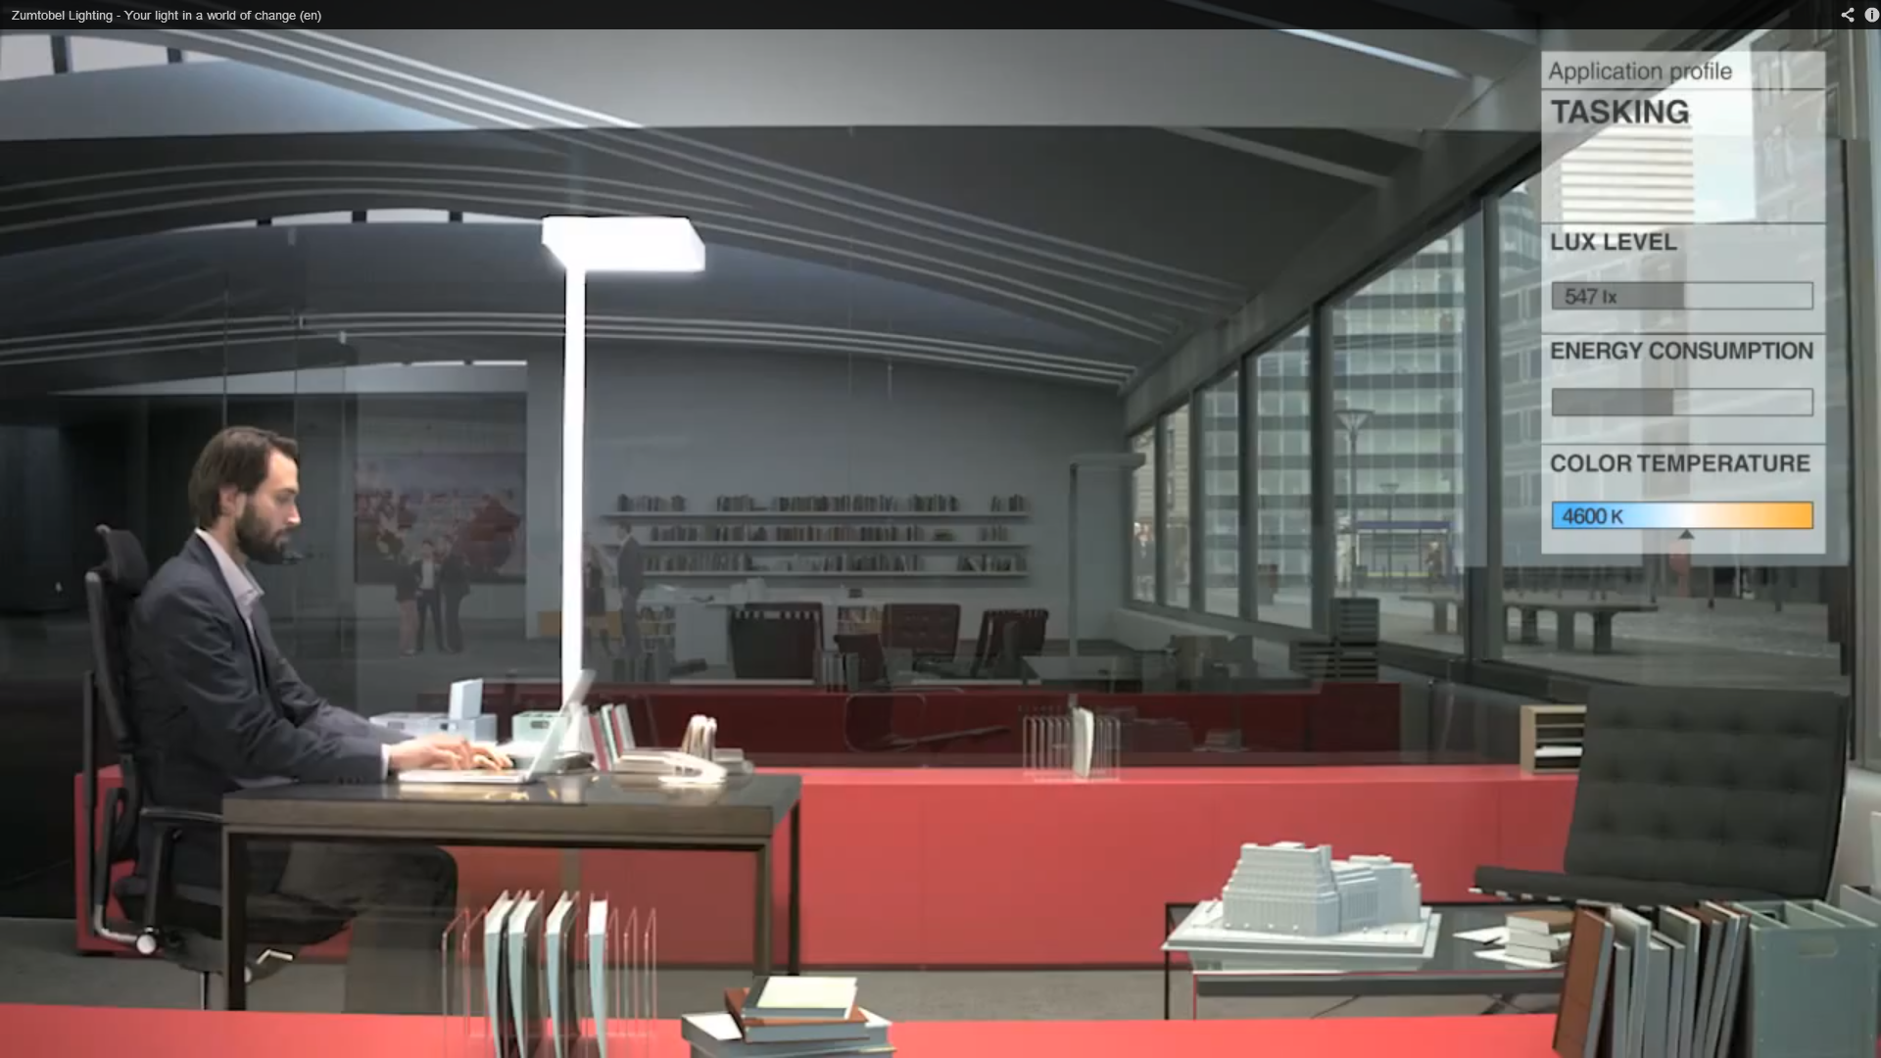

Image 2:

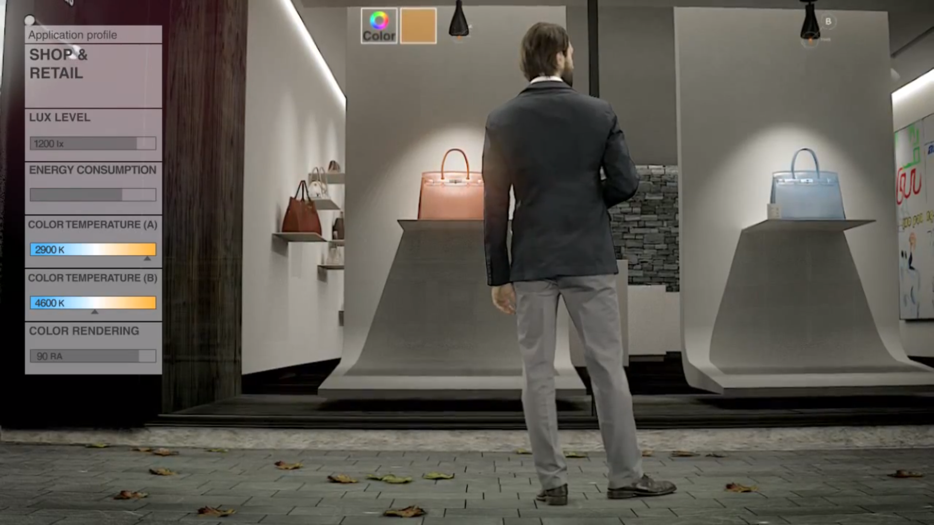

Image 3:

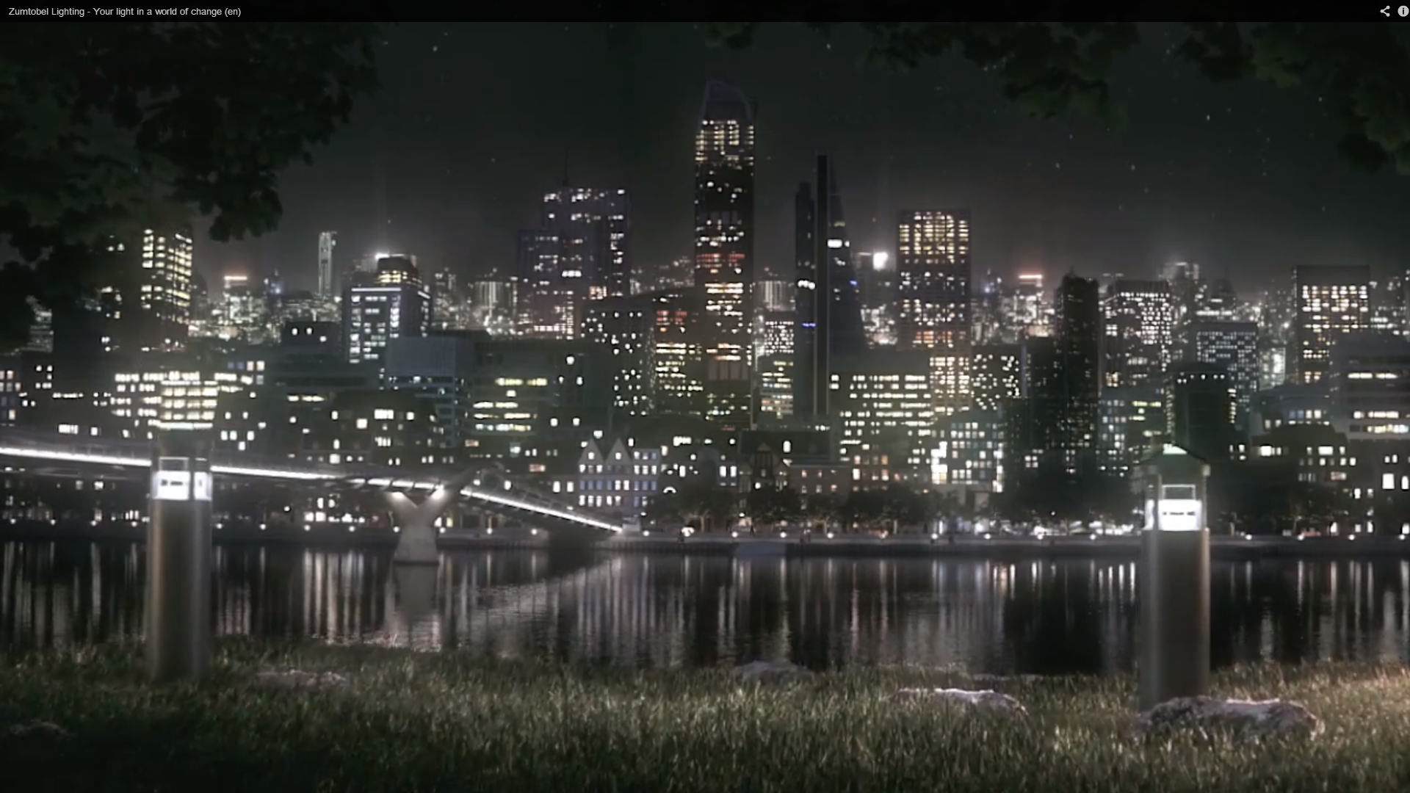

For more information, please contact:

Zumtobel Lighting GmbH

Nikolaus Johannson
Head of Brand Communication

Schweizer Strasse 30
A-6851 Dornbirn

Tel. +43-5572-390-26427
Mobile +43-664-80892-3202
E-mail nikolaus.johannson@zumtobel.com
www.zumtobel.com

About Zumtobel
Zumtobel is a leading international supplier of integral lighting solutions that enable people to experience the interplay of light and architecture. As a leader in innovation, the luminaire manufacturer provides a comprehensive range of high-quality luminaires and lighting management systems for the most varied application areas of professional interior lighting – includ-ing offices and educational facilities, presentation and retail, hotels and wellness, health and care, art and culture as well as industry and engineering. Zumtobel is a brand of Zumtobel AG with its head office in Dornbirn, Vorarlberg (Austria).

Zumtobel. The Light.

