Press release
Dornbirn, November 2011

Modern Internet presence
Zumtobel is going live with its new website

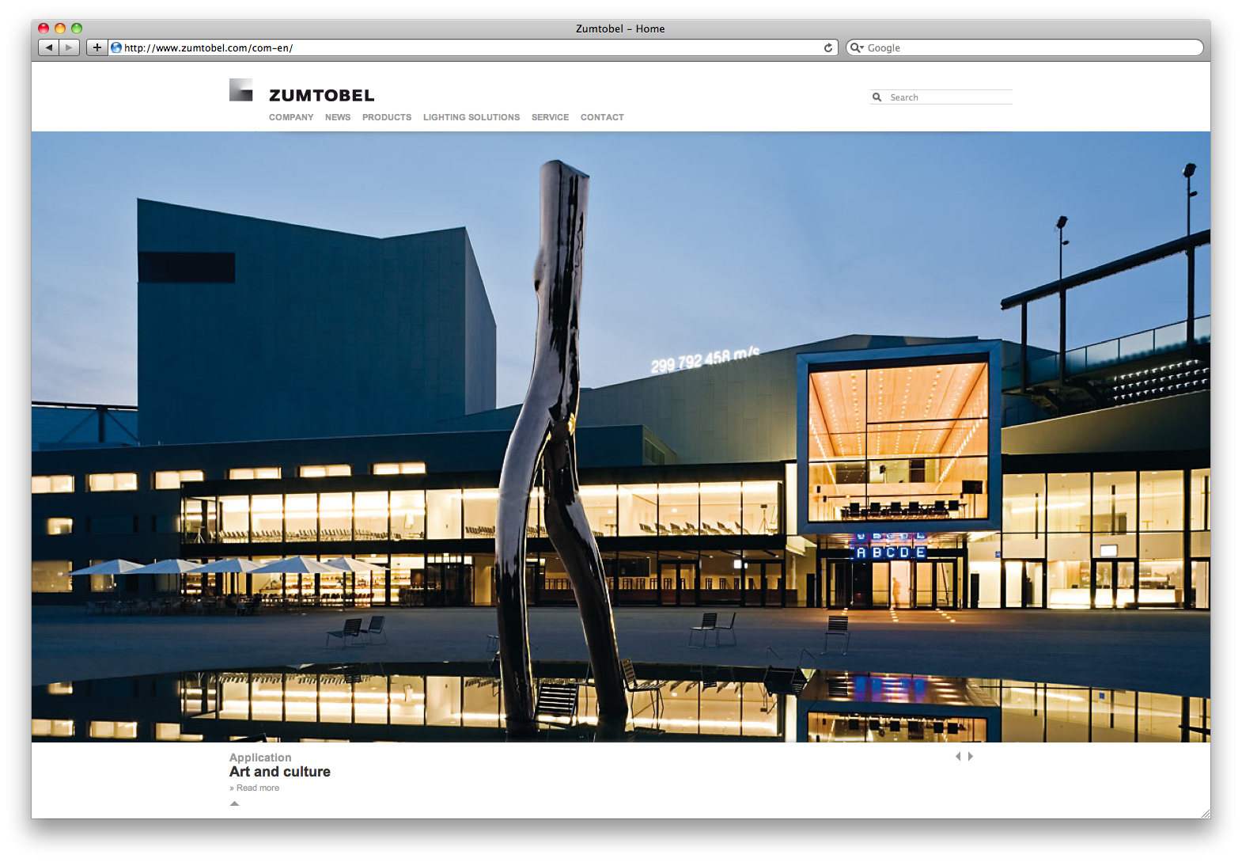
As a leader in innovation, Zumtobel keeps it rolling in the digital world as well. Since the end of November, the luminaire manufacturer has been present on the Internet with a new website which not only features a contemporary design but is also extremely user-friendly.

The new website blends harmoniously into the overall presence of the international organisation. Easy to use, informative and entertaining – these were the main goals implemented in the context of Zumtobel's online presence.

The new website ensures clear menu-driven operation and intuitive navigation through the various contents. In the very comprehensive product section in particular, care has been taken to provide users with all product information directly on one page.

A clear navigation structure as well as a powerful search function ensure that current product and company information can be found easily.As soon as the first letters of a search string are entered, e.g. the product range or order number, an illustrated list of search results is displayed via the auto suggest function. For website visitors, this means significantly shorter time to get information, speeding up their work.
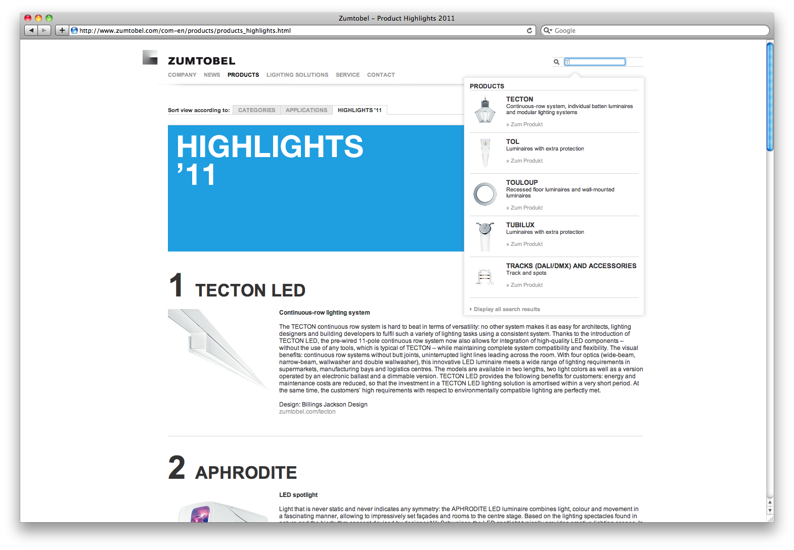
Last but not least, another important criterion of the website is its entertainment factor: to entertain visitors, Zumtobel mainly uses picture galleries in large format and interactive features such as videos and animations, for instance. The interactive world map, the Map of Light, has also been integrated into the new website, showing projects implemented all over the globe. Users can independently navigate through the world map, look at individual lighting solutions and download them in pdf format. The website features numerous download functions, making it easy for visitors to download interesting contents and save them on their local PC.
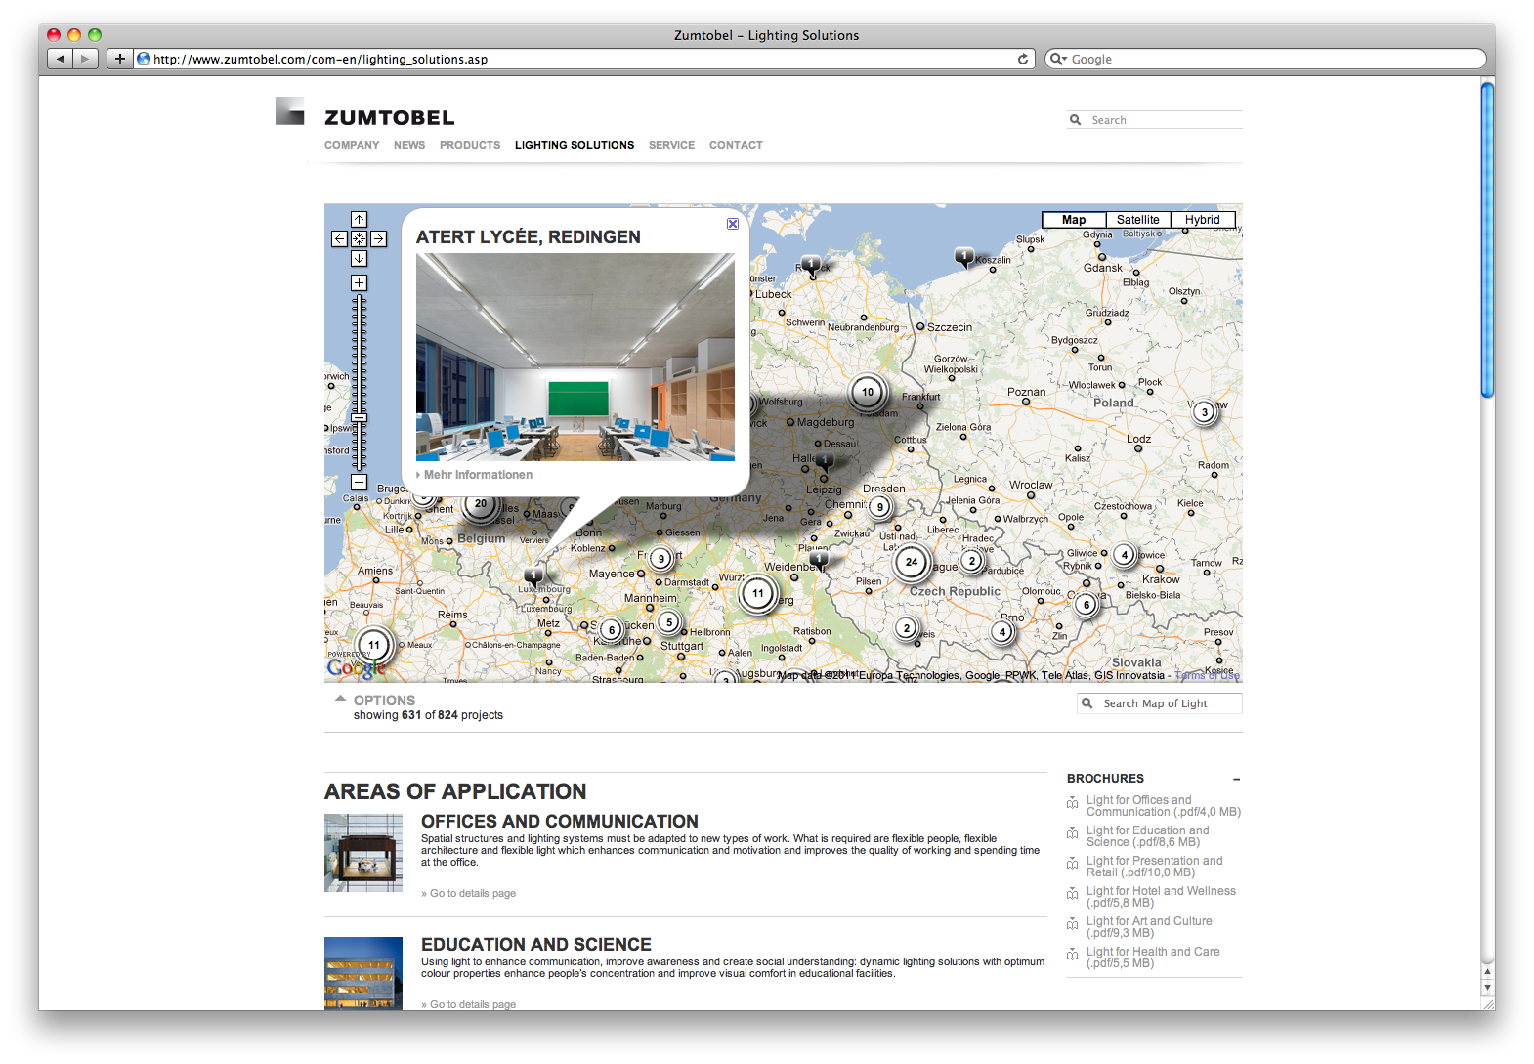
Zumtobel's new Internet presence is entirely based on advanced standards such as HTML 5, making it ideal for use with iPads and mobile terminal units. Moreover, the complete product catalogue has been designed for mobile use. To this end, all the user needs to do is go to http://mobile.zumtobel.com (or the page of the respective country, e.g. http://mobile.zumtobel.de) via his mobile device’s browser. This means that architects, designers and electricians can access important product information at any time, even if they are not in their offices.

When implementing the website, use across various media was also taken into account: the online product catalogue, for instance, can be accessed directly via QR codes printed on brochures, catalogues and product packaging.
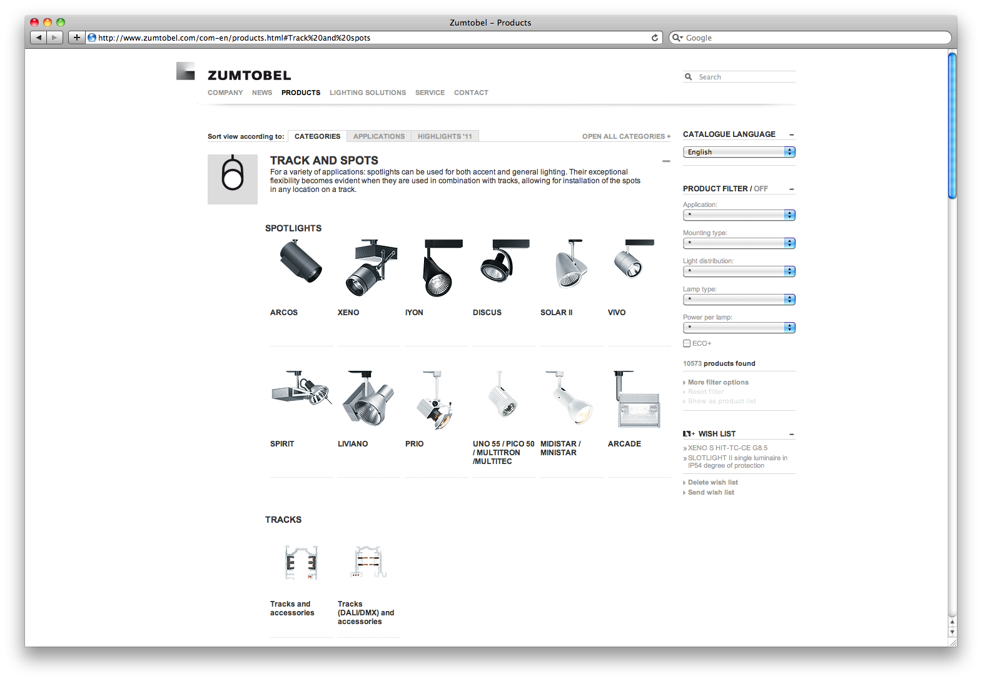
The German-English website www.zumtobel.com has been implemented completely in line with Zumtobel's new presence. The country pages for Austria (www.zumtobel.at), Germany (www.zumtobel.de) and the bilingual page for Switzerland (www.zumtobel.ch) are also online with immediate effect. All other country pages will be migrated successively. In due time for light+building in April 2012, the new website is scheduled to be available in the key languages, i.e. German, English, Italian, French and Dutch.

Zumtobel. The Light.

Captions:
B1_ Thanks to implementation based on advanced standards like HTML 5, the website can also be accessed via iPad and mobile terminal units.

B2_In the very comprehensive product section in particular, care has been taken to provide users with all product information directly on one page.

B3_ Website visitors can let themselves be inspired by large-format picture galleries, interactive features such as videos and animations, and the lighting solutions on the “Map of Light”.

B4_ The new website's clear navigation structure and powerful search function provide information much more quickly.

Publication of this document is free if due acknowledgement is made: Zumtobel

For more information, please contact:
ZumtobelLighting GmbH
Nadja Frank
PR Manager

Schweizer Strasse 30
A-6851 Dornbirn
Tel. +43-5572-390-1303
Fax +43-5572-390-91303
E-mail: nadja.frank@zumtobel.com
www.zumtobel.com

