Press release
Dornbirn, April 2012

Zumtobel is showing trend-setting lighting solutions at Light+Building 2012
Your Light in a World of Change – a new quality of light

In a constantly changing world, the requirements placed on advanced lighting systems are also becoming more exacting. Zumtobel is squaring up to this challenge with an innovative, intelligent and sustainable product portfolio.

In an age of technological, economic and societal change, the world in which we live and work is undergoing fundamental change. It is against this backdrop that Zumtobel is unveiling future-oriented lighting solutions at Light+Building 2012 under the watchword "Your Light in a World of Change": solutions that are adaptable, user-centred and in harmony with the environment. In a context like this, the quality of space and lighting becomes a crucial success factor for people and companies alike. Drawing on its extensive knowledge of light and its effects, as well as current trends and their impact on the way in which light is used, Zumtobel is presenting lighting solutions that offer customers measurable added value at Light+Building 2012:

- Intelligent lighting solutions that can adapt to meet particular needs, thus improving well-being, health, productivity and space utilisation.
- Sustainable lighting solutions that reconcile lighting quality and energy efficiency, cut costs and make buildings more energy efficient and more environmentally friendly.
- Highly communicative lighting solutions that help companies worldwide use light to create an identity of their own and convey corporate messages in a targeted manner.

Stefan von Terzi, Zumtobel's Marketing Director, explains: "In a world that is shaped by constant change, the success of a lighting solution no longer depends only on the functionality of luminaires or their control system. Success depends much more on the adaptability of lighting solutions and whether they manage to meet the customer's expectations. For us, this means providing our customers with a new quality of light: light that responds intelligently and adapts to changes in users' environments and their needs. Our ambition is always to provide customers with the best lighting quality and optimum energy efficiency."

Zumtobel. The Light.

Brief profile
Zumtobel is a leading international supplier of integral lighting solutions that enable people to experience the interplay of light and architecture. As a leader in innovation, the luminaire manufacturer provides a comprehensive range of high-quality luminaires and lighting management systems for the most varied application areas of professional interior lighting – including offices and educational facilities, presentation and retail, hotels and wellness, health and care, art and culture as well as industry and engineering. Zumtobel is a brand of the Zumtobel group with its head office in Dornbirn, Vorarlberg (Austria).

For more information, please contact:

Zumtobel Lighting GmbH Zumtobel Lighting GmbH
Nikolaus Johannson Nadja Frank
Head of Brand Communication PR Manager
Schweizer Strasse 30 Schweizer Strasse 30
A-6850 Dornbirn A-6850 Dornbirn

Tel. +43-5572-390-26427 Tel. +43-5572-390-1303
Fax.+43-5572-390-926427 Fax.+43-5572-390-91303
nikolaus.johannson@zumtobel.com nadja.frank@zumtobel.com
www.zumtobel.com www.zumtobel.com

Captions:
Credits: Zumtobel
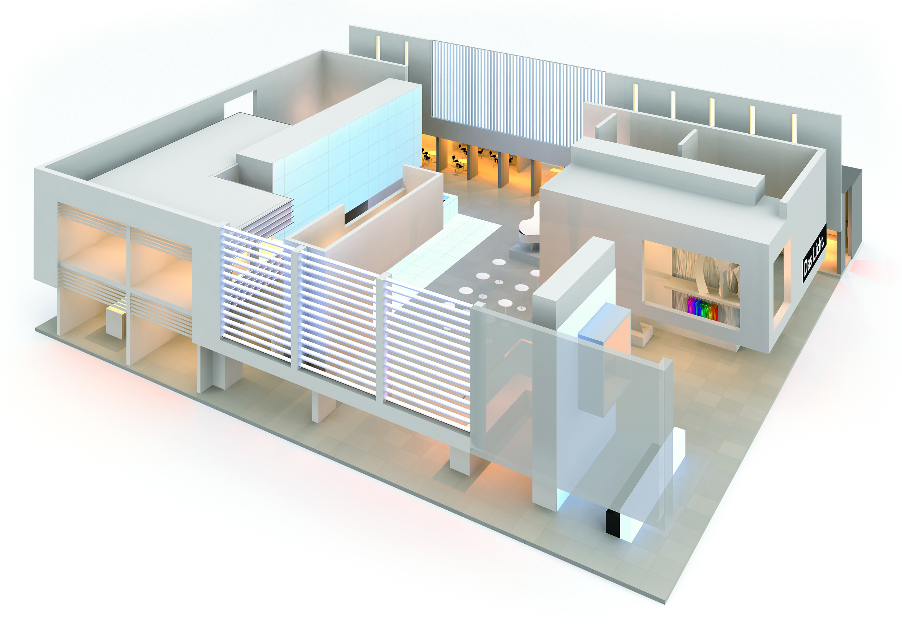

Caption 1: “Your Light in a World of Change”: the Zumtobel stand at Light+Building will focus on future-oriented lighting solutions for a world determined by change

