Press release
Dornbirn, May 2012

Glowing mountains
Zumtobel has made the new Salewa headquarters in Bolzano shine.

Thanks to the company's many years of experience and know-how, Zumtobel managed to integrate an innovative lighting concept into a completely new building concept. In the process, a new dimmable luminaire was developed in collaboration with the architects involved to achieve constant lighting conditions inside the building; what's more, the client's ambitious wish to use intelligent lighting for presenting the Salewa headquarters as a fountain of ideas, research and development was complied with.

Salewa is one of the market leaders for high-tech mountaineering equipment in Europe. Even the location of the new corporate headquarters reflects this position: the building designed by the Milan-based architects' studios Cino Zucchi Architetti and Park Associati is situated in Bolzano, at the foot of the “pale mountains”, as the Dolomites are often called due to the colour of their rocks.

Does it make any sense at all to build high-rise buildings in the Alps? Against the background of heated discussions in Bolzano, the architects managed to design a building which can be considered a shining example of urban construction. The multifaceted complex situated on the Mitterberg mountain blends in with the mountainous silhouettes surrounding the Bolzano Basin. Its vertical office towers are supplemented by horizontally aligned exhibition and storage facilities and the climbing hall. The smooth façade skin consisting of glass panels and perforated aluminium panels in three different grey scales can be perceived as a reference to the Dolomite mountains, which have been proclaimed a UNESCO World Natural Heritage site. In a considerate way, the construction respects the genius loci of the South Tyrolean landscape and enters into dialogue with it. The building complex extends its wings northwards, towards the town of Bolzano, generously welcoming guests and visitors. “A gate to Bolzano for all those coming via the motorway”, says Heiner Oberrauch, President of the Oberalp-Salewa Group. The glass façade of the office and exhibition spaces reveals a view across Bolzano and the mountains surrounding it.

A literally shining example is set by the building's sophisticated integral lighting concept developed by Zumtobel, the internationally renowned Austrian company. As it was a prerequisite that the staff should be able to see the Alpine world at any time, no blinds were installed to protect the office and exhibition rooms from the sun. Moreover, constant lighting conditions were required inside the building despite different daytime brightness levels. In order to meet these requirements, the dimmable IBLA luminaire was developed by Park Associati in collaboration with Zumtobel: the light it produces is not only indirectly reflected from the ceiling, it also directly illuminates the computer workstations, thus ensuring ideal lighting conditions without glare. The special folding of the luminaire made of mineral material corresponds to the building's architecture, reflecting it in miniaturised form. In the conference rooms, too, unobtrusive recessed luminaires were installed that offer variable lighting options to be used in a variety of ways, such as for meetings or video presentations; thanks to balanced light distribution, a bright and pleasant atmosphere is created in the rooms. From application examples and trials conducted by Zumtobel, we know beyond doubt that optimum room lighting not only improves the staff's well-being, but also enhances their performance and willingness to communicate. For the exhibition and reception rooms, uniform general lighting is provided by batten luminaires and focussed display lighting via spotlights, ensuring individual illumination of the Salewa products on display.

Of particular importance to the client was the building's appearance at night. As an expert of integral lighting solutions, Zumtobel was able to contribute its know-how in this respect as well. The lighting concept provides that the light comes from the glazed façade panels and the surface lighting of the closed structural elements made of aluminium and concrete, to the effect that the building is clearly, but discreetly presented as a laboratory of ideas, research and development.

The unusual design of the building accommodates a variety of functions under one roof: office and administrative rooms for some 160 staff members, storage rooms for logistics, the largest climbing gym in Italy for up to 250 climbers, a fitness room for staff members, a day nursery and a public meeting room. The design focused on the individual – above all the staff members. The South Tyrolean model company wants to set an example of an active life-style – this is especially important for a mountaineering expert. In addition, the building boasts an integral energy and lighting concept that was certified according to the renowned South Tyrolean “Climate House” concept; some parts of the building even achieved the highest level of certification: gold. As to building materials, care has been taken to reduce the transport routes and hence, the carbon footprint, as much as possible. 90 percent of the suppliers are located in the immediate vicinity. The solar panels on the building produce more energy than it needs. In addition, technologies for heat recovery, for heating and cooling the building with additional, controllable surface temperature adjustment resulted in potential reductions of 330 tonnes of CO₂ per year. This amazing value is achieved also thanks to a two-layer glass façade mounted in front of the load-bearing concrete elements for the ceiling and the pillars, which serves as back-ventilated thermal protection with sunscreen glazing on a steel structure.

Zumtobel. The Light.

Fact box:
Client: Oberalp Salewa/I
Architects: Cino Zucchi Architetti and Park Associati (Filippo Pagliani, Michele Rossi), Milan/I
Electrical consultants: Energytech, P.I. Gabriele Frasnelli, Bolzano/I

Lighting solution: IBLA special office luminaires, MELLOW LIGHT IV recessed luminaires, SLOTLIGHT II light lines, TECTON SLIMLINE continuous-row lighting system, LINARIA batten luminaires, PERLUCE recessed luminaires, LIVIANO spotlights, ONDARIA circular luminaires, ONLITE CPS emergency lighting system, PURESIGN escape-sign luminaires, RESCLITE LED emergency luminaires

Brief profile
Zumtobel is a leading international supplier of integral lighting solutions that enable people to experience the interplay of light and architecture. As a leader in innovation, the luminaire manufacturer provides a comprehensive range of high-quality luminaires and lighting management systems for the most varied application areas of professional interior lighting – including offices and educational facilities, presentation and retail, hotels and wellness, health and care, art and culture as well as industry and engineering. Zumtobel is a brand of the Zumtobel group with its head office in Dornbirn, Vorarlberg (Austria).

For more information, please contact:

Zumtobel Lighting GmbH Zumtobel Lighting GmbH
Nikolaus Johannson Nadja Frank
Head of Brand Communication PR Manager
Schweizer Strasse 30 Schweizer Strasse 30
A-6850 Dornbirn A-6850 Dornbirn

Tel. +43-5572-390-26427 Tel. +43-5572-390-1303
Fax +43-5572-390-926427 Fax +43-5572-390-91303
nikolaus.johannson@zumtobel.com nadja.frank@zumtobel.com
www.zumtobel.com www.zumtobel.com

Captions:
Credits: Zumtobel

Caption 1: ©Oskar da Ritz
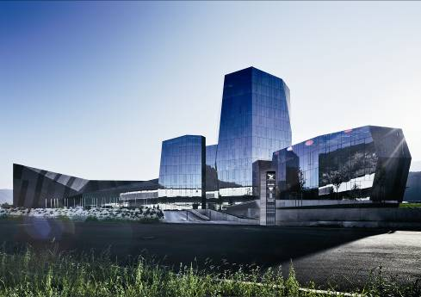
The distinctive architecture of the new Salewa headquarters blends naturally into the surrounding mountainous silhouette.

Caption 2:
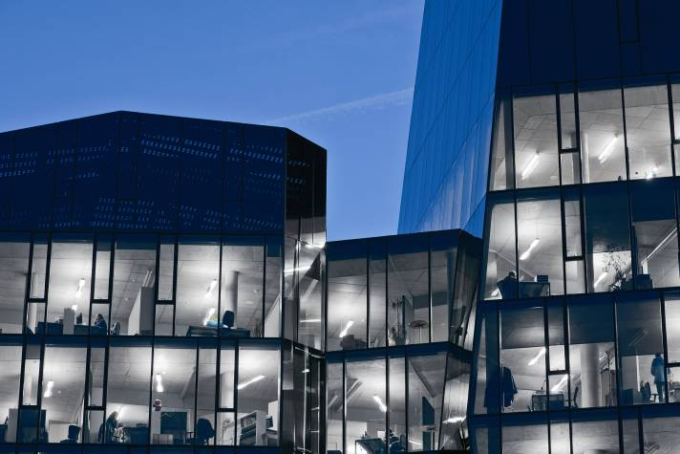
The IBLA special luminaires was developed by Studio Park Associati in collaboration with Zumtobel. Its design reflects the cubic structure of the building

Caption 3:
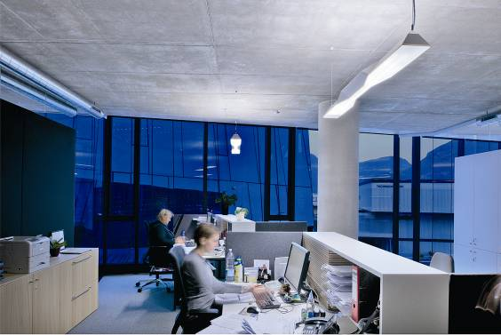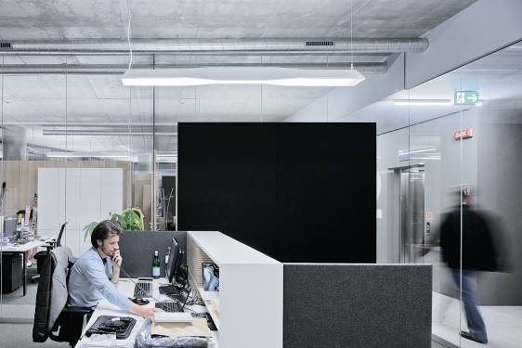
For the staff members to feel at ease at their workplaces, constant lighting conditions in the course of the day and glare-free illumination were required.

Caption 4:
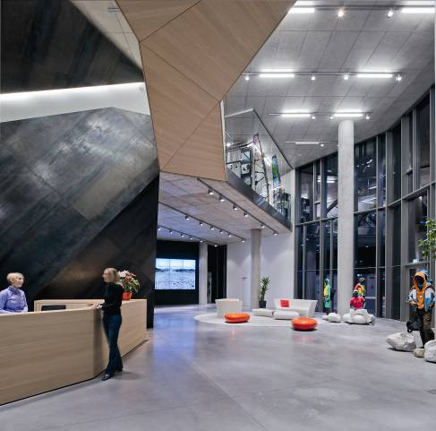
Salewa deliberately relies on an integral energy and lighting concept promoting sustainability.

Caption 5:
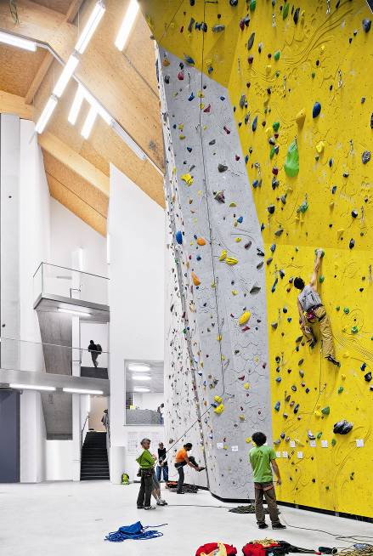
A giant climbing wall, also perfectly illuminated by Zumtobel luminaires, ensures an Alpine feeling inside.

