Press release

Overview of Zumtobel's autumn 2013 product innovations
LIGHT FIELDS evolution LED luminaire range
Dornbirn, November 2013 - Zumtobel presents the Light Fields evolution LED luminaire range for use in modern office environments involving a variety of requirements. Light Fields evolution combines clear design with innovative technology: the result is an LED luminaire range including recessed, pendant, surface-mounted, wall-mounted and free-standing luminaires in a uniform and slim design, perfectly in line with contemporary office architecture.
Perfect lighting quality for a variety of working situations is provided by the patented micro-pyramidal optic (MPO+). The optic's diffuser layer resolves the LED points perfectly, while the high-precision formed micro-pyramids ensure superior lighting quality. The luminaire elements feature innovative technologies providing the best light for workstations. The 3Dprotect reflector protects the LED modules, effectively preventing damage from electrostatic discharge during installation. In order to obtain a well-balanced relation between indirect and direct light, LED light is emitted upwards and downwards thanks to litePrint light guide technology. Two colour temperatures are available for the luminaire (3,000 K and 4,000 K). With a luminaire efficiency factor of up to 105 lm/W, the LED luminaire also makes a significant contribution towards sustainable added value.
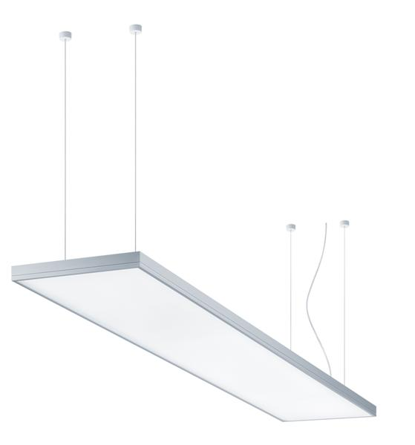
Image 1: Light Fields evolution combines clear design with innovative technology: the result is an LED luminaire range.
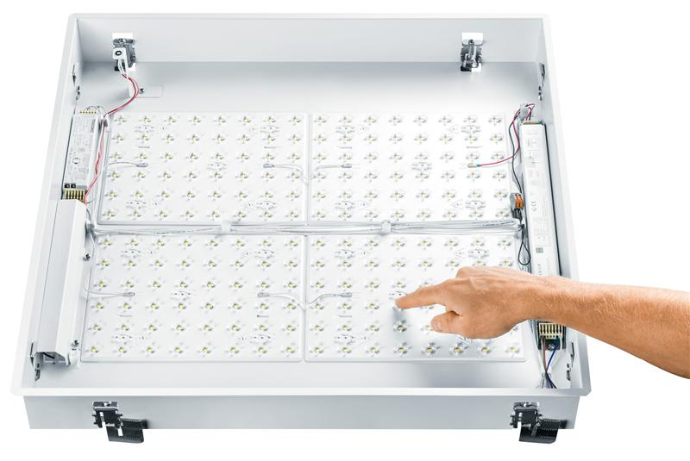
Image 2/3: The 3Dprotect reflector protects the LED modules, effectively preventing damage from electrostatic discharge during installation.

ARCOS Xpert LED spotlight
Thanks to its perfect lighting quality and innovative reflector technology, the Arcos Xpert LED spotlight cannot fail to impress in museums and art galleries. Due to the high colour rendering index of Ra 94 and the LEDs' narrow colour tolerance, artworks and exhibits can be illuminated authentically to provide visitors with a perfect art experience. The spotlight is optionally available in a warm (3,000 K) or intermediate (4,000 K) colour temperature. Flexibility is ensured by five different replaceable optics, four different lenses and two louvre options protecting against direct glare. Pinpoint superspot light distribution is used to highlight even the smallest details. This high-precision lighting is made possible by a patented tapering dual reflector made of PC developed in-house. The tried-and-tested design of the Arcos spotlight has been left unchanged to allow gallery owners and museum curators to easily extend their existing luminaire portfolio by the spotlight's LED model.
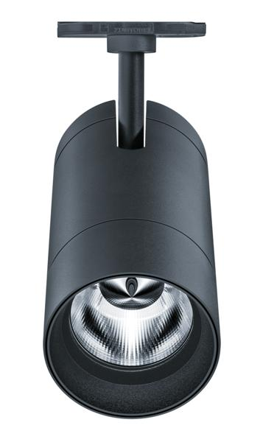
Image 4: Thanks to its perfect lighting quality and innovative reflector technology, the Arcos Xpert LED spot-light cannot fail to impress in museums and art galleries.

ARCOS LED wallwasher
For illuminating homogeneous areas, Zumtobel now also offers an LED version of the Arcos wallwasher. The wallwashers' uncluttered design language blends unobtrusively into the surrounding architecture, ensuring uniform illumination of vertical surfaces. Thanks to a sophisticated optical solution and constant colour temperature of light emitting diodes, the standard 620 mm version and the short 320 mm version of this dimmable linear wallwasher ensure uniform illumination. Zumtobel relies on top quality in terms of materials as well: the housing is made of extruded aluminium section, with die-cast aluminium front sides.
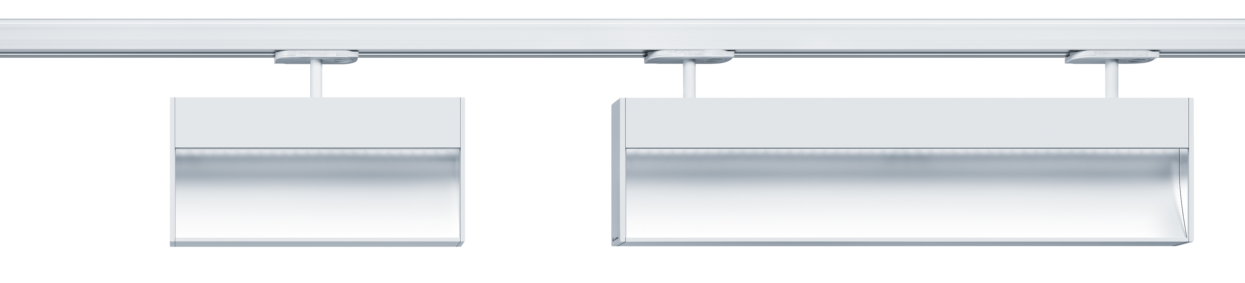
Image 5: The Arcos LED Wallwasher ensures the uniform illumination of vertical surfaces.

VIVO LED spotlight system
For accent lighting in shops and small retail spaces, Zumtobel has added the small Vivo XS spotlight to the Vivo spotlight system and now also offers an LED version of the Vivo M spotlight. This rounds out Zumtobel's LED spotlight range for retail lighting, which now includes suitable lighting solutions for small boutiques with low ceiling heights as well as for display windows and for shops with high ceilings, so that products can be set centre stage in a targeted manner.
The small size of the Vivo XS spotlight is made possible by a combination of compact LED modules and innovative cooling. When looking for a suitable design language, the EOOS designers let themselves be inspired by the shape of a turbine. Thus, the Vivo spotlight makes use of the airflow that is essential for cooling.
Vivo M, one of the most successful products in the Vivo spotlight range, is now also available as an LED version. Thanks to its excellent colour rendering index of more than Ra 90, glare-free light and especially uniform light distribution, the compact and versatile spotlight cannot fail to impress when used for shops or display windows.
IR and UV-free technology makes it possible to illuminate sensitive products, such as groceries for example, very gently. Thus, fruit and vegetables remain luscious, meat stays fresh and textiles retain their colours.
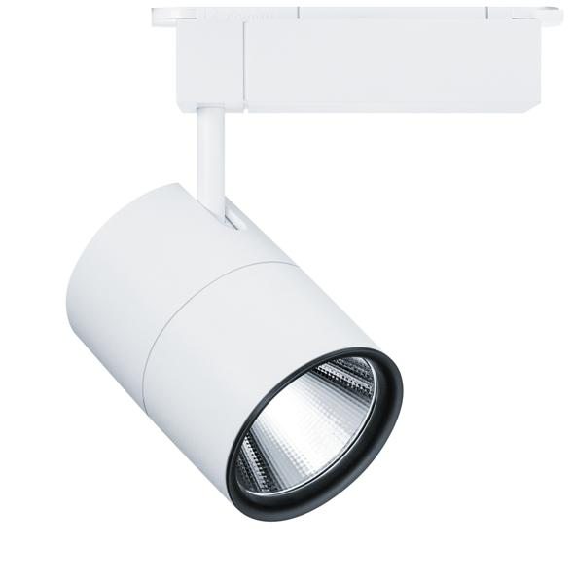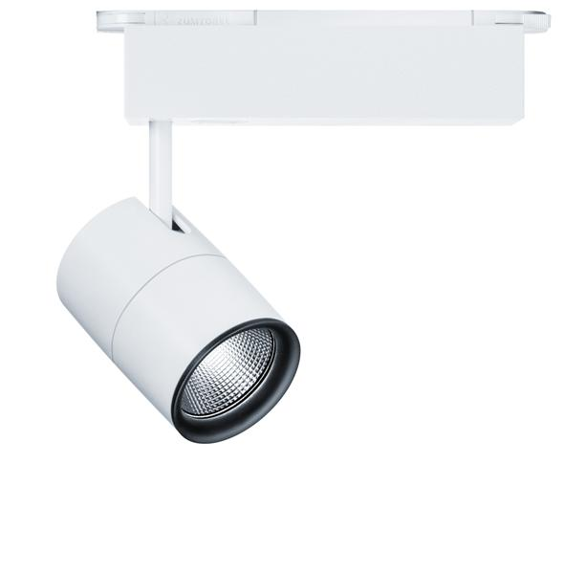
Image 6/7: For accent lighting in shops and small retail spaces, Zumtobel has added the small Vivo XS spot-light to the Vivo spotlight system and now also offers an LED version of the Vivo M spotlight.

Moisture-proof LED luminaires
Special conditions apply to car parks when it comes to lighting. In addition to the protection rating required (IP 65), the requirements in terms of material and quality are high as well. In addition to the existing portfolio of Chiaro II and Scuba LED moisture-proof luminaires, Zumtobel has now added models with higher luminous flux levels.
The Chiaro II 840 moisture-proof luminaire now optionally delivers 5,900 lm or 6,400 lm with a wattage of 54 W and is available in either an intermediate or cool colour temperature. Chiaro II achieves significant potential energy savings thanks to its luminaire efficiency factor of 109 lm/W at a colour temperature of 4,000 K or 118 lm/W at 6,500 K.
With an installed load of 54 W, Scuba LED now offers a choice of luminous flux levels of up to 5800 lm (Scuba LED 840) or up to 6300 lm (Scuba LED 765). Two colour temperatures are available depending on specific needs: 4,000 K or 6,500 K. In case of continuous operation, moisture-proof luminaires with a luminaire efficiency factor of up to 108 lm/W (Scuba LED 840) or up to 117 lm/W (Scuba LED 765) have proved to be efficient lighting solutions.
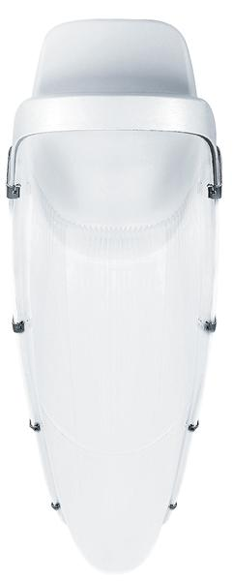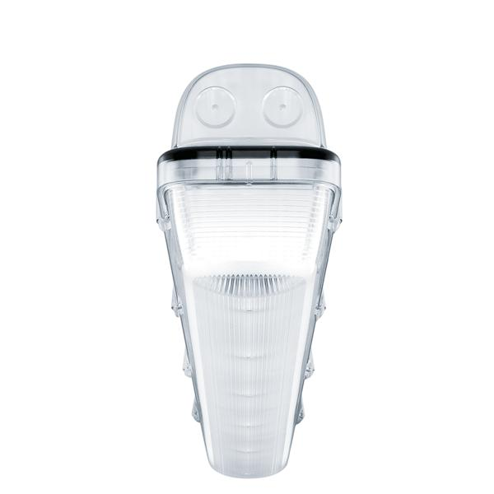
Image 8/9: The moisture-proof luminaires Scuba LED (left) und Chiaro II (right) now offer higher luminous flux levels

METRUM LED continuous-row lighting system
With Metrum LED, Zumtobel introduces an LED model of the lighting system. Metrum LED cannot fail to impress on account of its straightforward planning and installation. As trunking, luminaire and LED optic form a fixed luminaire unit, installation effort is significantly reduced. Available in two different lengths (2 m and 3 m) and with narrow-beam and wide-angle light distribution, Metrum LED is able to solve a wide variety of lighting tasks. The continuous-row lighting system features high colour rendering (Ra > 80) at an intermediate colour temperature of 4000 K.
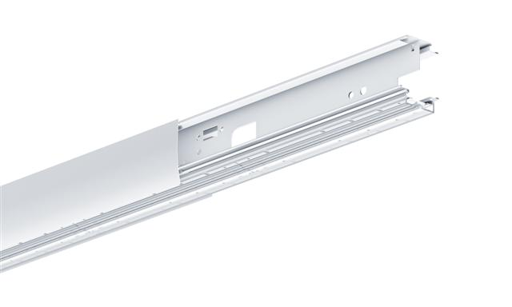
Image 10: Available in two different lengths (2 m and 3 m) and with narrow-beam and wide-angle light distribution, Metrum LED is able to solve a wide variety of lighting tasks.

CIELOS LED monocolor modular lighting system
Cielos uses diffuse wide-area lighting as a variable, malleable design feature, thereby producing an impressive effect. The LED modules in the new Cielos LED monocolor system ensure excellent light distribution and constant colour temperature. In particular reception areas or conference rooms appear in a positive light to the viewer. Available in two different sizes (600 mm or 900 mm), the square luminaire is the perfect solution for various applications and is also impressively cost-efficient.
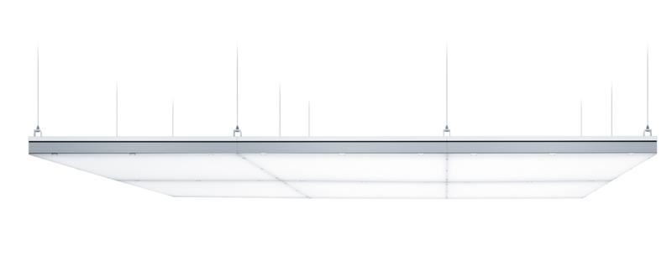
Image 11: The LED modules in the new Cielos LED monocolor system ensure excellent light distribution and constant colour temperature.
ECOOS LED pendant and surface-mounted luminaire
Ecoos LED meets exacting demands when it comes to design, efficiency and visual comfort: an innovative combination of micro-pyramidal optic (MPO+) and diffuser-pearl material enables unique 360° light distribution to ensure the best possible visual comfort and glare control in offices and classrooms. The timeless, sophisticated design of the luminaire adds a perfect flourish to any architectural and lighting design concept. Available as a pendant or surface-mounted LED luminaire in various lengths, this latest evolutionary iteration of ECOOS is particularly flexible in use. Installation using TECTON trunking provides even more scope for creative design. The luminaire is available in a warm or intermediate colour temperature. The LED version's luminaire efficiency factor of 74 lm/W also improves sustainability and cost effectiveness in professional applications.
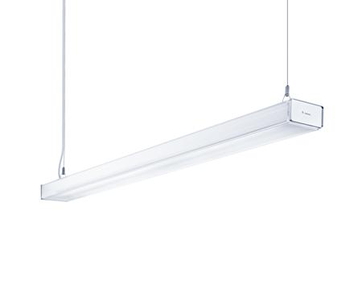
Image 12: An innovative combination of micro-pyramidal optic (MPO+) and diffuser-pearl material enables unique 360° light distribution.
LINCOR – pendant and surface-mounted LED luminaire
LINCOR's clear design language brings a linear look into offices. By its focus on technical essentials and its cross-sectional area of just 6 × 6 centimetres, the luminaire emphasises architectural ideas and blends seamlessly into various settings. The microprisms of the luminance-reducing optic (LRO) reduce harsh shadows in task areas and annoying reflections on screens. The surface-mounted version of LINCOR is the perfect solution for offices with low ceilings. A luminaire efficiency factor of more than 89 lm/W makes Lincor a sustainable office lighting solution.
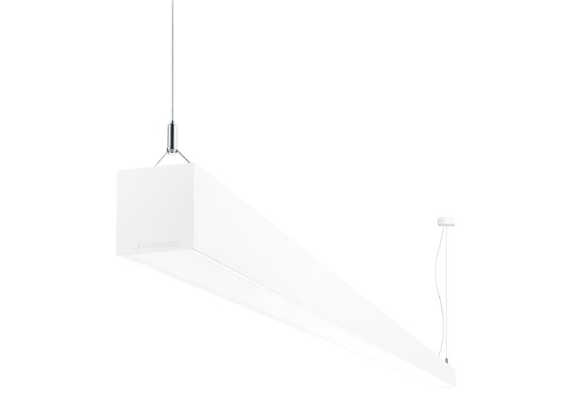
Image 13: By its focus on technical essentials and its cross-sectional area of just 6 × 6 centimetres, the luminaire emphasises architectural ideas and blends seamlessly into various settings.
SINUS LED medical supply unit
Zumtobel introduces Sinus, a flexible LED supply unit that meets various requirements in the health care sector. While doctors and care staff need ideal lighting conditions to perform treatments and examinations, patients need ideal lighting conditions to aid their convalescence. In addition, sustainability and energy efficiency are increasingly important factors, especially for operators and investors. The system can be flexibly adjusted to rooms with one to three patient beds. Fitted with innovative LED technology, Sinus provides room lighting (5940 lm per bed), examination lighting (6770 lm), reading light (830 lm) and night light (50 lm) combined in one medical supply unit. The LED room lighting with indirect light distribution creates a pleasant atmosphere in the patient room. Optionally, it can be positioned continuously anywhere over the entire length of the supply unit. The electrically adjustable LED reading light inside the horizontal Sinus supply unit allows even more flexibility when determining room layouts: the lighting can be adapted to suit the arrangement and number of beds in a patient room at the touch of a button. The high level of flexibility makes Sinus a medical supply unit that is fit for the requirements of today and tomorrow.
Components such as socket outlets, switches and phones, emergency nurse call buttons and data jacks for communications, as well as outlets for medical gases, are all unobtrusively housed in the Sinus system. This makes Sinus a functional supply unit which, thanks to its slimline design, is capable of making a significant contribution towards a feel-good atmosphere in patient rooms. The amortisation period of Sinus is reduced by its luminaire efficiency factor of 101 lm/W, its flexibility and long service life as well as the 5-year guarantee granted by Zumtobel for its products.
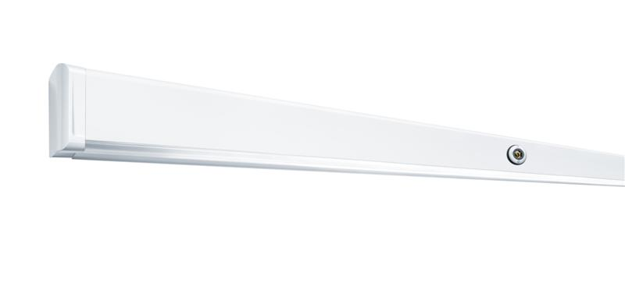
Image 14: Fitted with innovative LED technology, Sinus provides room lighting, examination lighting, reading light and night light combined in one medical supply unit.
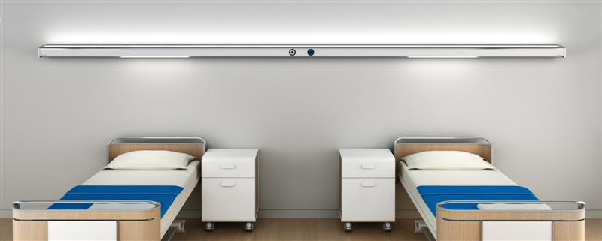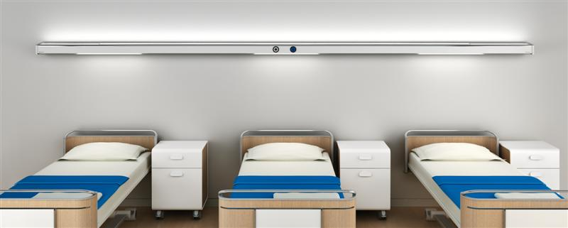
Image 15/16: The system can be flexibly adjusted to rooms with one to three patient beds.

Medical supply units and bedside luminaires featuring LED technology
The VE-L and Pureline II medical supply units and the IMWS integrated medical wall system as well as the Pureline II and Belia bedside luminaires are now also available with LED technology. The low maintenance effort and long service life of LED systems are not only impressive in economic terms; these solutions also have a positive impact on a room's ambience and deliver light that is perfectly adjusted to suit various situations in accordance with EN 60598-2-25 standards – from examination through to reading light.
Configuration of luminaire models using myPRODUCT
Zumtobel now provides the option of configuring one's own luminaire on the company's website according to individual requirements. Select a product range on the website, go to the Configurator and choose the appropriate options to suit the functions matching your individual project requirements from a wide variety of additional options. The portfolio offered in the product catalogue has thus been extended by more than 1,000,000 options.
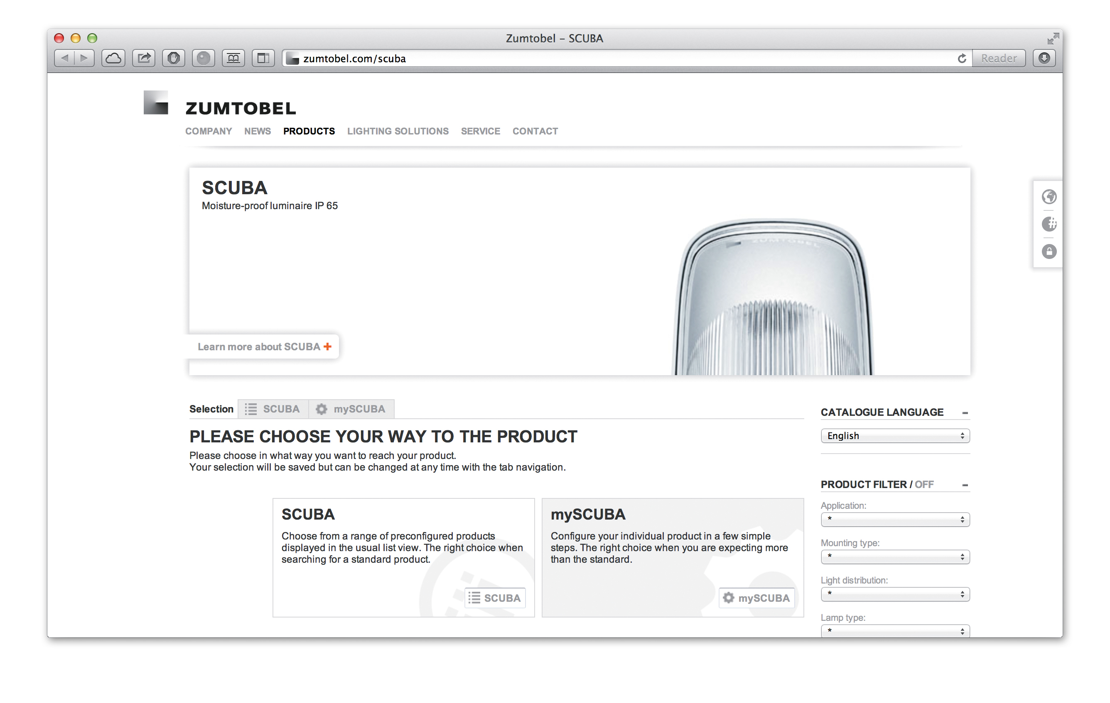
Image 17: With myProduct, the portfolio offered in the product catalogue has thus been extended by more than 1,000,000 options
For more information, please contact:
Zumtobel Lighting GmbH  Nikolaus Johannson  Head of Brand Communication  Schweizer Strasse 30  A-6851 Dornbirn  Phone: +43 (0) 5572 390-26427  Mobile: +43-(0)-664-80892-3202  E-mail: nikolaus.johannson@zumtobel.com  www.zumtobel.com | Zumtobel Lighting GmbH  Sophie Moser  PR Manager  Schweizer Strasse 30  A-6851 Dornbirn  Phone: +43-5572-390-26527  Mobile: +43-664-80892-3074  E-mail: sophie.moser@zumtobel.com  www.zumtobel.com

About Zumtobel
Zumtobel is a leading international supplier of integral lighting solutions that enable people to experience the interplay of light and architecture. As a leader in innovation, the luminaire manufacturer provides a comprehensive range of high-quality luminaires and lighting management systems for the most varied application areas of professional interior lighting – including offices and educational facilities, presentation and retail, hotels and wellness, health and care, art and culture as well as industry and engineering. Zumtobel is a brand of Zumtobel AG with its head office in Dornbirn, Vorarlberg (Austria).

Zumtobel. The Light.

