Press release

Differentiated retail lighting solutions
In a laboratory study conducted by Zumtobel and Gruppe Nymphenburg it has been possible to measure people's affective responses to various lighting scenarios in shops on an empirical basis. The findings of this study will help to develop lighting concepts for retail, to present goods perfectly and to increase the customers' sense of well-being, thus making them stay in the shop longer. Building on these research findings, Zumtobel is extending its product portfolio with LED lighting solutions suitable for various shop scenarios.
Dornbirn, February 2014 – Light is an indispensable tool for presenting brands and products effectively in retail settings. In addition to brand-appropriate, authentic presentation, energy efficiency also plays a crucial role when it comes to implementing shop and retail lighting concepts. The Intro modular lighting system incorporates different types of luminaires that use the very latest LED technology, and offers retailers an efficient lighting solution that can be fully customised to cater for various areas of a store: from shop windows, shelves and recesses through to activity spaces – Intro can be used in any area.
liteCarve® - first vertical flood-spot made possible by new reflector technology
liteCarve© reflector technology developed by Zumtobel offers extreme design precision. This freeform reflector (patent pending) allows extremely precise, well-balanced rectangular light distribution, right up to the outermost peripheries. Mounted in front of a single LED (CoB) point light source, the reflector directs 100% of the light indirectly in a targeted manner and makes it possible to bring vertical surfaces alive: this allows uniform, efficient illumination, not only of displays, but also shelves, large posters, recesses and specific wall areas. This system spotlight has established a completely new product category – the vertical flood-spot or vertical wallwasher. The system can also be fitted with other gimbal-mounted spotlights, depending on the particular lighting task in hand. This means that merchandise in shops is superbly presented to customers – attention is focused on the areas that are to be highlighted
Separate lighting modules and installation frames allow designers and architects plenty of creative scope: a large number of possible combinations on the ceiling underscore Intro's great flexibility. Zumtobel offers the system in single, double and triple units, as well as in lighting channel form. All the spotlight modules can be fitted with different front ring versions that are available in white, black, matt silver, chrome and copper as required. There are virtually infinite customisation options. All RAL colour hues are possible as special versions. Intro's modular design and the possibility of integrating various different spotlights provide a lighting solution that is tailor-made for efficient LED technology, offers plenty of customisation options, and specifically caters for setting the perfect stage for brands. This enables retailers to implement brand scenarios that are consistently configured to address a particular target group.
TrueGamutRendering (TGR) technology – A new level of quality for fashion lighting
White light plays a really significant role in achieving authentic retail presentation because light is the most important component when it comes to perceiving and evaluating goods. TGRfashion technology has enabled Zumtobel to achieve new levels of shop lighting quality. It lends a fresh quality to white, light but also to a brilliant appearance of bright colours. TGRfashion displays white colours with particular purity, and the LED spotlight emphasises and differentiates the various properties of different materials. At the same time, this technology makes it possible to present colours really vividly. This technology is initially available in the size M IYON LED spotlight, which provides a luminous flux of more than 2000 lm.
FACTOR: reduced complexity and high lighting quality
Zumtobel has added Factor, a modular LED spotlight, to its product range for shops and retail areas. Factor combines reduced complexity with great lighting quality and is available in two design versions: its conical or cylindrical housing provides plenty of creative scope for implementing retail lighting solutions. To ensure flexibility, it is installed on a 3-phase track or on Metrum, Zumtobel's simple continuous-row system: Factor spotlights can be repositioned without fuss if a shop needs to be redesigned. Factor is optionally available in a warm (3000K) or intermediate white (4000K) colour temperature to ensure presentation that matches specific merchandise.
Facts & figures
INTRO | Designed as single, double or triple  units or as a lighting channel  liteCarve reflector allows vertical flood-spot  Colour temperature 3000 K or 4000 K
FACTOR | Installed on 3-phase track or  METRUM  Colour temperature 3000K or 4000K
IYON TGRfashion | IYON LEM  Luminous flux of luminaire > 2000 lm

Captions:
(Photo credits: Zumtobel)
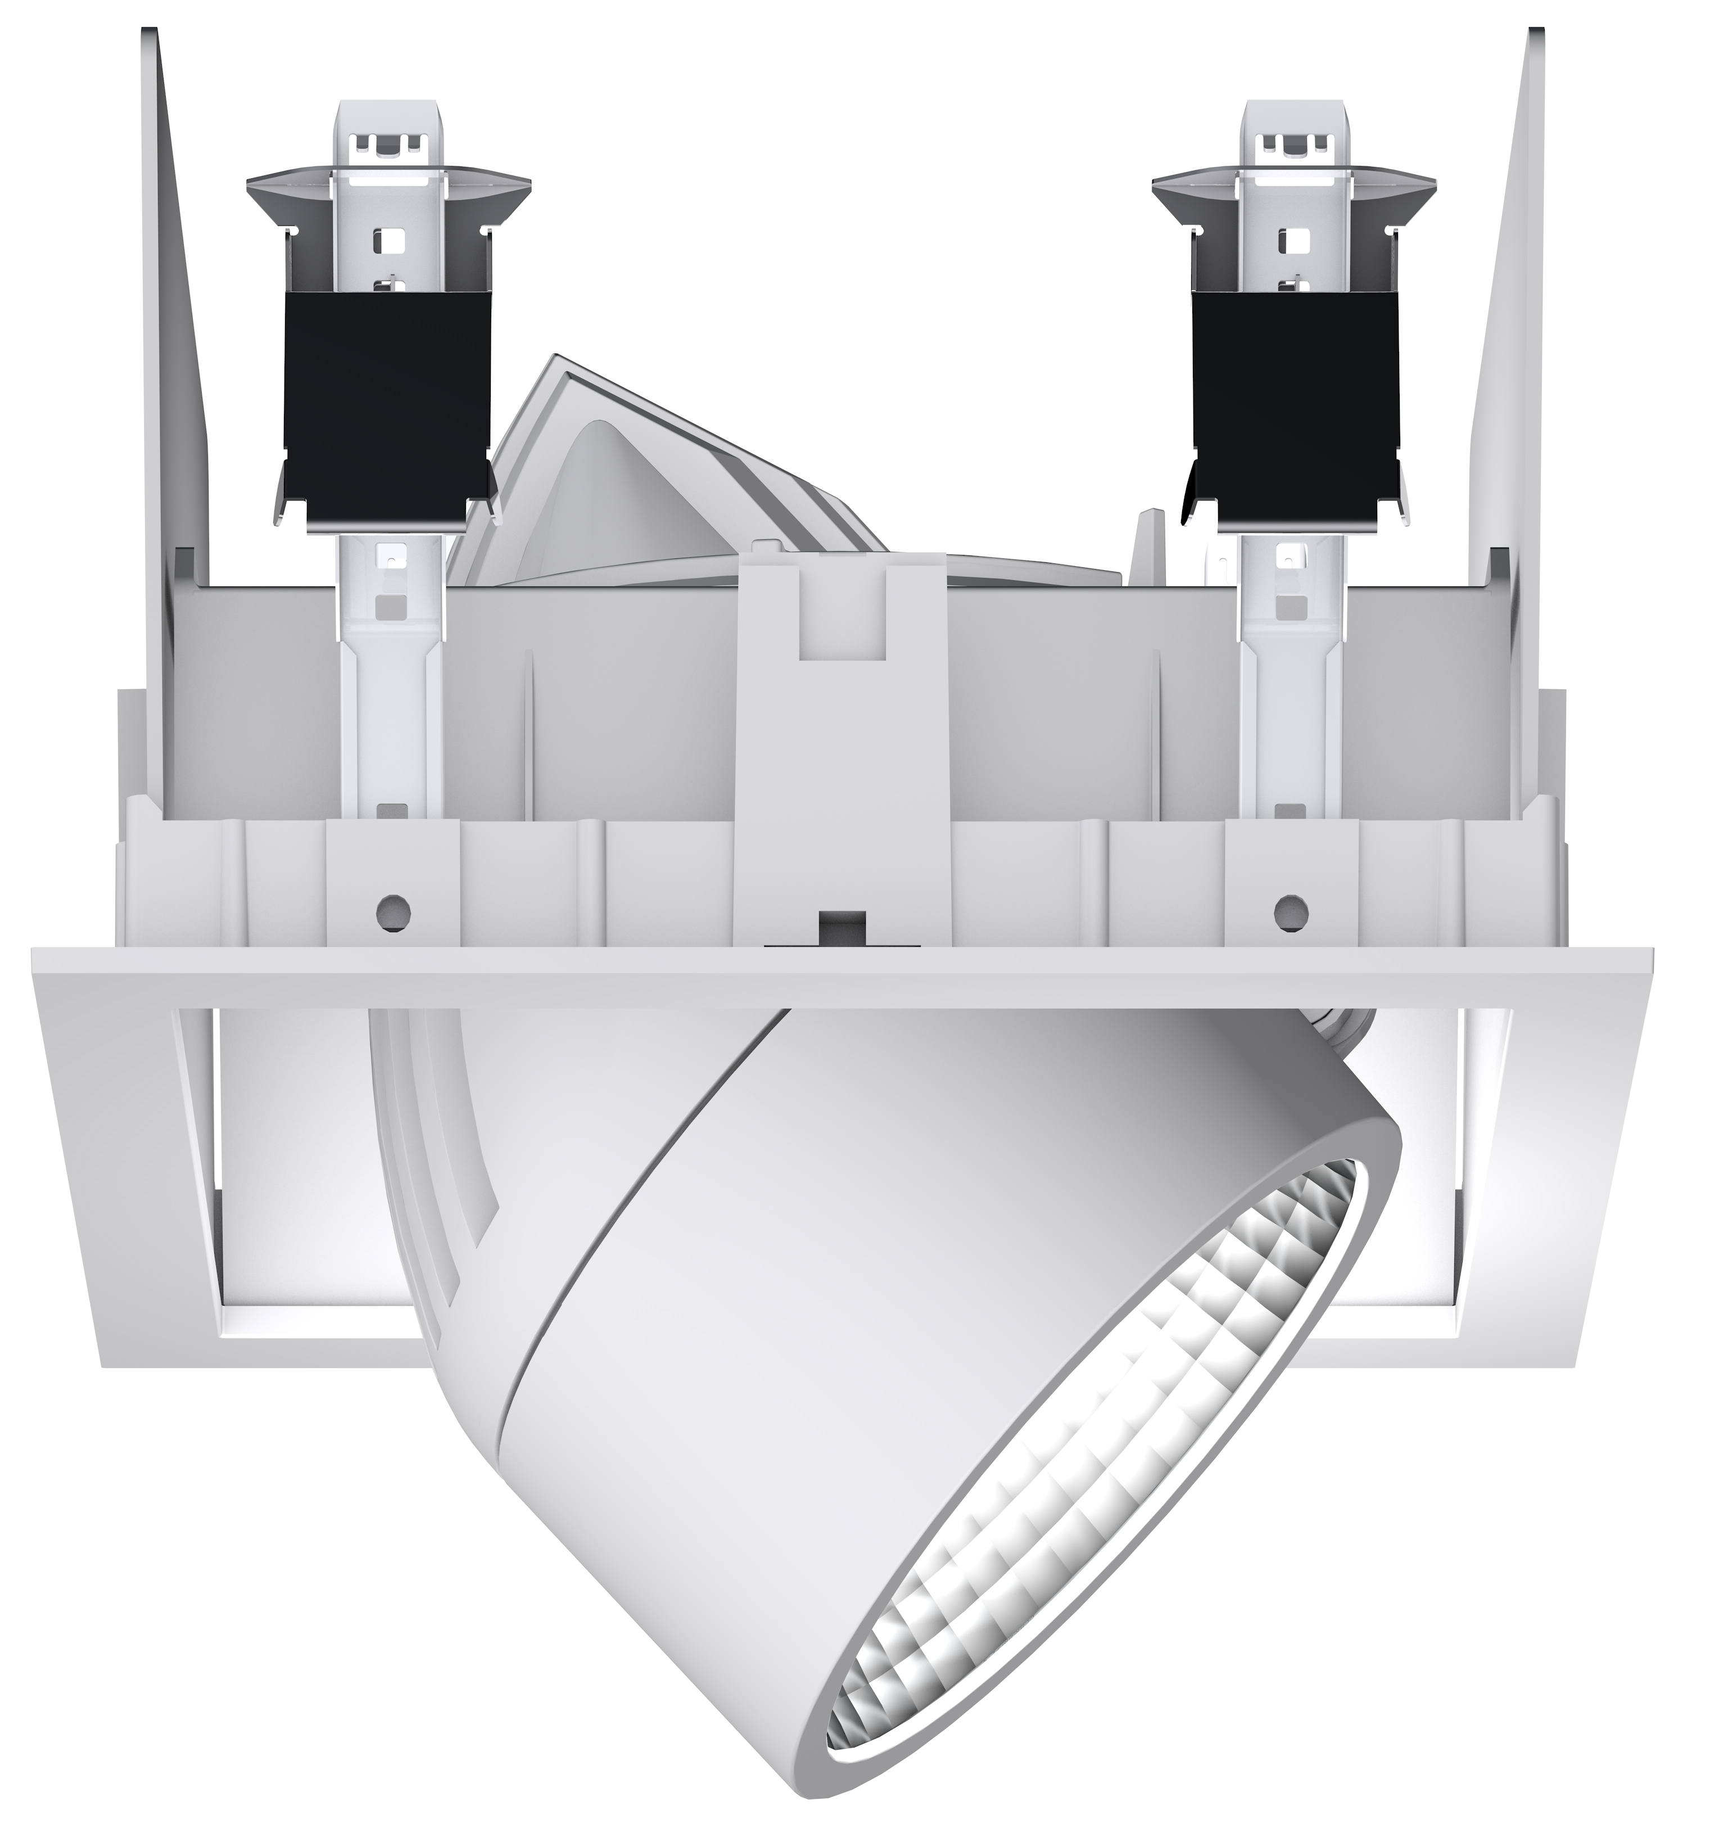
Caption 1: Single version of INTRO

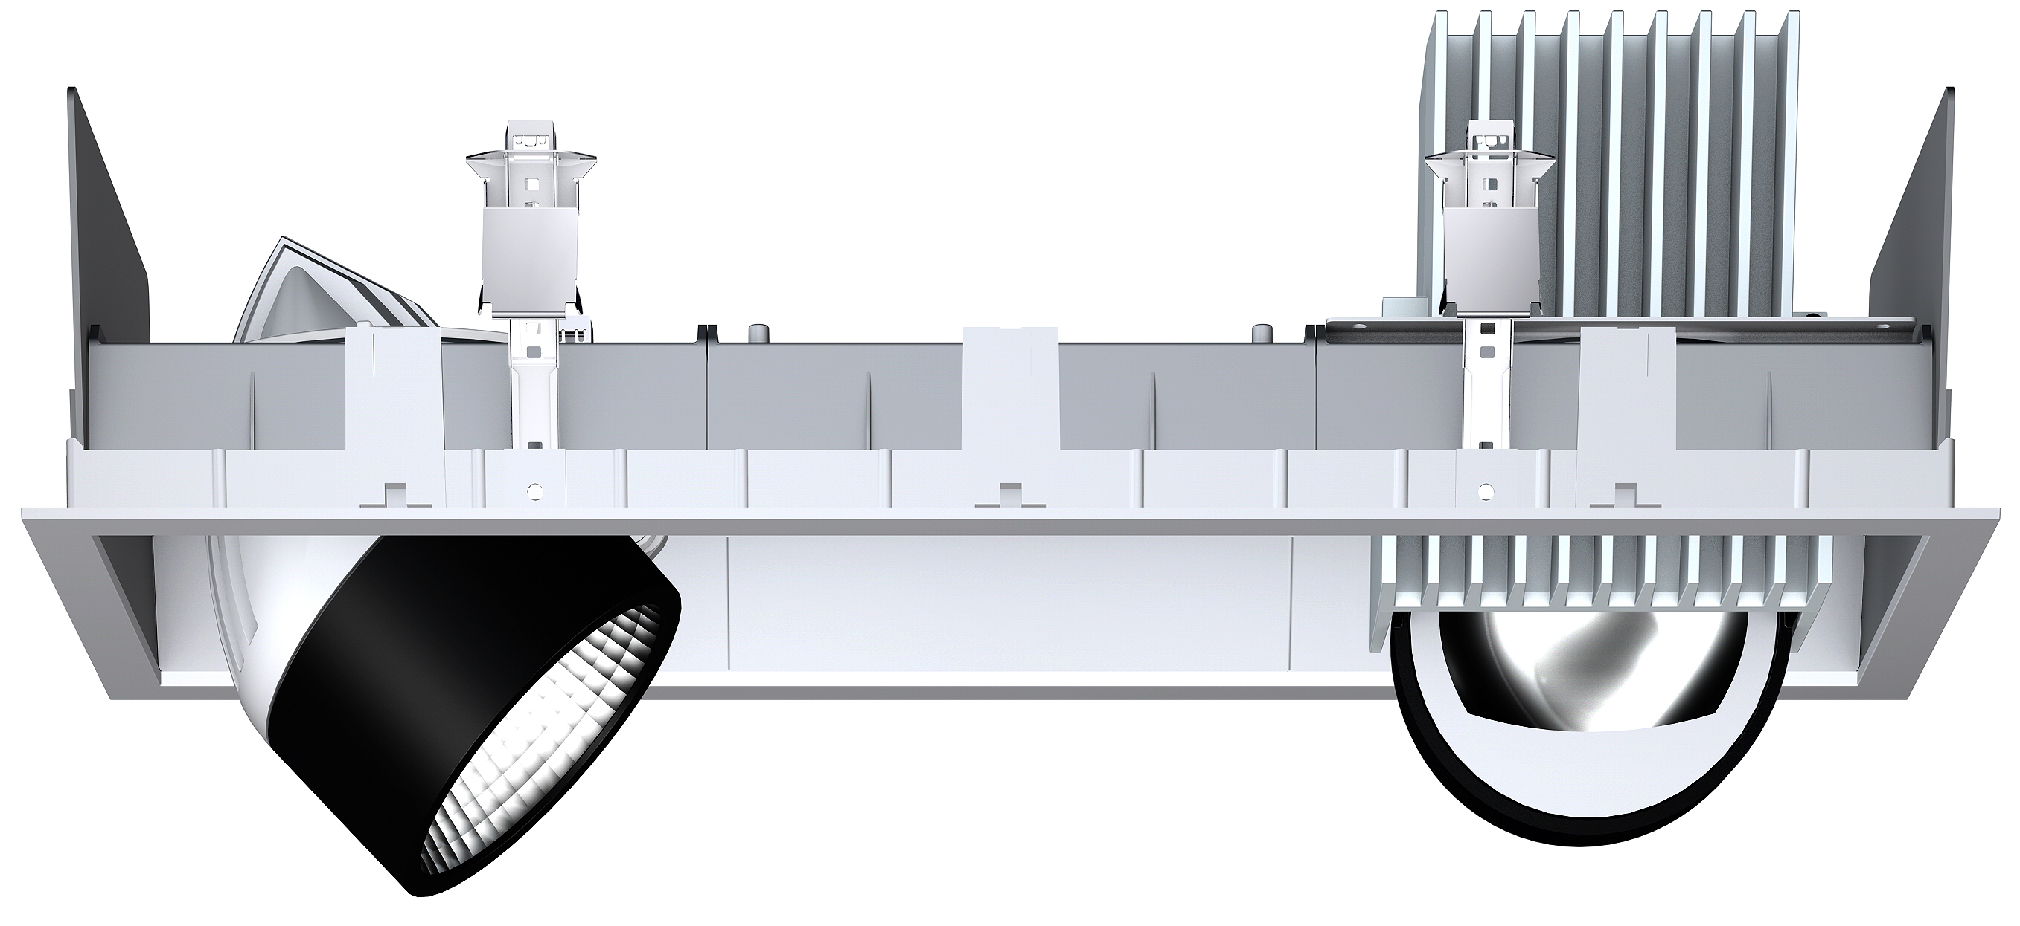
Caption 2: liteCarve© reflector technology developed by Zumtobel offers extreme design precision. This freeform reflector (patent pending) allows extremely precise, well-balanced rectangular light distribution, right up to the outermost peripheries.

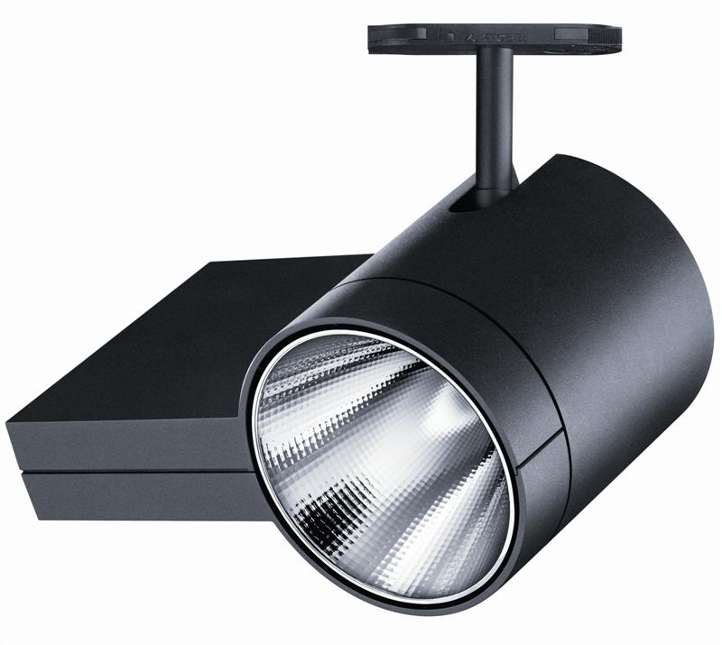
Caption 3: Round version of FACTOR
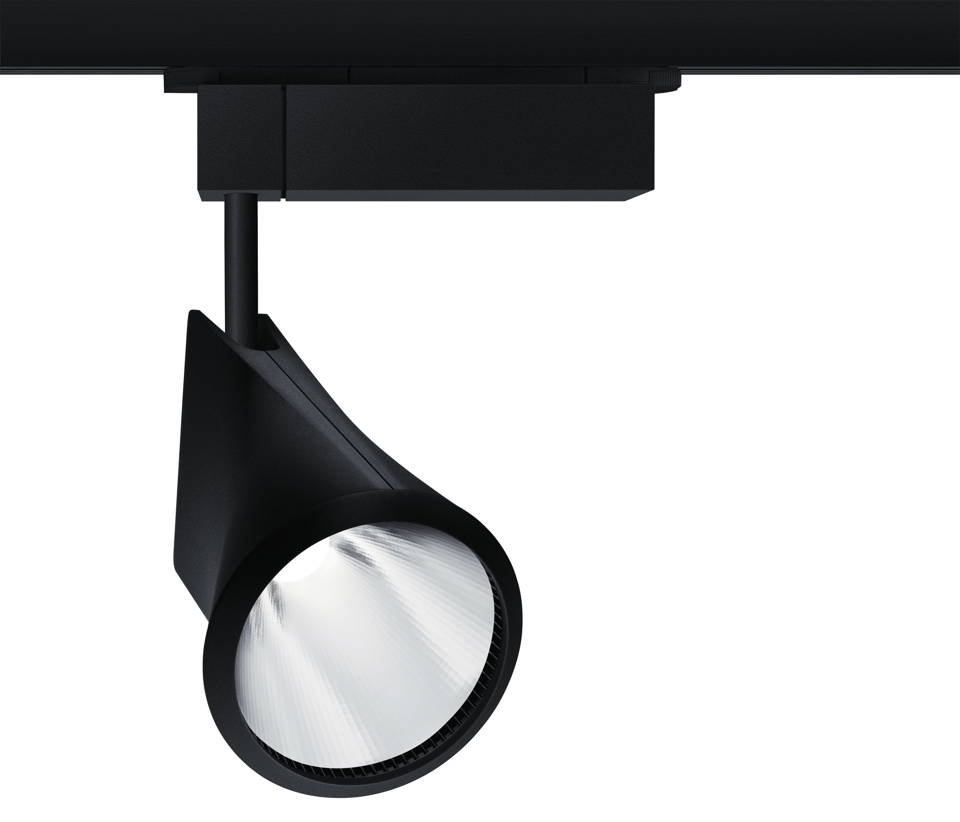
Caption 4: TrueGamutRendering-Technologie (TGR) will be initially available in the size M IYON spotlight.

Press contact:
Zumtobel Lighting GmbH
Sophie Moser
PR Manager
Schweizer Strasse 30
A-6851 Dornbirn

Tel +43-5572-390-26527
Mobile +43-664-80892-3074
E-mail sophie.moser@zumtobel.com

www.zumtobel.com

About Zumtobel
Zumtobel, a leading international supplier of integral lighting solutions, enables people to experience the interplay of light and architecture. As a leader in innovation, Zumtobel provides a comprehensive range of high-quality luminaires and lighting management systems for professional interior lighting in the areas of offices, education, presentation & retail, hotel & wellness, health, art & culture as well as industry. Zumtobel is a brand of Zumtobel AG with its head office in Dornbirn, Vorarlberg (Austria).
Zumtobel. The Light.

