Press release

Medical LED supply unit by Zumtobel: Sinus
Zumtobel introduces Sinus, a modular LED supply unit that meets various requirements in the health care sector. While doctors and care staff need ideal lighting conditions to perform treatments and examinations, patients need ideal lighting conditions to aid their convalescence. In addition, sustainability and energy efficiency are increasingly important factors, especially for operators and investors. The system can be flexibly adjusted to rooms with one to three patient beds and includes outlets for communication and medical gases.
Dornbirn, November 2013 - High-quality lighting in hospitals makes a difference. Especially in patient rooms, natural light enhances the patients' well-being and, as a consequence, promotes their convalescence and health. However, medical staff needs perfect lighting conditions for examinations and nursing services as well. Fitted with innovative LED technology, Sinus provides room lighting (5,940 lm per bed), examination lighting (6,770 lm), reading light (830 lm) and night light (50 lm) combined in one medical supply unit. The LED room lighting with indirect light distribution creates a pleasant atmosphere in the patient room. Optionally, it can be positioned continuously anywhere over the entire length of the supply unit. The electrically adjustable LED reading light inside the horizontal Sinus supply unit allows even more flexibility when determining room layouts: lighting can be adapted to suit the arrangement and number of beds in a patient room at the touch of a button. This new scope for creative design also makes huge savings possible. In addition to the large number of functions, Sinus cannot fail to impress thanks to its clear formal language and elegant slimline design and the high-grade materials used.
Components such as socket outlets, switches and phones, emergency nurse call buttons and data outlets for communications, as well as outlets for medical gases, are all unobtrusively accommodated in the Sinus system. This makes Sinus a functional supply unit which, thanks to its slimline design, is capable of making a significant contribution towards a feel-good atmosphere in patient rooms. The amortisation period of Sinus is reduced by its luminaire efficiency factor of 101 lm/W, its flexibility and long service life as well as the 5-year guarantee granted by Zumtobel for its products.
Flexibility for the benefit of patients
When developing Sinus, designer Andrea Ciotti integrated the light emitting diodes that provide reading and examination lighting exclusively in the front part of the supply unit. This makes sure that the entire length of the medical supply unit remains available for mounting a suspension bracket or a storage shelf for depositing personal items of patients.

Facts & figures
Using LEDs for room lighting | Colour temperature 3,000 K or 4,000 K  Colour rendering: Ra >80  Luminous flux of luminaire: > 5,940 lm  Installed load < 58.7 W  Luminaire efficiency factor > 101 lm/W  Length of module: 1,500 / 1,250 / 1,000 mm
Using LEDs for reading light/  examination lighting | Mean illuminance 300 lx  Colour temperature 3,000 K or 4,000 K  Colour rendering: Ra >80  luminous flux: > 830 lm  Installed load < 8.4 W  Luminaire efficiency factor > 99 lm/W  Length of module: 300 mm
Optionally: using LEDs for  night light | Maximum illuminance level < 5 lx  Colour temperature 3,000 K  Luminous flux of luminaire > 51 lm at 350 mA  Installed load < 1.2 W  Luminaire efficiency > 43 lm/W

Captions:
(Photo credits: Zumtobel)
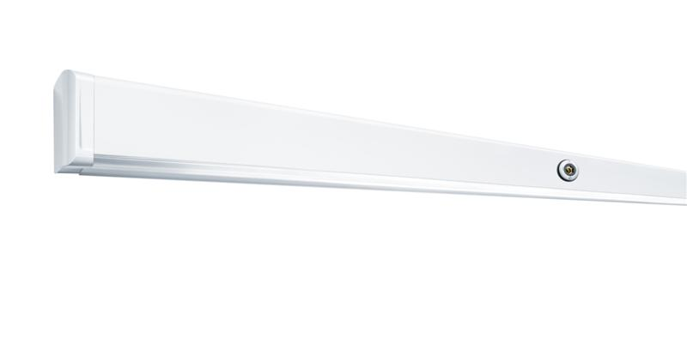
Caption 1: Sinus combines flexibility and clear design in a medical supply unit.
Caption 2: Two-bed room with continuous-row LED system (room light) and LED lighting modules (reading light/examination lighting).

Caption 3: Three-bed room with continuous-row LED system (room light) and LED lighting modules (reading light/examination lighting).
For more information, please contact:
Zumtobel Lighting GmbH  Nikolaus Johannson  Head of Brand Communication  Schweizer Strasse 30  A-6851 Dornbirn  Phone: +43 (0) 5572 390-26427  Mobile: +43-(0)-664-80892-3202  E-mail: nikolaus.johannson@zumtobel.com  www.zumtobel.com | Zumtobel Lighting GmbH  Sophie Moser  PR Manager  Schweizer Strasse 30  A-6851 Dornbirn  Phone: +43-5572-390-26527  Mobile: +43-664-80892-3074  E-mail: sophie.moser@zumtobel.com  www.zumtobel.com

About Zumtobel
Zumtobel is a leading international supplier of integral lighting solutions that enable people to experience the interplay of light and architecture. As a leader in innovation, the luminaire manufacturer provides a comprehensive range of high-quality luminaires and lighting management systems for the most varied application areas of professional interior lighting – including offices and educational facilities, presentation and retail, hotels and wellness, health and care, art and culture as well as industry and engineering. Zumtobel is a brand of Zumtobel AG with its head office in Dornbirn, Vorarlberg (Austria).

Zumtobel. The Light.

