Press release

Zumtobel SERVICES: Zumtobel extends its service offer

Dornbirn, March 2014 – Zumtobel NOW! enables customers to switch to an LED solution without incurring any extra costs. With Zumtobel MAINTENANCE SERVICES for ONLITE, operators have a serviced emergency lighting installation in place at all times.

Zumtobel NOW! – Full-service package for switching to an advanced LED lighting solution
With the new Zumtobel NOW! full-service package, Zumtobel offers its customers a straightforward exchange of their conventional lighting system for an advanced LED system. Within the scope of this service, Zumtobel assumes all services associated with project planning, implementation and management. There are no costs involved for the customer, for installation and investment costs are paid from part of the energy costs saved in subsequent years. Right from the first day, the electricity costs saved will reduce the company's operating cost. The Zumtobel NOW! agreement covers all areas: disassembly and disposal of old luminaires, delivery and installation of the new lighting system as well as commissioning. The agreement comprises the servicing of the system throughout the contract term, including maintenance and repairs. To implement the package, a Zumtobel representative will first visit the customer on site, recording the key data of the existing lighting installation and providing a first glance of potential energy savings after switching to LED technology. Then a team of Zumtobel experts from the fields of lighting, electrical engineering, installation, and maintenance will work out an individual lighting solution, as well as a timeline and budget for implementation. In a first step, Zumtobel NOW! is going to be available in the UK, Belgium, the Netherlands, Germany, Austria and Switzerland.

The benefits which the customer derives from this full-service package are obvious:
- All inclusive: the entire process of switching, from lighting design via installation, commissioning up to maintenance of the lighting system, is handled under the responsibility of Zumtobel.
- No costs: upon switching to a contemporary LED lighting solution with efficient luminaires and intelligent lighting control, no costs will be incurred by the company. Far from it: with the new LED lighting solution, electricity costs will be reduced significantly right from the first day.
- No maintenance effort: due to the long service life of LED luminaires of up to 50,000 h, frequent time-consuming relamping routines or luminaire repairs, and the associated high personnel cost, are eliminated. Moreover, maintenance is part of the NOW! agreement.
- Improved lighting quality: innovative LED lighting solutions with specifically matched optics enhance lighting quality and the perception of light. In this way, employees are better able to cope with the tasks incumbent upon them, and they feel more at ease.
- Reduced CO₂ emissions: efficient lighting systems ensure reduction of CO₂ emissions, thus improving the company's eco-balance.
- Observing European lamp bans: inefficient light sources are gradually being taken from the market under EU directives. By switching to an advanced LED lighting solution, the problem of imminent refurbishment is solved.

Zumtobel MAINTENANCE SERVICES for ONLITE – Maintenance and inspection package for emergency lighting
A company's emergency lighting system must always be in an impeccable, functional condition. A continuously maintained system not only reduces follow-up costs, but also ensures compliance with legal provisions. Zumtobel not only provides the required lighting technology, but now - with the Maintenance Services package for ONLITE - also an individual service offer for separate battery and central battery supplied emergency lighting installations. The maintenance and inspection package for ONLITE local SB 128 and ONLITE central eBox, CPS and LPS is based on annual maintenance of the emergency lighting system and direct contact with Zumtobel experts. The service package is rounded off by access to a knowledge base as well as by the Zumtobel service booklet and special preferential rates for spare parts and training events. The optional inspection of the individual emergency and escape sign luminaires is also included in the service package. Customers may choose between two service models as required.

Optimising energy consumption
Zumtobel's new Lighting Performance Platform also offers customers another benefit: this online platform enables customers to compare the consumption data of buildings and rooms at a glance, thus tapping into potential energy savings. This monitoring tool is perfectly matched to lighting management systems such as LITECOM; it monitors energy consumption within a company and shows how to achieve optimum energy efficiency using lighting management. Buildings, floor levels, rooms or even individual workstations can be addressed and conveniently presented in sunburst diagrams, so that their energy consumption can be optimised.

Captions:
(Photo credits: Zumtobel)
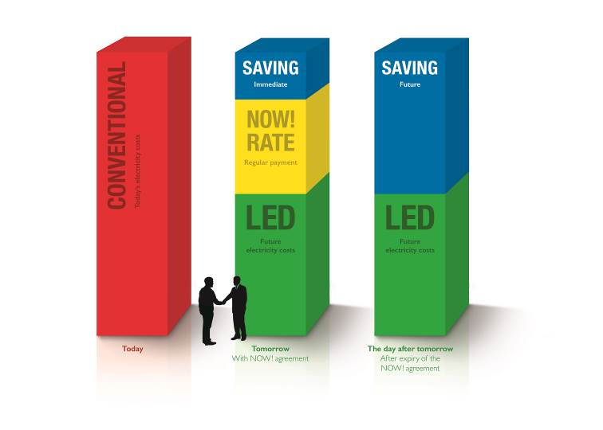
Caption 1: Zumtobel NOW! enables customers to switch to LED lighting without incurring any extra costs

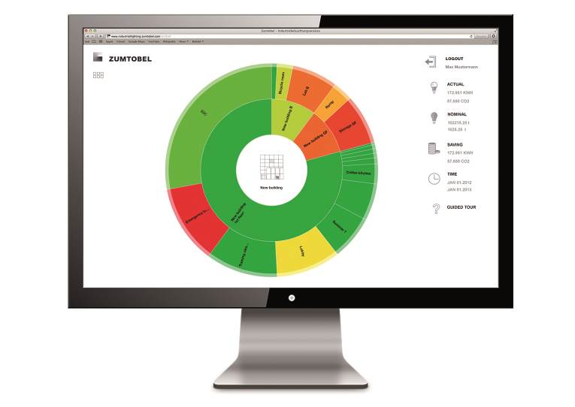
Caption 2: Buildings, floor levels, rooms or even individual workstations can be addressed and conveniently presented in sunburst diagrams, so that their energy consumption can be optimised.

Press contact:
Zumtobel Lighting GmbH  Sophie Moser  PR Manager  Schweizer Strasse 30  A-6851 Dornbirn  Phone +43-5572-390-26527  Mobile +43-664-80892-3074  Email sophie.moser@zumtobelgroup.com  www.zumtobel.com | Zumtobel Lighting GmbH  Nikolaus Johannson  Head of Brand Communication  Schweizer Strasse 30  A-6851 Dornbirn  Phone +43-5572-390-26427  Mobile +43-664-80892-3202  Email nikolaus.johannson@zumtobelgroup.com  www.zumtobel.com

About Zumtobel
Zumtobel, a leading international supplier of integral lighting solutions, enables people to experience the interplay of light and architecture. As a leader in innovation, Zumtobel provides a comprehensive range of high-quality luminaires and lighting management systems for professional interior lighting in the areas of offices, education, retail, hotel & wellness, health, art & culture as well as industry. Zumtobel is a brand of Zumtobel AG with its head office in Dornbirn, Vorarlberg (Austria).

