Press release

Discovering the world with a lighting solution by Zumtobel

Science meets art – since the reopening of the Royal Cabinet of Mathematical and Physical Instruments at the Zwinger palace in Dresden, an LED lighting solution by Zumtobel provides the right light for embarking on a journey of discovery through the history of science. At the same time, the highest conservational aspects are taken into account.

Dresden, August 2013 – After six years of reconstruction, the Royal Cabinet of Mathematical and Physical Instruments at the Zwinger palace in Dresden has been open to the public since April 2013. Today, the experimental cabinet of the Saxon elector, established in 1728, is the oldest museum located in the Zwinger. The new exhibition design enhances the architectural structures of the palace and allocates more space to the fascinating collection. On a floor space that has almost doubled, 400 of the around 2,500 historic scientific instruments are still displayed. Terrestrial and celestial globes, burning mirrors, telescopes, clocks and watches provide visitors with an insight of how scientists used to explore the world in the past. The oldest exhibit is a Persian celestial globe from the twelfth century. Thanks to the materials used and their exquisite craftsmanship, many items are impressive works of art. Large exhibits are presented free-standing, while smaller and especially sensitive objects are protected by showcases. Visitors are invited to stroll around and make discoveries for themselves.
“The new exhibition layout of the Royal Cabinet of Mathematical and Physical Instruments sets the masterpieces of the collection centre stage. Thus, visitors can enjoy the beauty and technical brilliance of the devices made for the Saxon Court up close and down to the finest detail. Media stations and presentations of historic experiments using replicas illustrate the functions of the instruments that were used for active research on site, at the Dresden Zwinger” – this is how Hartwig Fischer, General Director of the Dresden State Art Collections, explains the new concept. The lighting solution plays an important role against this background: it accompanies visitors along the galleries and pavilions, facilitating orientation and ensuring that they can experience the instruments authentically, while at the same time allowing for targeted and gentle presentation.

LED opens up new opportunities
One of the most important decisions in the context of the new concept was the changeover to an LED-only lighting solution. The minimalist Supersystem LED spots blend unobtrusively into the interior, enhancing the Baroque architecture to optimum effect. It is, however, not only their reduced dimensions and low energy consumption, but above all the LED luminaires' excellent lighting quality that is so impressive: since the new generation of LED luminaires emits significantly less heat and the light they generate is nearly completely free from IR and UV radiation, potential damage is reduced to a minimum. Outstanding colour rendering of more than Ra 90 allows visitors to experience the exhibits in their natural appearance, which could not differ more in terms of materials and colours, for since silver is presented to optimum effect in cool white light colours, warm white is ideal for shades of gold and bronze.
Some 400 exhibits are set centre stage authentically yet gently by approximately 1100 LED spots. Thanks to their performance potential, accent lighting is possible even across longer distances. Here, the modular lighting system is able to proof its outstanding versatility. Depending on the lighting task, various Supersystem models have been installed in the entire exhibition area as well as in public spaces: recessed in the ceiling, surface-mounted or as pendant luminaires. Moreover, the individual spots can be swivelled in and out and rotated in all directions to provide selective accent lighting .
Another characteristic feature of the new lighting solution is the interplay of daylight and artificial lighting. In the bright galleries, which were originally not intended as museums and meet conservational requirements to a very limited extent only, a great deal of sensitivity was necessary to integrate air-conditioning and light-shielding devices in order to protect the precious and sensitive exhibits. Thanks to a built-in DALI unit, Supersystem is compatible to a variety of lighting management systems, and the spots can be subdivided into useful control groups, adjusted to the prevailing lighting situation and set to ideal luminous intensity levels to suit the respective exhibition situation. “The combination of artificial lighting and daylight has been especially adjusted to the requirements of the interior design. State-of-the-art LED technology allows even the presentation of sensitive exhibits in a contemporary fashion, while the original flair of the premises is preserved,” explain Raoul Hesse and Carla Wilkins, the design team of Lightvision, the lighting design studio in charge, who are very pleased with the results.

Fact box
Lighting solution: | modular SUPERSYSTEM LED lighting system
Client: | Staatsbetrieb Sächsisches Immobilien und Baumanagement (SIB), Dresden
Architects (exhibition): | Holzer Kobler Architekturen GmbH, Zurich
Architects (structural engineering) | Lungwitz studio, Dresden
Lighting design: | Lichtvision Design & Engineering GmbH, Berlin
Electrical consultants: | Elektro Ing-Plan GmbH, Dresden
Electrical installations: | Elektro Dresden West

Captions:
(Photo credits: Andrea Flak)
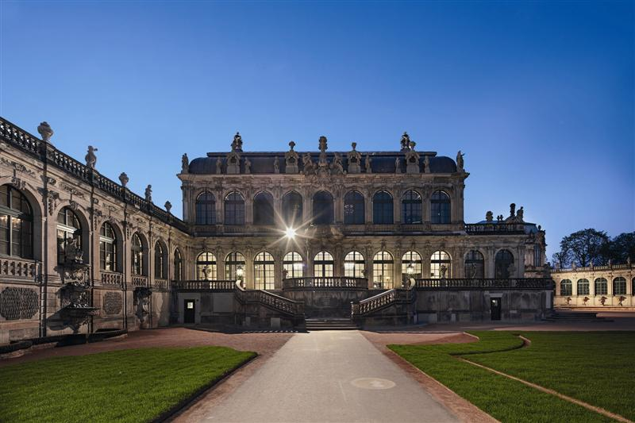
Picture 1: In the Royal Cabinet of Mathematical and Physical Instruments at the Zwinger palace in Dresden, an LED lighting solution by Zumtobel provides the right light for embarking on a journey of discovery through the history of science.
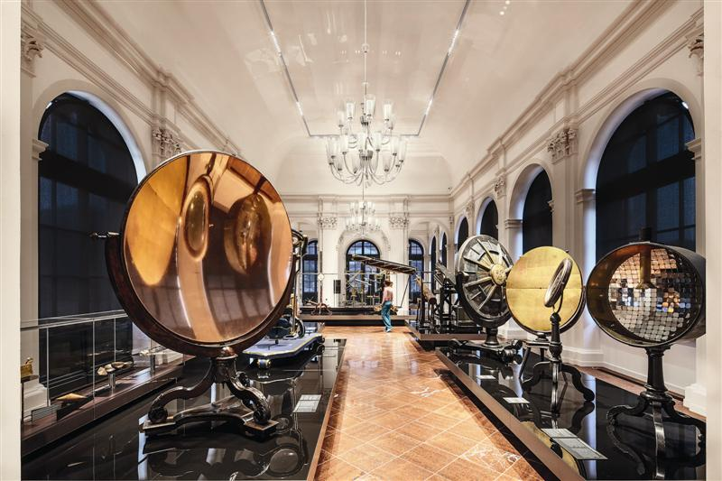
Picture 2: Some 400 exhibits are set centre stage authentically yet gently by approximately 1100 LED spots.
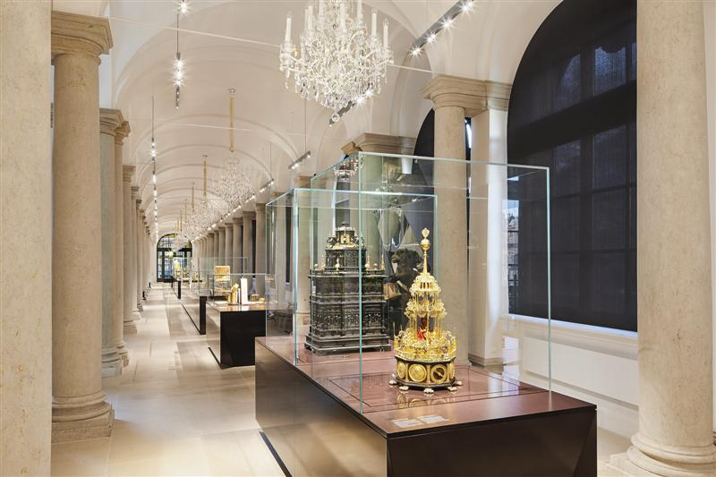
Picture 3: Depending on the lighting task, various Supersystem models have been installed in the entire exhibition area as well as in public spaces: recessed in the ceiling, surface-mounted or as pendant luminaires.
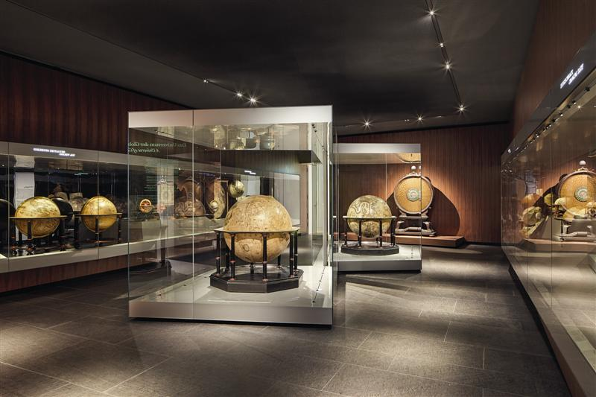
Picture 3: One of the most important decisions in the context of the new concept was the changeover to an LED-only lighting solution.

Further information:
Zumtobel Lighting GmbH  Nikolaus Johannson  Head of Brand Communication  Schweizer Strasse 30  A-6850 Dornbirn  Tel +43-5572-390-26427  Mobile +43-664-80892-3202  E-mail nikolaus.johannson@zumtobel.com  www.zumtobel.com | Zumtobel Lighting GmbH  Sophie Moser  PR Manager  Schweizer Strasse 30  A-6850 Dornbirn  Tel +43-5572-390-26527  Mobile +43-664-80892-3074  E-mail sophie.moser@zumtobel.com  www.zumtobel.com

Brief profile
Zumtobel is a leading international supplier of integral lighting solutions that enable people to experience the interplay of light and architecture. As a leader in innovation, the luminaire manufacturer provides a comprehensive range of high-quality luminaires and lighting management systems for the most varied application areas of professional interior lighting – including offices and educational facilities, presentation and retail, hotels and wellness, health and care, art and culture as well as industry and engineering. Zumtobel is a brand of the Zumtobel group with its head office in Dornbirn, Vorarlberg (Austria).

Zumtobel. The Light.

