Press release

Zumtobel won German Design Award 2015
LIGHT FIELDS evolution honoured for outstanding design
Zumtobel's design competence has been acknowledged once again by the prestigious German Design Award 2015. The renowned German Design Council has honoured even three products by Zumtobel for their outstanding product design and efficient lighting technology: the LIGHT FIELDS evolution range of LED luminaires impressed the jurors on account of their innovative creative power and superior lighting quality. The CRAFT high-bay LED luminaire and the SEQUENCE LED luminaire were awarded a “Special Mention” distinction for special design quality.
Dornbirn, 27 October 2014 – The German Design Award, the premium prize awarded by the German Design Council, is awarded for the fourth time this year. Awards are granted to high-calibre products and projects as well as their manufacturers and designers, who are pioneers in the German and international design scene. “Being honoured with the German Design Award acknowledges our ambitions to develop products and lighting solutions of superior design quality that provide the user with true added value,” says Stefan von Terzi, Zumtobel Marketing Director. “With LIGHT FIELDS we have managed to develop a product range that combines architectural design and cutting-edge technologies in one lighting solution.” The prizes will be awarded in Frankfurt on 13 February 2015.
An overview of the award-winning products:
LIGHT FIELDS evolution: LED luminaire range for sophisticated lighting projects
The LIGHT FIELDS evolution LED luminaire range designed by British industrial designer Christopher Redfern from Sottsass Associati combines straightforward design with innovation. Thanks to their uniformly slim-line design, narrow mounting height and high-grade materials, the luminaires blend perfectly into contemporary office interiors. However, LIGHT FIELDS evolution is impressive not only in visual terms but also in terms of technical features: innovative technologies have been incorporated in the various luminaire models. For the recessed and surface-mounted luminaires, Zumtobel has developed the 3Dprotect® reflector. Its 3D structure protects the LED modules during installation, preventing damage from electrostatic discharge. At the same time, the structure's reflection factor ensures an increase in the luminaire efficiency level. The free-standing, wall-mounted and pendant luminaires are fitted with innovative litePrint® waveguide technology, so that the light source remains concealed despite the luminaire's minimum height and delicate frame. This means that the high luminance of the individual LED lighting points is resolved perfectly. Thanks to the highly effective micro-pyramidal optic (MPO+), all LIGHT FIELDS evolution models feature optimum glare control and maximum lighting quality at all times in a variety of working situations.
CRAFT: efficient and targeted high-bay LED lighting
The CRAFT high-bay LED luminaire is the result of a joint development project by Zumtobel and Arup. CRAFT provides high luminous flux levels of up to 28,000 lumens for lighting tasks in industrial areas; innovative lens technology allows for high-precision light control. The luminaire features square and narrow-beam lighting characteristics to perform a variety of lighting tasks; the lighting solution's uniformity and efficiency are significantly improved as the luminous fields do not overlap. A special design feature, the rib structure, ensures cooling and cleaning on account of the airflow, which significantly increases the LED's service life.
SEQUENCE: adaptive, pinpoint task area lighting
The SEQUENCE LED luminaire offers an optimum combination of direct and indirect lighting and boasts modules than can be individually controlled. Thus, the luminaire meets the various requirements of employees with respect to ideal office lighting as well as the need for customisation to the utmost degree. SEQUENCE has been designed as a pendant and surface-mounted luminaire and consists of 8 or 14 module units arranged alongside each other, each with 6 x 3 centrally arranged LED light points. Thanks to an opal cover frame, the 24 outer LEDs provide diffuse ambient light as well as an altogether softer light distribution. Besides this exceptional performance feature, SEQUENCE, thanks to its flat aluminium housing, boasts an especially slim shape that blends perfectly into any interior design. The luminaire's sophisticated design – all its electronic components are almost invisibly enclosed in a slightly raised area on the top of the luminaire unit – ensures a delicate appearance.
About the German Design Award
As a competition that emphasises the high design competence of its participants, the German Design Award enjoys high public esteem on an international level, also thanks to the high reputation of the body awarding the prizes: the German Design Council, which has been representing the German design scene for more than 60 years. The independent institution acting on a global level helps companies to communicate their design competence in an efficient manner and at the same time aims at raising public awareness of design. The jury of the German Design Award is composed of renowned design experts coming from the worlds of business, science and the design industry. This year, German Design Awards will be granted for the first time in the separate competition formats of Excellent Product Design and Excellent Communications Design. In the Excellent Product Design segment, a total of 2,250 international entries were submitted.
Captions:

(Photo credits: Zumtobel)

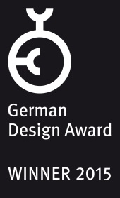
Fig. 2: German Design Award 2015
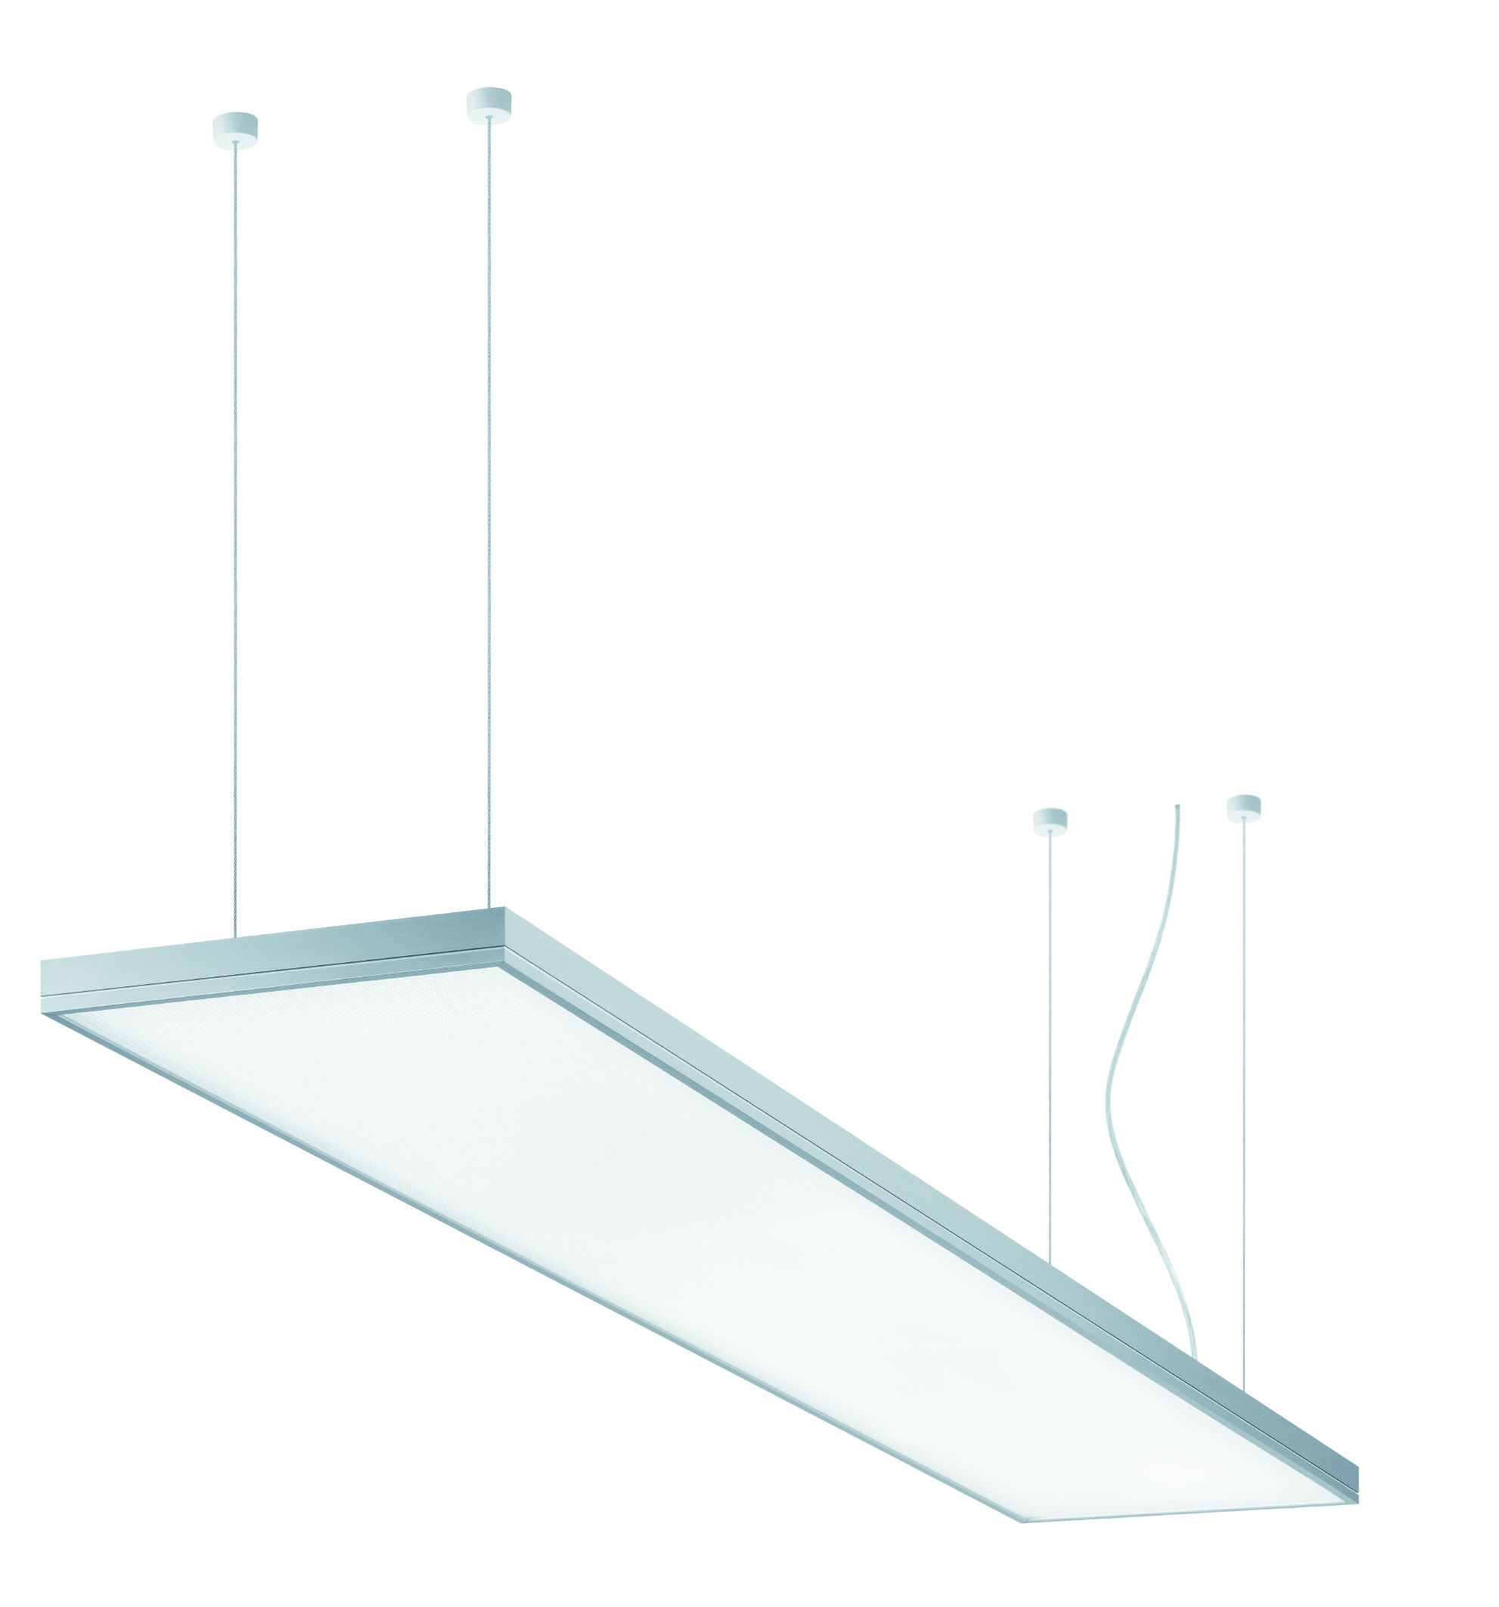
Fig. 2: LIGHT FIELDS evolution – LED luminaire range for sophisticated lighting projects

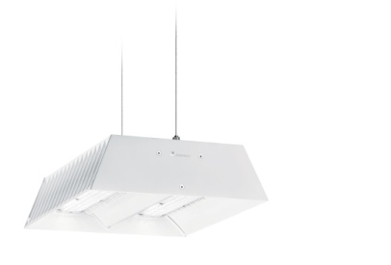
Fig. 3: CRAFT – efficient and targeted high-bay LED lighting

Fig.4: SEQUENCE – for adaptive, pinpoint task area lighting

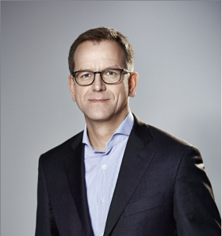

Fig. 5: Stefan von Terzi, Zumtobel Marketing Director
Press contact:
Zumtobel Lighting GmbH
Sophie Moser
PR Manager
Schweizer Strasse 30
A-6851 Dornbirn

Tel.: +43-5572-390-26527
Mobile: +43-664-80892-3074
E-mail: sophie.moser@zumtobel.com
www.zumtobel.com

About Zumtobel
Zumtobel, a leading international supplier of integral lighting solutions, enables people to experience the interplay of light and architecture. As a leader in innovation, Zumtobel provides a comprehensive range of high-quality luminaires and lighting management systems for professional interior lighting in the areas of offices, education, presentation & retail, hotel & wellness, health, art & culture as well as industry. Zumtobel is a brand of Zumtobel AG with its head office in Dornbirn, Vorarlberg (Austria).
Zumtobel. The Light.

