Press release

Exciting lighting partnership with BVB
Zumtobel invites lighting solution partners to the kick-off at Signal Iduna Park

Borussia Dortmund is synonymous with real passion and an incomparably intense football experience. The purpose of the lighting partnership between the Zumtobel Group and traditional club Borussia Dortmund is to showcase this experience in the right light. And now Zumtobel's Lighting Solution Partners are also set to benefit from this partnership with BVB. As a thank you for their excellent cooperation, Zumtobel has come up with a unique training and adventure package for its partners built around a visit to one of BVB's Bundesliga home matches.

Dornbirn, August 2014 – The Zumtobel Group and Borussia Dortmund set a shining example with their lighting partnership. Zumtobel has already developed an innovative LED lighting concept for BVB's recently opened Fan World, which sets the first division club and its Fan World centre stage in an exciting way. In addition, there are plans to equip BVB's playing and training facilities with high-performance lighting solutions over the next few years. Zumtobel's customers are already benefiting from this close collaboration. This scheme is directed in particular at electricians, wholesalers and other customer groups. The scheme will be backed up by training programmes, project workshops and other sales-supporting measures intended to achieve joint sales figures. Zumtobel, together with BVB, has put together an exclusive training and event package for this purpose.

"With our Lighting Solution Partner programme we have built a successful platform to facilitate cooperation with our customers" says Stefan von Terzi, Director Marketing Zumtobel. "We're glad that, through this partnership, cooperation with BVB will add another emotional component to our close collaboration and, at the same time, it will give us the chance to combine knowledge transfer with a unique experience."

Zumtobel Group and Borussia Dortmund – real partners
The Zumtobel Group is a partner of BVB. The partnership is shaped by the Group’s two lighting brands, Thorn and Zumtobel. With its strategic multi-brand approach, the Group covers the full range of professional lighting solutions, making it a strong and versatile partner for Borussia Dortmund. The partnership includes the implementation of various lighting projects for the football club, as well as sales supporting measures for the target groups of both brands.

Captions:
(Photo Credits: Zumtobel)
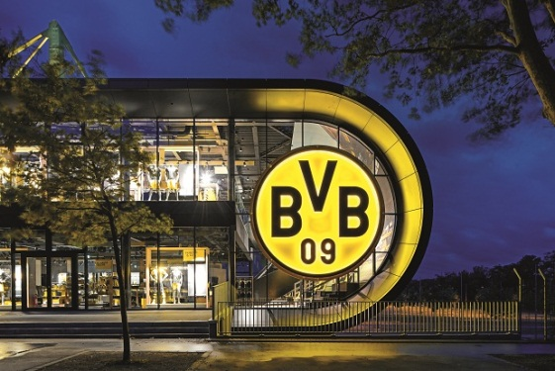
Caption 1: The Zumtobel Group and Borussia Dortmund set a shining example with their lighting partnership.
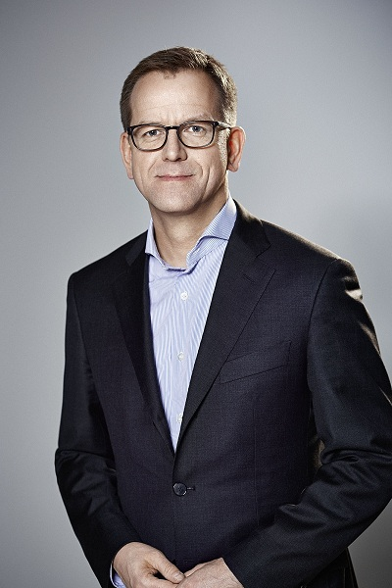

Caption 2: Stefan von Terzi, Director Marketing Zumtobel Lighting

Press contact:
Zumtobel Lighting GmbH
Sophie Moser
PR Manager
Schweizer Strasse 30
A-6851 Dornbirn

Tel.: +43-5572-390-26527
Mobile; +43-664-80892-3074
e-mail: sophie.moser@zumtobelgroup.com

www.zumtobel.com

About Zumtobel
Zumtobel, a leading international supplier of integral lighting solutions, enables people to experience the interplay of light and architecture. As a leader in innovation, Zumtobel provides a comprehensive range of high-quality luminaires and lighting management systems for professional interior lighting in the areas of offices, education, presentation & retail, hotel & wellness, health, art & culture as well as industry. Zumtobel is a brand of Zumtobel AG with its head office in Dornbirn, Vorarlberg (Austria).
Zumtobel. The Light.

